Appendix D
Concept of Operations for WRTM Strategies

Table of Contents
D-1 Active Traffic Management (ATM) During Weather Events 5
1.1 Scope 5
1.2 Referenced Documents 7
1.3 Current System or Situation 7
1.4 Nature and Justification of Changes 11
1.5 Concepts for the Proposed Strategy 12
1.6 Operational Scenarios 16
1.7 High-Level System Design 24
1.8 Analysis of the Proposed System 29
D-2 Weather Responsive Traffic Signal Management 30
2.1 Scope 30
2.2 Referenced Documents 31
2.3 Current System or Situation 31
2.4 Nature and Justification of Changes 33
2.5 Concepts for the Proposed Strategy 33
2.6 Operational Scenarios 40
2.7 High-Level System Design 43
2.8 Analysis of the Proposed System 48
D-3 Regional Traveler Information for Weather Events 50
3.1 Scope 50
3.2 Referenced Documents 50
3.3 Current System or Situation 51
3.4 Nature and Justification of Changes 53
3.5 Concepts for the Proposed Strategy 53
3.6 Operational Scenarios 57
3.7 High-level System Design 59
3.8 Analysis of the Proposed System 65
D-4 Seasonal Weight Restrictions 66
4.1 Scope 66
4.2 Referenced Documents 67
4.3 Current System or Situation 68
4.4 Nature and Justification of Changes 68
4.5 Concepts for the Proposed Strategy 68
4.6 Operational Scenarios 74
4.7 High-level System Design 76
4.8 Analysis of the Proposed System 78
D-5 Intra-Agency and Inter-agency Coordination 79
5.1 Scope 79
5.2 Referenced Documents 80
5.3 Current System or Situation 80
5.4 Nature and Justification of Changes 81
5.5 Concepts for the Proposed Strategy 82
5.6 Operational Scenarios 93
5.7 Functional Requirements for Intra- and Inter-agency Coordination 95
5.8 Analysis of the Proposed Strategy 114

List of Tables
Table D-1. System Requirements for Deploying Weather Responsive ATM Strategy 25
Table D-2. Potential Performance Measures for Assessing the Effectiveness of Using ATM Strategies during Weather Events 29
Table D-4. System Requirements for Deploying Weather Responsive Regional Traveler Information Strategy 61
Table D-5. System Requirements for Deploying SWR Strategy 77
Table D-6. Performance Measures for SWR 78
Table D-7. Key Systems for Weather-Related Intra- and Inter-agency Coordination 82
Table D-8. Systems included in Intra and Inter-Agency Coordination Services 87
Table D-9. System Interconnections for Inter- and Intra-agency Communications 90
Table D-10. Applicable Standards for WRTM Strategy 92
Table D-11. High-Level Functional Requirements for Intra- and Inter-agency Coordination 96

List of Figures
Figure D-1. Configuration of ATM Sign Gantries during Normal Travel Condition (No ATDM Strategy Deployed; Source: Texas Transportation Institute) 9
Figure D-2. Use of ATM Technologies to Implement Variable Speed Limits (Source: Texas Transportation Institute) 10
Figure D-3. Use of ATM Technologies to Implement a Lane Closure Strategy (Source: Texas Transportation Institute) 10
Figure D-4. High-level, Functional Components of ATM System (Source: Texas Transportation Institute) 11
Figure D-5. Components of Weather-Responsive ATM System (Source: Texas Transportation Institute) 13
Figure D-6. Potential Implementation of a Weather-Responsive Variable Speed Limit Using ATM Technologies (Source: Texas Transportation Institute) 17
Figure D-7. Potential Implementation of a Weather-Responsive Reduced Speed Limit for High-Profile Vehicles Using ATM Technologies (Source: Texas Transportation Institute) 19
Figure D-8. Potential Implementation of Weather-Responsive Truck Use Prohibitions Using ATM Technologies (Source: Texas Transportation Institute) 21
Figure D-9. Potential Implementation of a Weather-Responsive Vehicle Use Restriction for High-Profile Vehicles Using ATM Technologies (Source: Texas Transportation Institute) 22
Figure D-10. Potential Implementation of Weather-Responsive Moving Lane Closure to Assist with Snow Removal Using ATM Technologies (Source: Texas Transportation Institute) 23
Figure D-11. Components of Weather-Responsive Traffic Signal Management Strategy (Source: Texas Transportation Institute) 36
Figure D-12. Concept of Weather-Responsive Traffic Signal Management Deployment with Operator as Decision Maker (Source: Texas Transportation Institute) 38
Figure D-13. Concept of a Fully Automated Weather Responsive Traffic Signal Management Deployment (Source: Texas Transportation Institute) 39
Figure D-14. Concept of Weather-Responsive Traffic Signal Timing Deployment in a Connected Vehicle Environment (Source: Texas Transportation Institute) 40
Figure D-15. Map of South Dakota Showing Forecast Road Conditions (Source: Meridian Environmental Technologies) 52
Figure D-16. Precipitation and Road Condition Forecast for April 2, 2010 (Source: Meridian Environmental Technologies) 53
Figure D-17. Functional Components of a Regional Road Weather Travel Impact Prediction System (Source: Texas Transportation Institute) 54
Figure D-18. High-Level Concept Diagram for Seasonal Weight Restriction (Source: Created by Authors) 70
Figure D-19. Example Temperature Profile (Source: Meridian, Clarus Multi-state Regional Demonstration, Use-Case #2 Website) 71
Figure D-20. Example Resilience Profile (Source: Meridian, Clarus Multi-state Regional Demonstration, Use-Case #2 Website) 72
Figure D-21. NDOT Load Restrictions Chart (Source: NDOT Website, http://www.dot.nd.gov/roadreport/loadlimit/spring-load-restrictions-chart.asp) 74

D-1 Active Traffic Management (ATM) During Weather Events

1.1 Scope
Traffic management is rapidly expanding to include technology, communication, and control systems that provide a more proactive approach to managing demand and supply in complex travel situations. A concept called Active Traffic Management (ATM) consists of a suite of traffic management/control strategies and advanced technologies designed to improve the operational efficiency of highway systems. These technologies and systems are used to dynamically manage traffic flow and enhance capacity through the dissemination of control and advisory information to the users of the system. The operational goals and objectives of most ATM deployments are as follows:
- To maximize both safety and traffic flow during periods of congestion;
- To reduce the potential of collisions caused by rapid and severe speed differentials due to queuing during congested periods;
- To optimize the use of existing infrastructure during recurrent and non-recurrent congestion with minimum operator intervention;
- To improve trip reliability by limiting the effects of abrupt speed and lane changes by motorists approaching the end of a queue; and
- To provide additional capacity during periods of congestion and/or incidents.
Fundamentally, ATM requires moving to a dynamic, proactive set of strategies looking at travel reliability as a core objective. Common traffic management strategies deployed in freeway applications as part of an ATM system include the following:
- Speed Harmonization/Lane Control: Dynamically adjust speed limits on a freeway corridor based on the level of congestion to reduce the risk of accidents and optimize the flow of vehicles through the corridor.
- Queue Warning: Display information about downstream traffic backups to the motorists using Variable Message Signs (VMS) to inform motorists of downstream queuing and lane closures, allowing motorists to select alternate routes or lanes and reduce queue buildup.
- Dynamic Re-routing: Provide information and guidance to motorists regarding diversions and alternate routes when there is downstream congestion.
- Dynamic Vehicle Restrictions: Restrict specific classes of vehicles, in particular large trucks, from all or a portion of the freeway. It can also consist of placing different types of restrictions on different types or classes of vehicles. Chain requirements for heavy vehicles or specific truck speed limits during limited visibility events are examples of dynamic vehicle restrictions imposed during adverse weather conditions.
- Dynamic Lane Restrictions: Place restrictions on the types of movements that are permitted in a lane. For freeway applications, this could mean restricting use of the lane by all or specific classes of vehicles.
- Hard Shoulder Running: Allow motorists to use the freeway shoulder during congested periods to reduce congestion during peak periods. For this strategy the shoulders should be upgraded to full depth pavements, and monitored vehicle refuge areas should be constructed for disabled or stopped vehicles.
Managing traffic during adverse weather fits in the ATM framework. A concept of operations for Weather Responsive Traffic Management needs to include many if not all of the strategies identified for ATM. For example, during severe weather events, it is not uncommon for transportation and law enforcement personnel to want to implement speed, lane-use, and vehicle-use restrictions in response to deteriorating weather and pavement conditions. These restrictions are intended to improve safety by matching the operating characteristics of the traffic stream to the physical conditions that exist on the roadway. Transportation and law enforcement personnel may implement speed restrictions because of deteriorating pavement friction or limited sight distance. Speed harmonization techniques might be implemented during inclement weather to reduce and limit the effects of speed differentials in the traffic stream, which might lead to increased collisions. Similarly, transportation agencies may want to separate vehicles in the traffic stream – restricting trucks and high-profile vehicles to specific lanes. Likewise, in some situations, the appropriate response to deteriorating roadway and travel condition might be to restrict particular vehicles (such as trucks and other high-profile vehicles) from using the roadway until travel conditions have improved. Critical to all these strategies is the need to warn motorists of impending restrictions and disseminate to them the reasons for the actions.

1.1.1 Document Overview
The purpose of this document is to provide a concept of operations for using ATM strategies to better manage traffic during weather events. This concept of operations show how strategies like variable speed limits/speed harmonization, vehicle type restrictions, vehicle lane restrictions, and traveler information systems can be implemented in an holistic manner to assist in managing traffic operations during inclement weather.
- Section 1.2: Indicates the documents referenced in the development of this concept of operations.
- Section 1.3: Provides an overview of what ATM is and how it currently operates in the United States.
- Section 1.4: Provides a justification of the changes to the current situation.
- Section 1.5: Provides a discussion of the proposed changes to the system so as to allow agencies to provide weather-responsive ATM.
- Section 1.6: Provides several operational scenarios that illustrate how ATM strategies and technologies might be used to provide weather-responsive traffic management advisories and controls on freeways.
- Section 1.7: Provides the high-level user needs and system requirements.
- Section 1.8: Discusses the analysis and the potential performance metrics that can be used to measure system effectiveness.

1.1.2 Concept Overview
Various strategies can be used to counter the effects of lost capacity and reduced operating speeds during inclement weather. Strategies like speed harmonization can be used to reduce the maximum posted speed limits based on snow, ice, wind, or other weather conditions. Dynamic message signs can be used to implement truck prohibitions or restrict trucks to specific lanes on a freeway to separate slow moving vehicles from vehicles not impacted by the weather conditions. Lane control signals can also be deployed to provide travelers with end of queue warnings and lane closure information. Generally these strategies are implemented at the request of police, emergency management, or maintenance personnel. Once implemented, strategies need to be updated continuously as weather conditions change over time.

1.2 Referenced Documents
The following documents were used in the development of this concept of operations document:
- Active Traffic Management Concept of Operations. Washington State Department of Transportation, December 2008.
- Active Traffic Management Standard Operating Procedures I-5, SR-520, I-90. Washington Department of Transportation, July 29, 2010.
- Active Traffic Management: The Next Step in Congestion Management. Report No. FHWA-PL-07-012. FHWA, U.S. Department of Transportation. July 2007.
- Synthesis of Active Traffic Management Experiences in Europe and the United States. Report No. FHWA-HOP-10-031. FHWA, U.S. Department of Transportation. March 2010.

1.3 Current System or Situation
Although widely used in Germany, the Netherlands, and the United Kingdom, the concept of Active Traffic Management (ATM) has only been gaining traction in the United States since 2006. With ATM, agencies try to dynamically manage capacity and demand in real-time, based on prevailing traffic and roadway conditions. The concept relies heavily on agencies having the ability to measure prevailing travel conditions in real-time, to identify root sources and specific locations of congestion, and using advance traveler information systems and technologies to implement actions and strategies to affect travel behavior in a corridor. ATM focuses on trip reliability – ensuring a level of consistency in service from the facility while at the same time reducing the amount of inconsistency (or variability) in operating conditions.
ATM deployments in Europe and the United States use combinations of symbols and words displayed on dynamic message signs (DMS) mounted on sign gantries that span over all the freeway lanes in a particular direction. These gantries are spaced at regular intervals (e.g., every ½ mile). Each gantry contains a number of different system DMS’s installed over each lane or mounted to the side of the freeway. As the driver passes through sections of freeway, the messages on the signs are used to convey the specific regulatory and driving conditions that are in effect until the next sign gantry.
Key to the system is the over-the-lane DMS (ODMS). The ODMS are small in nature (e.g. 42 pixels by 42 pixels, 6 characters per line, 4 lines of 9-inch characters) and have the capability of displaying both text, and colored graphics to display vehicle and truck speed limits, truck restrictions, and lane use symbols. These ODMS are used to convey conditions to drivers driving in each lane. Side-mounted DMS (SDMS) signs mounted on the side of each lane are then used to provide drivers with information about a specific condition.
The SDMS are larger than the ODMS but still not as large as a conventional DMS. These signs are full matrix signs and are capable of displaying messages in color. The messages displayed on each sign are limited to short message (no more than three lines of eight characters each). Both SDMS on each sign gantry would display the same message (unless overridden by the operator). Each SDMS would be used to display speed limit messages, reduced speed warning messages (in conjunction with reduced speed limits on the ODMS), lane closure/ lane restriction information, and vehicle restriction messages.
On every second or third sign gantry (depending on need, geometric conditions, and sign conspicuity), the two SDMS would be replaced with a single conventional DMS located over the right shoulder. This sign would be the typical DMS sign used in most freeway management applications (3 lines of 12 to 21 – 18” characters per line). Typical messages displayed on this DMS might include safety and congestion alerts, incident messages, amber alerts, emergency restrictions, roadway or lane closures, public service announcements, etc. However, during adverse weather conditions, these signs would be used to provide travelers with weather information associated with a weather traffic management response (e.g., “ICE ON ROAD”, “FOG AHEAD”, “HIGH WINDS”, etc.).
While the discussion below is not exhaustive of the capabilities and situations in which ATM systems and technologies might be used, it is intended to illustrate some of the potential uses and capabilities of the ATM technologies deployed on a freeway.
Figure D-1 shows a typical sign configuration during normal driving conditions. In this particular situation, the ODMS are blank (or black-out). The SDMS may be used to display the speed limit of the roadway under normal driving conditions or may also be blank, while the large DMS could be blank or display normal traveler information messages.
One application of the system is to implement speed harmonization/queue warning through the use of dynamic speed limits. Sensors in the roadway constantly monitor lane-by-lane travel speeds. When congestion forms, the speed on the freeway begins to drop. The ATM control logic senses that speeds are dropping and activates the ODMSs upstream of the congested section, slowing down traffic approaching the congestion. The SDMS are also activated indicating that a reduced speed limit is in effect and/or drivers should be aware that they are approaching slow traffic ahead. This strategy is intended to reduce the speed differential between traffic regimes (i.e., congested and uncongested regimes); thereby reducing the potential for drivers to be surprised when they encounter the congested region. Figure D-2 shows how the sign gantries would be used to implement a variable speed limit ATM strategy. Speed limits can vary lane-by-lane and can be adjusted dynamically as travel conditions warrant.
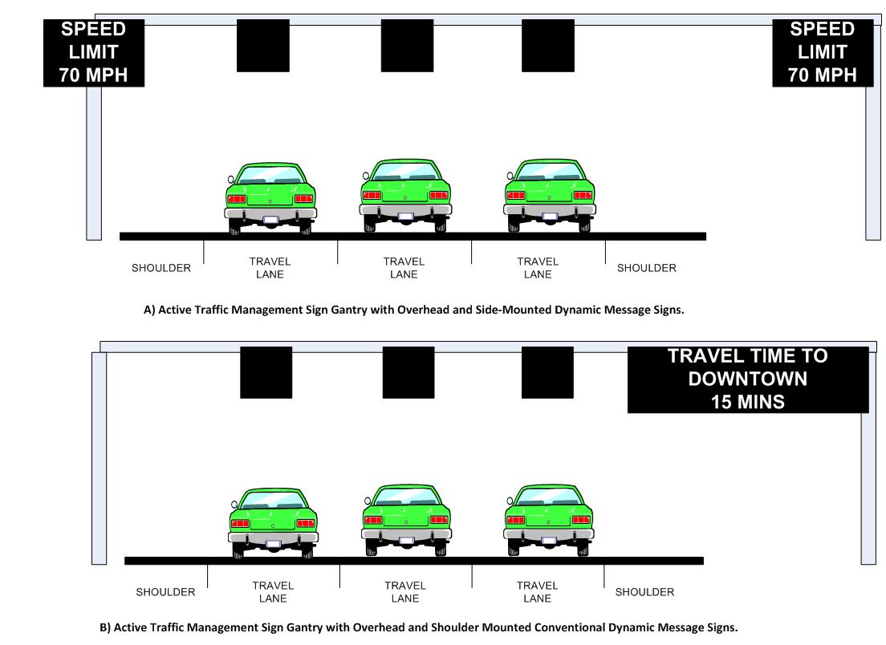
Figure D-1. Configuration of ATM Sign Gantries during Normal Travel Condition (No ATDM Strategy Deployed; Source: Texas Transportation Institute)
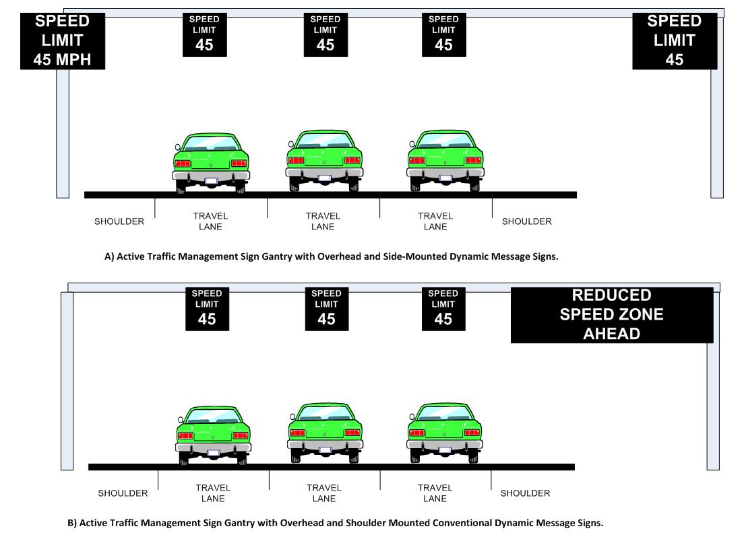
Figure D-2. Use of ATM Technologies to Implement Variable Speed Limits (Source: Texas Transportation Institute)
Another common application of the ATM technology is to provide advance warning of lane closures due to incidents or work zones. In this particular application, the ODMS can also function as lane-use control signals. (Figure D-3) shows how the ATDM system might be used to implement a notification of a lane closure strategy. A red “X” would be used to indicate that a lane is closed or blocked because of an incident or maintenance activity. A yellow “X” is used to warn travelers of an impending blockage and inform them that they should begin vacating the lane. A green downward point arrow is used tell motorists that the lane is open and available for use. By sequencing messages upstream of the closure, the intent of this signing strategy is to provide information to approaching motorists in advance of the lane closure in an attempt to encourage drivers to vacate closed lanes further upstream of the point of closure.
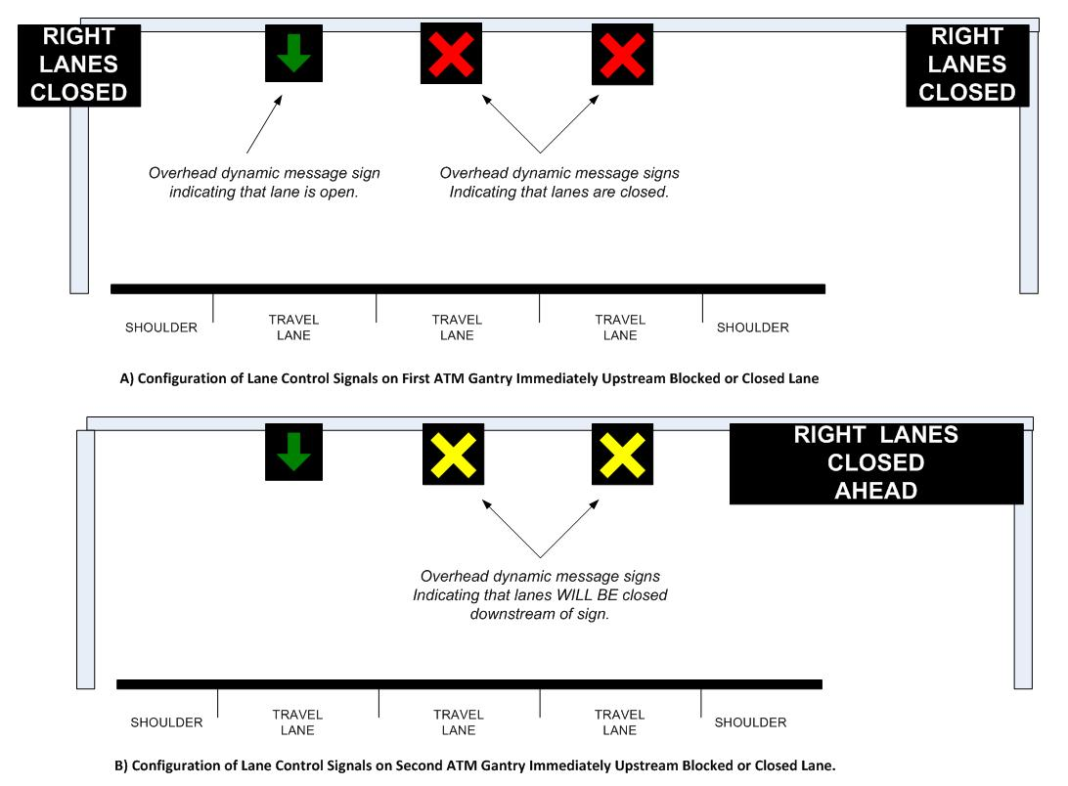
Figure D-3. Use of ATM Technologies to Implement a Lane Closure Strategy (Source: Texas Transportation Institute)
Figure D-4 shows a high-level, functional architecture of a current implementation of ATM in the United States. In both Seattle and Minneapolis, the ATM is deployed as part of a much larger freeway management system. This figure only shows the high-level, functional components needed to provide the ATM capabilities.
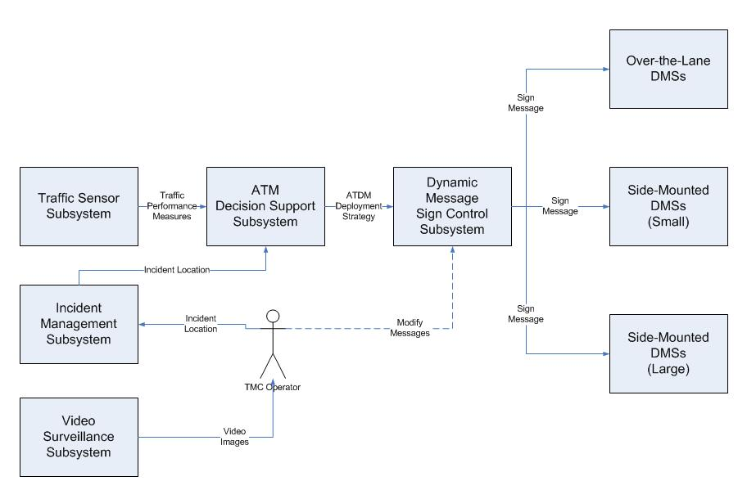
Figure D-4. High-level, Functional Components of ATM System (Source: Texas Transportation Institute)
Most ATM deployments are envisioned to operate with little or no operator involvement in the decision-making process. Traffic operating conditions are measured in real-time, and strategy selection and implementation are designed to occur automatically. The systems are designed this way so that they can be more responsive to changing traffic conditions than traditional freeway management systems.

1.4 Nature and Justification of Changes
Past research and experience have shown that adverse weather can significantly reduce not only capacity but also operating speeds on freeways. According to the 2000 Highway Capacity Manual, adverse weather can have the following impacts on traffic flow, operating speeds, and capacity.
- While light rain does not have much effect on operating speeds, heavy rains that affect visibility can have a noticeable impact on traffic flow and operating speeds.
- Similarly, light snows have a minimal effect on freeway traffic flows and operating speeds, but heavy snow can significantly influence the speed-flow curve.
- If not removed from the roadway, snow accumulation on highways cause drivers to not only increase their headways, but to also increase their lateral clearance, causing three-lane segments of freeway to operate as two widely separated lanes.
As such, the greatest benefits of ATM type strategies may be during periods of inclement weather. Coupling weather information integration into the ATM framework will enable strategies that can be used to counter the effects of lost capacity and reduced operating speeds during inclement weather.

1.5 Concepts for the Proposed Strategy
This concept of operations focuses on the systems and technologies that agencies need to deploy the following weather-responsive ATM strategies:
- To implement weather-related variable speed limits/speed harmonization.
- To implement truck speed restrictions in response to changing weather conditions.
- To prohibit trucks and other classes of vehicle from using a facility during weather events.
- To restrict trucks and high-profile vehicles from using certain lanes during weather events.
- To provide traveler information in support of weather-responsive maintenance operations.
The following section discusses some to the operational policies and constraints and the functional components of ATM strategies that are needed to implement these weather-responsive strategies.

1.5.1 Description of the Proposed Strategy
During adverse weather conditions, the ATM system could be used to provide various types of weather responsive traffic management responses, including variable speed limits (or speed harmonization), truck restrictions, truck speed limits, or lane-use control. Weather responsive ATM strategies could be implemented either automatically (with or without operator approval) or manually. Figure D-5 shows the basic architecture of the system. The pink shaded boxes with bold typeface represent new components being added to the system to accomplish the functions listed above.
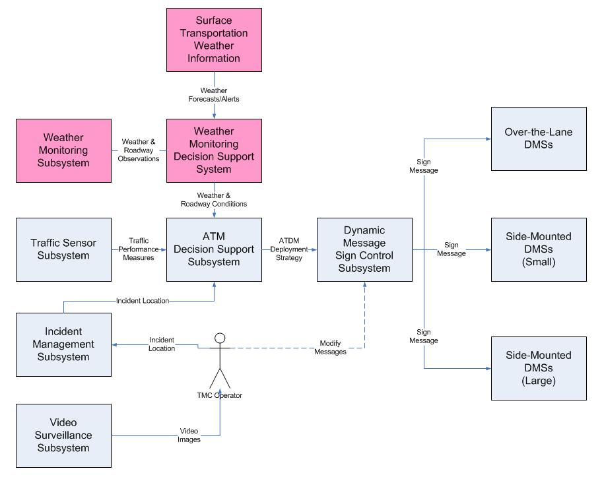
Figure D-5. Components of Weather-Responsive ATM System (Source: Texas Transportation Institute)

Weather Monitoring Subsystem
The weather monitoring component is responsible for obtaining all the road surface and weather information needed to assist in determining when and where to implement different types of weather ATM strategies. Through sensors located in the field communicating back to the weather monitoring system, the ATM decision support system would be provided with updates of weather conditions, particularly visibility, surface conditions and/or precipitation accumulations. These sensors could be agency-owned or information can be provided by a private weather information provider. The types of data needed from the weather monitoring component would include the following:
- The current wind speed and direction,
- The current ambient air temperature,
- The presence of precipitation,
- The rate at which precipitation is currently falling and the start and stop time of the latest recorded precipitation,
- The current visibility distance,
- The current temperature of the pavement surface and an indication of the presence of any moisture on the surface,
- The current depth of snow and packed snow on the traveled way,
- Expected time of snow fall or rain storm, and the probability of snow and rain, and
- The current thickness of ice on the traveled way.
The weather monitoring system may also provide situation assessments of weather conditions, such as the following:
- An assessment of the current wind condition (e.g., calm, light breeze, gale, gusty, etc.);
- An assessment of the type and intensity of the current precipitation (e.g., no precipitation, moderate snow, heavy rain, etc.);
- An assessment of the visibility (e.g., clear, foggy, smoke, sun glare, etc.); and
- An assessment of the pavement state (e.g., dry, standing water, flowing water, packed snow, etc.)

Surface Transportation Weather Information Subsystem
This represents the providers of value-added sector specific meteorological services. These providers utilize National Weather Service data and predictions (including the qualified environmental data from the Clarus system), road condition information and local environmental data provided by the traffic management or maintenance organizations, and their own models to provide surface transportation related weather observations and forecasts including pavement temperature and conditions. Such information could also include services like Clarus-enabled quality-checked ESS information or other value-added surface transportation weather forecasts at hourly frequencies (and when thresholds have been exceeded for weather/road weather parameters). This subsystem includes ongoing interaction with meteorologists for weather impact prediction and location-specific forecasts. Information from this subsystem may be directly integrated and overlaid with Traffic Management Center (TMC) management software and the ATM decision-support system.

Weather Monitoring Decision Support System (WMDSS)
The WMDSS is a subsystem component is responsible for collecting, processing, integrating, and synthesizing weather information from different sources, and assessing and predicting its impact on traffic operations in a corridor. The purpose of this assessment is to identify for transportation management agencies when, where, and for how long traffic operations in the network will be affected by weather conditions. This subsystem might use real-time or off-line micro- or mesoscopic simulation or other similar forecasting tools to model the effects of weather operations and determine where operational problems are likely to develop. This model would also illustrate how operational problems or impacts are likely to grow and expand as weather conditions continue to deteriorate.

ATM Decision Support Subsystem
The decision support subsystem is responsible for making the decisions about when and what kind of ATM strategy to implement. This component would contain the rules and criteria for when and where to implement the various active signal management strategies. Measured weather, roadway surface, and traffic conditions would be compared to agency criteria established for each of the traffic signal management strategies approved by the agency. The output of this component would be the recommended ATM strategy. This component is responsible for performing the following functions:
- Retrieving and processing traffic and travel condition information from the roadway and weather monitoring subsystems,
- Comparing actual traffic, pavement, and weather conditions to established thresholds and criteria,
- Assessing and recommending the appropriate active traffic management strategies to deploy based on the prevailing traffic and travel conditions
- Implementing the accepted/approved active traffic management strategy on the sign gantries, and
- Updating implemented active traffic management strategies as conditions change.

DMS Control Subsystem
This component of the system is responsible for controlling the ATM technologies that have been deployed on the roadway (i.e., the dynamic messages signs located on the sign gantries). This component interfaces with the decision support system and is responsible for formatting the messages to be displayed on the sign gantries and for communicating those messages to the various dynamic message signs in the system. This subsystem would also monitor the status of the various dynamic message signs and be responsible for managing the messages that are displayed on the system. This subsystem would also need to prioritize message and strategies to be deployed. As the system is likely to be used to display strategies for purposes other than just weather (such as incidents, etc.), agencies would need to develop a hierarchy of conditions for displaying different types of ATDM treatments.

TMC Operator
The goal of most ATM systems is to operate autonomously, with little or no intervention from an operator; however, a TMC operator remains a vital component of the system. The TMC operator would be responsible for developing the initial responses that needed to be implemented by the decision support system. The operator would also be responsible for identifying rules and procedures for implementing ATM strategies for different operating scenarios, and for establishing criteria and thresholds needed to implement a response. System operators would also have general oversight authority of the decision support system to fine-tune responses after they are implemented or to address issues, improvements and situations not identified during the development of the implementation rules and scenarios.

1.5.2 Operational Policies and Constraints
A number of operational constraints exist when deploying weather-responsive ATM strategies. First, ATM requires that agencies have staff and technologies that can support real-time decision-making and the dissemination of traffic and travel information to the traveling public. Generally, this means agencies have a traffic management center and an infrastructure that can support real-time traffic management. Agencies must also have the resources and capabilities to install, operate, and maintain not only the traffic detectors and the dynamic message signs, but also the weather sensing equipment.
Second, deploying weather-responsive ATM strategies requires a high density of both traffic detectors for measuring traffic conditions, and weather sensors for measuring prevailing roadway surface and visibility conditions. Roadway traffic data needs to be measured on a lane-by-lane basis and spaced at regular intervals to ensure that changes in traffic operating conditions can be measured quickly and accurately. Weather sensors need to be installed at regular intervals (every three to five sign gantries) next to the freeway to ensure that changes in weather conditions are also detected rapidly. Roadway sensors and weather information both need to be constantly updated in real-time. Robust and redundant communications systems are needed to ensure that both roadway and weather information reach the control center.
Finally, the ATM strategies are only effective if they can be enforced by local law enforcement agencies. State and local agencies may need to enact new laws and ordinances that will allow different operating strategies (such as variable speed limits or vehicle lane-use restrictions) to be implemented. Some agencies may also have to implement changes to their Manual on Uniform Traffic Control Devices (MUTCD) to permit the use of certain signs to be displayed through dynamic message signs.

1.6 Operational Scenarios
This section describes several operational scenarios that illustrate how an Active Traffic Management (ATM) system can be used to manage traffic during adverse weather conditions. The ATM techniques that are discussed are as follows:

1.6.1 Variable Speed Limits
In an automated mode, the decision support system would monitor both weather information from the ESS and traffic flow information from the agency’s traffic surveillance system. When pavement conditions or precipitation rates begin to impede traffic flow, the decision support system would recommend to the operator to activate the appropriate weather-responsive actions. These plans could be stored in a library of responses or generated by the decision support system based on the criteria established by the operations. TMC operators should work with weather forecasters, police and emergency management personnel, and maintenance personnel to identify the appropriate speed limits for a variety of pavement and visibility conditions and how these conditions should be monitored and evaluated by the decision support system.
Weather responsive variable speed limits could also be implemented based on requests by police or emergency response personnel, maintenance personnel, and/or DOT operations personnel. In these situations, system operators would implement the variable speed limits manually. Operators could manually input appropriate responses or select an appropriate response plan from a library of stored response plans. All manual overrides should be approved by the appropriate engineer-in-charge in the TMC.
Figure D-6 shows an example of how weather responsive variable speed limits could be implemented using ATM technologies. ODMS would be used to display the appropriate speed limit for each section of freeway. All speeds shown on the ODMS would be regulatory speed limits. The speeds shown on the sign would be in effect until either another set of signs show a different speed or the driver leaves the ATM zone. The SDMS would be used to alert drivers that they are in an area of reduced speeds. Large DMSs in the affected area could also be used to provide drivers information about why the reduced speed limits are in effect (e.g. ICE ON ROAD).
The decision support system and/or system operators would first need to identify the section of freeway impacted by adverse weather conditions. Using pavement and visibility information provided by the road weather information system, the decision-support system would then determine what speed limit is appropriate for the prevailing conditions. Multiple sign gantries upstream of the affected area would be used to step down the speed to the appropriate limit according to agency policies. Similarly, the transition from the reduced speed limit to the normal speed limit would be spread over multiple sign gantries according to agency policy. If a full reduction step is not required, the sign group closest to the impact area should show the full step reduction while the sign groups upstream of the full speed reduction would show a partial speed reduction.

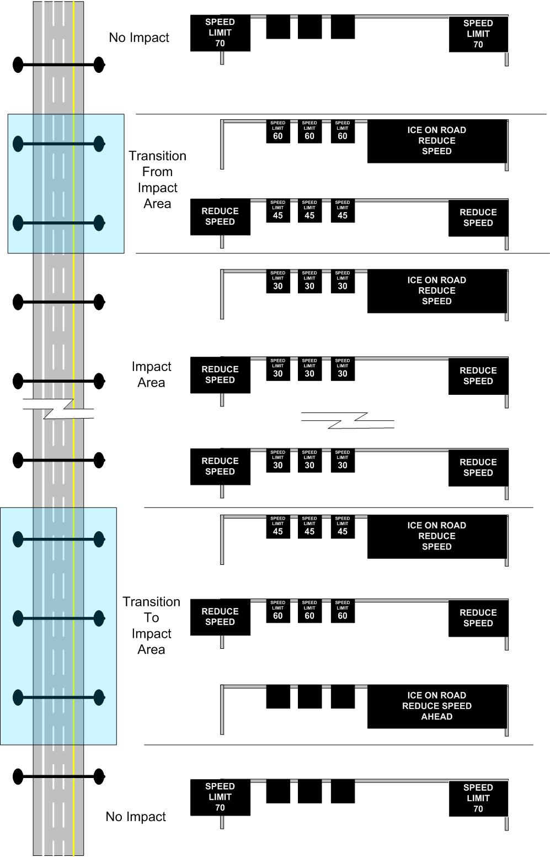
Figure D-6. Potential Implementation of a Weather-Responsive Variable Speed Limit Using ATM Technologies (Source: Texas Transportation Institute)

1.6.2 Truck Speed Restrictions
During some adverse weather events (such as high winds or icy conditions), it may be beneficial to restrict the speed at which trucks and other high-profile vehicles travel. High winds may be associated with another weather event (such as a severe thunderstorm or winter weather event) or may be a sole phenomenon not associated with another weather event. High winds are commonly associated with downdrafts from severe thunderstorms, tall bridges, or severe roadway cuts that tend to create a wind tunnel effect. Reducing the speed of trucks and other high-profile vehicles is a common strategy deployed in high wind situations to limit the potential of these vehicles overturning due to significant wind force.
Wind speed and direction information from a RWIS station, installed adjacent to the freeway, would continuously measure wind speed and direction. This information would be fed continuously to the WMDSS, where the system would compute the wind speed vector normal to the direction of travel (crosswind speed). The WMDSS would then compare the computed crosswind speed to an established threshold to determine the potential for high winds to overturn high profile vehicles. If the potential is severe enough, the WMDSS could then determine the appropriate speed limit for the prevailing crosswind conditions.
After determining what the appropriate speed limit should be for the prevailing crosswind conditions, the WMDSS would communicate this speed to the ATM system, which would then implement the reduced speed traffic plan on the sign gantries. The ODMS would be used to display an appropriate speed limit to commercial vehicle operators. The SDMS signs would be used to warn all travelers that truck speed restrictions are in effect while the conventional DMS signs would be used to convey appropriate weather-related messages to commercial fleet operators. Figure D-7 shows an example of how a reduced speed limit for high profile vehicle might be implemented on the ATM system.

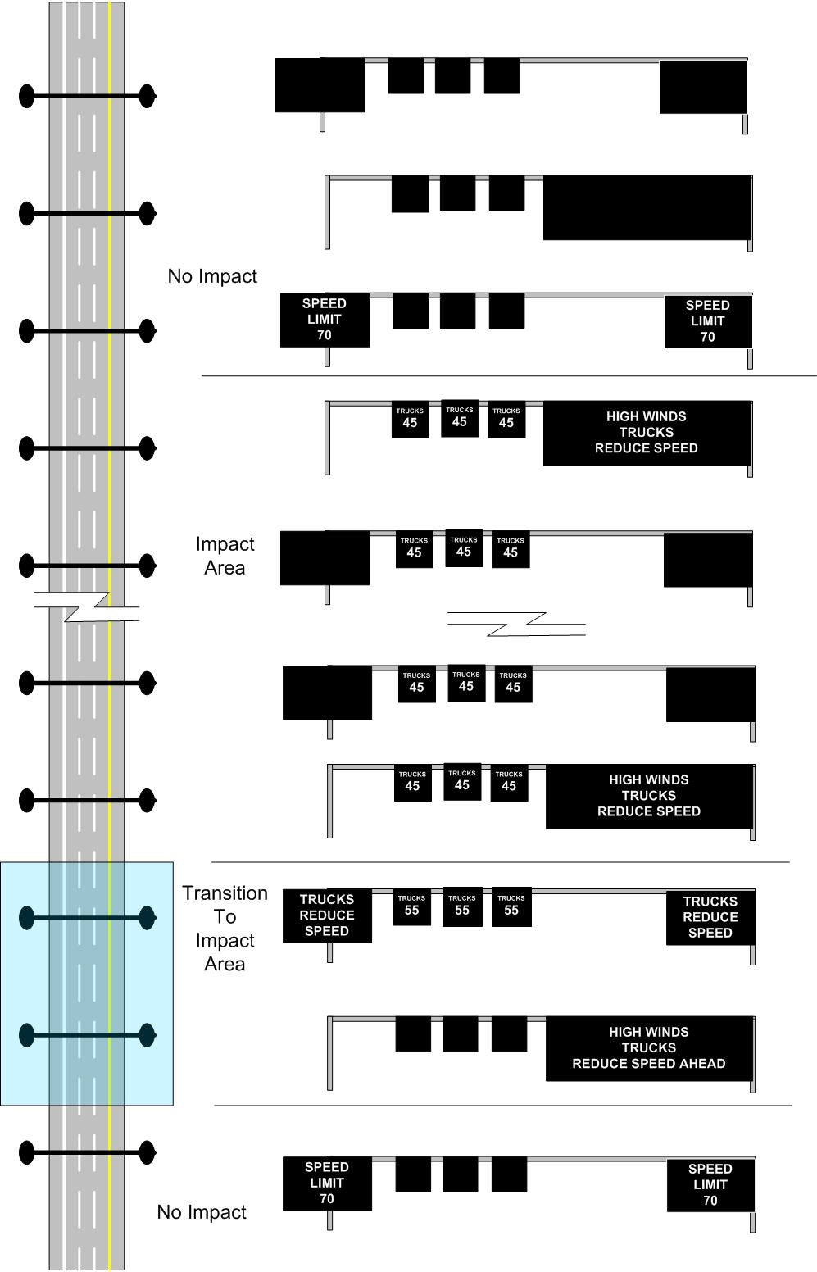
Figure D-7. Potential Implementation of a Weather-Responsive Reduced Speed Limit for High-Profile Vehicles Using ATM Technologies (Source: Texas Transportation Institute)

1.6.3 Truck Use Prohibitions
In some weather situations, agencies may want to use the ATDM system to restrict the use of certain sections of a facility by particular classes of vehicles. An example of this might be restricting high-profile trucks from using a particular section of freeway during high-wind events. For this particular weather-responsive ATDM strategy, the ODMS would be configured to display a vehicle restriction message, such as NO TRUCKS. The SDMS would then be used to provide travelers with information about why the restrictions were in place. Vehicle use restrictions could be implemented in concert with variable speed limits depending upon the weather conditions. Figure D-8 shows an example of how this strategy might be implemented in an ATDM system.

1.6.4 Vehicle Lane Use Restrictions
In other weather situations, agencies may want to use the ATDM system to restrict classes of vehicles to specific lanes. For example, during fog events, agencies may want to require trucks to use only the right lane of travel. Separate trucks from other vehicles in the traffic stream may reduce the potential for severe multi-vehicle collisions during limited visibility conditions. For this particular weather-responsive ATDM strategy, the ODMS would be configured to display a lane use restriction message, such as NO TRUCKS. The SDMS would then be used to provide travelers with information about why the restrictions were in place. Lane use restrictions could also be implemented in concert with variable speed limits depending upon the weather conditions. Figure D-9 shows an example of how this strategy might be implemented in an ATDM system.

1.6.5 Lane Closure
Figure D-10 shows how the system might be used to warn motorist of weather-related lane blockage. The figure shows the right two lanes being blocked because of a snow removal operation. To provide warning to motorists that the lanes are blocked by the plowing operation, a red “X” would be displayed on the ODMS over the closed lanes immediately upstream of the snow plow’s location. The red “X” is used to indicate to drivers that the lanes immediately downstream are closed (or blocked) by the snow plows. A green arrow would be displayed on the ODMS over the lanes not closed by the snow removal operations. On the second sign gantries immediately upstream of the plow’s location, a yellow “X” is displayed on the ODMS over the blocked lanes. This is intended to warn drivers that a downstream lane will be blocked, and that drivers should begin the process of vacating the lanes. The SDMS and the large DMSs would be used to provide motorists with traditional “lane blocked” or “lane closed” messages. Operators in the control center would need to continuously monitor the snow removal operations, and update the sign gantries as the operation continued downstream. Signs downstream of the moving operations could display reduced speed limits implemented by the WMDSS prior to the snow removal operations beginning on the roadway.

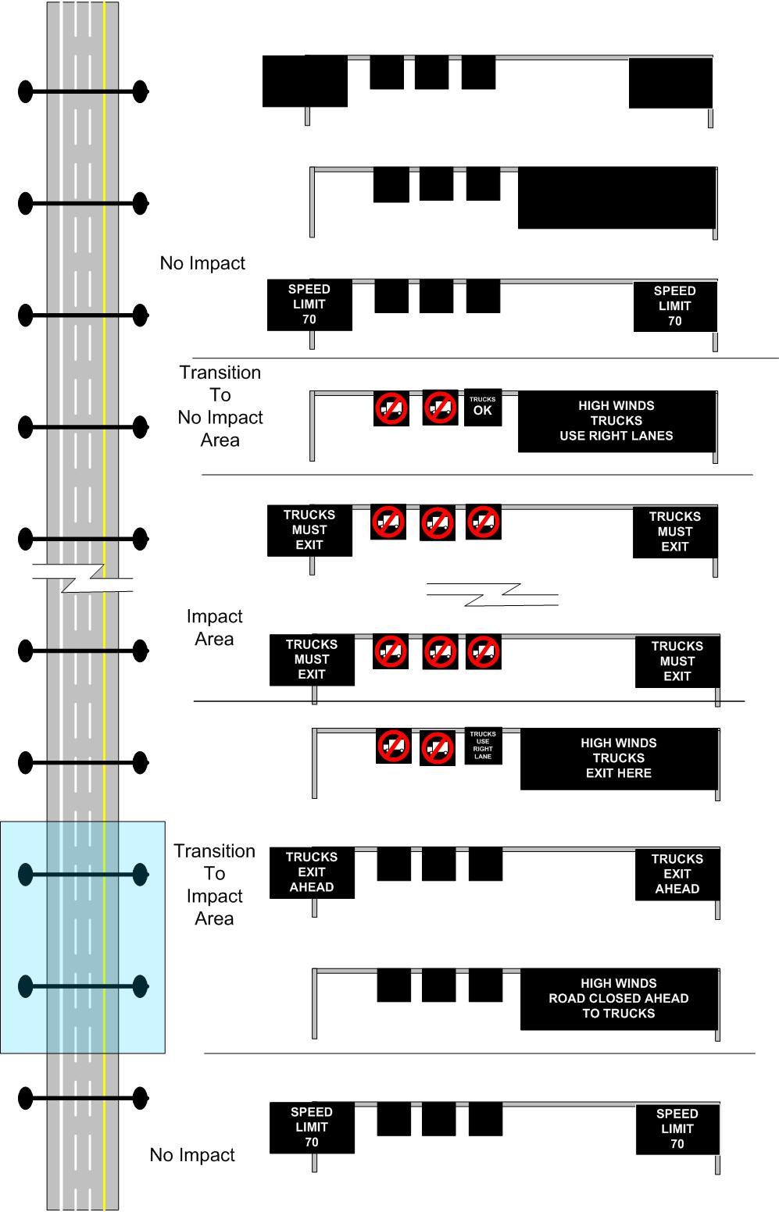
Figure D-8. Potential Implementation of Weather-Responsive Truck Use Prohibitions Using ATM Technologies (Source: Texas Transportation Institute)

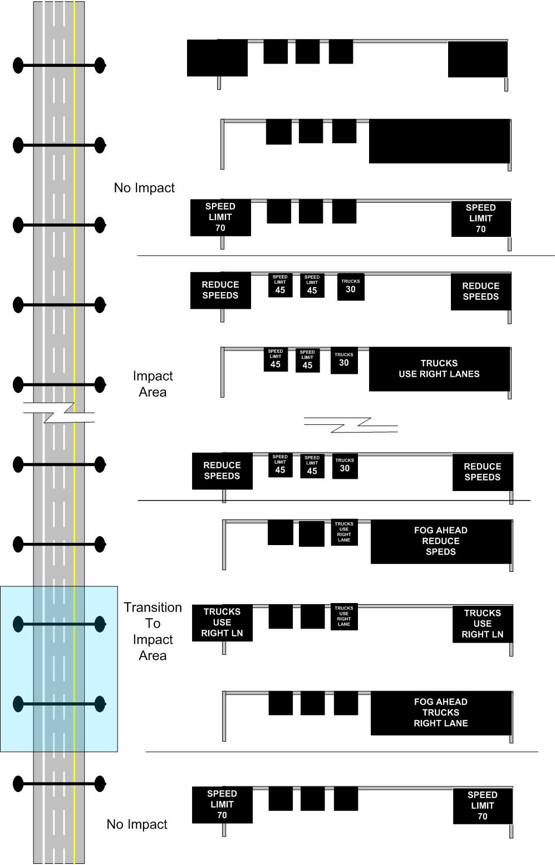
Figure D-9. Potential Implementation of a Weather-Responsive Vehicle Use Restriction for High-Profile Vehicles Using ATM Technologies (Source: Texas Transportation Institute)

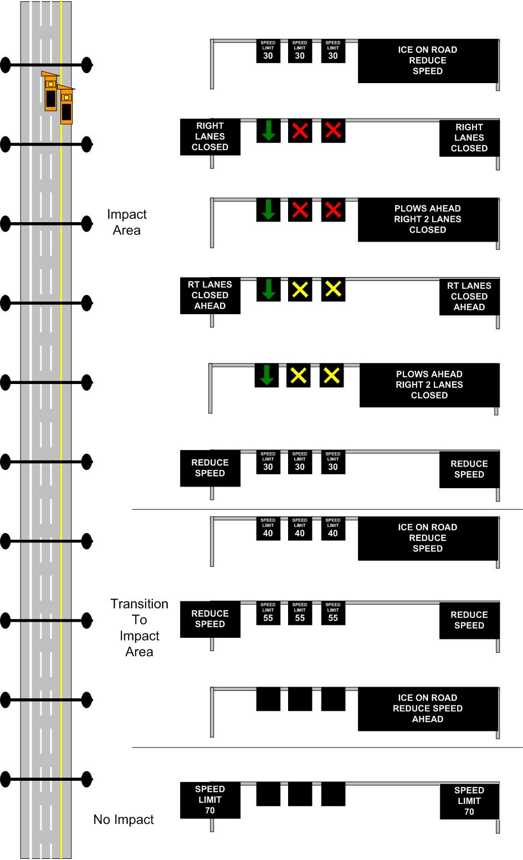
Figure D-10. Potential Implementation of Weather-Responsive Moving Lane Closure to Assist with Snow Removal Using ATM Technologies (Source: Texas Transportation Institute)

1.7 High-Level System Design

1.7.1 User Needs
Following is a list of the high-level user needs of transportation agencies that must be satisfied by ATM deployment during adverse conditions. These user needs are not in any particular order, and their order does not imply priority level.
- Accurately measure prevailing road weather and traffic conditions occurring on the freeways in their jurisdiction.
- Assess and predict the extent to which weather and traffic conditions will impact freeways.
- Rapidly deploy and alter speed, lane-use, and vehicle restriction and other active traffic management strategies.
- Monitor deployed active traffic management strategies.
- Adjust deployed ATM strategies in real-time.

1.7.2 High-Level System Requirements
The following table shows the high-level system requirements needed to fulfill the identified user needs associated with deploying the weather responsive ATM strategy.

Table D-1. System Requirements for Deploying Weather Responsive ATM Strategy
User Need ID | User Need | Functional Requirement ID | Functional Requirement
1. | Accurately measure prevailing road weather and traffic conditions occurring on the freeways in their jurisdiction. | 1.0 | The system shall obtain real-time measurements of weather and roadway surface conditions from sensors at or near sections of freeway where ATM technologies have been deployed.
1. |  | 1.1 | The system shall be able to obtain road weather information from multiple sources.
1. |  | 1.1.1 | The system shall obtain real-time road weather information from environmental sensor stations (ESS) deployed in the freeway corridor.
1. |  | 1.1.2 | The system shall obtain route-specific road weather information from weather information service providers in real-time.
1. |  | 1.2 | The system shall obtain current weather information likely to impact traffic flow and operations.
1. |  | 1.2.1 | The system shall obtain current wind speed and direction.
1. |  | 1.2.2 | The system shall obtain the current ambient air temperature.
1. |  | 1.2.3 | The system shall obtain the precipitation data.
1. |  | 1.2.4 | The system shall obtain the rate at which precipitation is falling.
1. |  | 1.2.5 | The system shall obtain the start time of the latest recorded precipitation.
1. |  | 1.2.6 | The system shall obtain the stop time of the latest recorded precipitation.
1. |  | 1.2.7 | The system shall obtain the current visibility.
1. |  | 1.3 | The system shall obtain current road weather information likely to impact traffic flow and operations.
1. |  | 1.3.1 | The system shall obtain the current temperature of the pavement.
1. |  | 1.3.2 | The system shall obtain an indication of the presence of moisture of the pavement surface.
1. |  | 1.3.3 | The system shall obtain the current depth of snow.
1. |  | 1.3.4 | The system shall obtain the current thickness of ice.
1. |  | 1.4 | The system shall obtain real-time measurements of traffic conditions.
1. |  | 1.4.1 | The system shall integrate with an agency’s traffic monitoring system.
1. |  | 1.4.2 | The system shall obtain volume measures.
1. |  | 1.4.3 | The system shall obtain measures of prevailing travel speeds.
1. |  | 1.4.4 | Traffic system data shall be updated at least every minute.
2. | Assess and predict the extent to which weather and traffic conditions will impact freeways. | 2.0 | The system shall have the ability to assess the degree to which the measured weather and roadway surface conditions will impact traffic operations.
2. |  | 2.1 | The system shall determine the degree to which the measured weather and roadway surface conditions will impact travel speeds.
2. |  | 2.2 | The system shall determine the degree to which the measured weather and roadway surface conditions will impact stopping distance.
2. |  | 2.3 | The system shall determine the degree to which the measured weather and roadway surface conditions will impact visibility.
2. |  | 2.4 | The system shall determine the degree to which the measured weather and roadway surface conditions will impact the speed differential between classes of vehicles.
2. |  | 2.5 | The system shall determine the degree to which the measured weather and roadway surface conditions will impact vehicle throughput.
2. |  | 2.6 | The system shall determine the degree to which the measured weather and roadway surface conditions will impact travel time reliability.
2. |  | 2.7 | The system shall determine the degree to which the measured weather and roadway surface conditions will impact the need for emergency maintenance/road clearing activities.
3. | Rapidly deploy and alter speed, lane-use, and vehicle restriction and other active traffic management strategies in responses to adverse weather conditions. | 3.0 | The system shall use real-time measurements of traffic operating conditions and weather and roadway surface conditions to determine which ATM strategy to implement for a given set of conditions.
3. |  | 3.1 | The system shall use real-time measurements to implement variable speed limits on the ATM system.
3. |  | 3.1.1 | The system shall automatically determine the appropriate speed limit for the prevailing traffic operating, weather, and roadway surface conditions using the real-time measurements.
3. |  | 3.1.1.1 | The system shall establish speed limits on a lane-by-lane basis.
3. |  | 3.1.1.2 | The system shall configure the DMS to produce a speed limit display that is consistent with the MUTCD and state and local guidelines.
3. |  | 3.1.2 | The system shall automatically determine the appropriate sequencing of speeds to be displayed on the DMSs to ensure proper transitions in speeds are displayed according to agency policy.
3. |  | 3.1.3 | The system shall have the capability to automatically configure the ODMSs to display the appropriate speed limit for each lane.
3. |  | 3.1.4 | The system shall have the capability to automatically configure the SDMSs to display the appropriate speed warning messages.
3. |  | 3.2 | The system shall use real-time measurements to implement truck speed limits on the ATM system.
3. |  | 3.2.1 | The system shall automatically determine the appropriate speed limit by vehicle class type for the prevailing traffic operating, weather, and roadway surface conditions using the real-time measurements.
3. |  | 3.2.2 | The system shall establish speed limits by vehicle class.
3. |  | 3.2.2.1 | The system shall configure the DMS to produce a truck speed limit display that is consistent with the MUTCD and state and local policy.
3. |  | 3.2.3 | The system shall automatically determine the appropriate sequencing of truck speeds to be displayed on the DMSs to ensure a proper transition in speeds is displayed according to agency policy.
3. |  | 3.2.4 | The system shall have the capability to automatically configure the ODMSs to display the appropriate truck speed limit for each lane.
3. |  | 3.2.5 | The system shall have the capability to automatically configure the SDMSs to display the appropriate truck speed warning messages.
3. |  | 3.3 | The system shall use real-time measurements to implement truck prohibitions on the ATM system.
3. |  | 3.3.1 | The system shall automatically determine when it is appropriate to prohibit trucks on the freeway based the prevailing traffic operating, weather, and roadway surface conditions using the real-time measurements.
3. |  | 3.3.2 | The system shall configure the DMS to produce a truck prohibition display that is consistent with the MUTCD and state and local policy.
3. |  | 3.3.3 | The system shall automatically determine the appropriate sequencing for displaying truck prohibitions according to agency policy.
3. |  | 3.3.4 | The system shall have the capability to automatically configure the SDMSs to display the appropriate warning messages associated with implementing truck prohibitions based on weather and roadway conditions and agency criteria.
3. |  | 3.4 | The system shall use real-time measurements to implement lane use restriction by vehicle class on the ATM system.
3. |  | 3.4.1 | The system shall automatically determine when it is appropriate to implement lane use restrictions by certain vehicle classes on the freeway based the prevailing traffic operating, weather, and roadway surface conditions using the real-time measurements.
3. |  | 3.4.2 | The system shall configure the DMS to produce a lane use restriction display that is consistent with the MUTCD and state and local policy.
3. |  | 3.4.3 | The system shall automatically determine the appropriate sequencing for displaying lane use restrictions according to agency policy.
3. |  | 3.4.4 | The system shall have the capability to automatically configure the SDMSs to display the appropriate warning messages associated with implementing lane use restrictions based on weather and roadway conditions and agency criteria.
4. | Monitor deployed active traffic management strategies. | 4.0 | The system shall monitor the impacts of implementing the weather-responsive ATM strategies on sections of freeway.
4. | Monitor deployed active traffic management strategies. | 4.1 | The system shall obtain the traffic performance data from the traffic monitoring subsystem.
4. | Monitor deployed active traffic management strategies. | 4.2 | The system shall generate traffic performance measures from the measured traffic data.
4. | Monitor deployed active traffic management strategies. | 4.2.1 | The system shall generate performance measures related to the improved safety.
4. | Monitor deployed active traffic management strategies. | 4.2.2 | The system shall generate performance measures related to the improved operational efficiency.
4. | Monitor deployed active traffic management strategies. | 4.2.3 | The system shall generate performance measures related to the reduced level of congestion.
4. | Monitor deployed active traffic management strategies. | 4.2.4 | The system shall generate performance measures related to the improved trip reliability.
4. | Monitor deployed active traffic management strategies. | 4.2.5 | The system shall generate speed differential performance related to improved customer satisfaction.
4. | Monitor deployed active traffic management strategies. | 4.3 | The system shall generate composite or aggregate performance measures during adverse weather conditions
4. | Monitor deployed active traffic management strategies. | 4.3.1 | The summary reports shall be based on measured traffic, weather, and roadway condition data.
4. | Monitor deployed active traffic management strategies. | 4.3.2 | The system shall produce summary reports by weather event.
4. | Monitor deployed active traffic management strategies. | 4.3.3 | The system shall produce summary reports by sections of roadway.
4. | Monitor deployed active traffic management strategies. | 4.3.4 | The system shall be able to produce summary reports that are configurable by the agency.
4. | Monitor deployed active traffic management strategies. | 4.3.5 | The system shall provide real-time measures of system performance and effectiveness that are simple and easy-to-understand and communicate.
5. | Adjust deployed ATM strategies in real-time | 5.1 | The system shall alter or adjust the implemented weather-responsive ATDM strategies as traffic, weather, and roadway conditions change.
5. | Adjust deployed ATM strategies in real-time | 5.2 | The system shall automatically update ATM strategies based on real-time measurements of traffic operating, weather, and roadway surface conditions.
5. | Adjust deployed ATM strategies in real-time | 5.3 | The system shall also allow implemented ATM strategies to be altered by an operator.
5. | Adjust deployed ATM strategies in real-time | 5.4 | The system shall notify the operator when changes to a deployed ATM strategy have occurred.
5. | Adjust deployed ATM strategies in real-time | 5.5 | The system shall automatically record when changes to a deployed ATM strategy have occurred.
5. | Adjust deployed ATM strategies in real-time | 5.6 | The system shall automatically return the DMSs to their previous state after the weather event is complete.

1.8 Analysis of the Proposed System
Weather-responsive ATM is one of the tools that agencies can use to improve safety and operating efficiencies during adverse weather events. Table D-2 contains a list of potential performance measures that could be used to assess the effectiveness of deploying weather-related ATM strategies on freeways.
Table D-2. Potential Performance Measures for Assessing the Effectiveness of Using ATM Strategies during Weather Events
Performance Category | Performance Measure
Operational Efficiency | - Increase in # of lane-miles with weather-related ATM deployment  - Change in time lag between weather-event start and activation of ATM deployment  - Ratio of time per month of weather-related ATM activation to other ATM activation  - Change in time to return to level of service post weather event
Safety | - Reduction in # of stranded motorists or abandoned vehicles  - Reduction in # of severe weather rescues  - Number of collisions (Property Damage only, injury, fatal) pre and post ATM deployment  - Ratio of weather-related collisions to all collisions  - Change in crashes per lane-mile affected by weather event  - Change in commercial vehicle crash rate
Congestion | - Change in median and 85-percentile travel time (or median travel speed) during weather  - Increase in maximum facility throughput  - Increase in weather event VMT  - Reduction in weather-related delay  - Reduction in delay per lane-mile affected by weather event  - Change in lane-miles and freeway miles “closed” by adverse weather
Reliability | - Change in percent of trips with inclement weather-related travel time greater than twice average travel time
Customer Satisfaction | - # of compliments/complaints received during weather event  - # of positive & negative news articles related to agency performance during weather events

D-2 Weather Responsive Traffic Signal Management

2.1 Scope

2.1.1 Document Overview
Most traffic signal timing strategies are designed assuming ideal weather conditions. Traffic detection systems, vehicle clearance intervals, and coordination timing plans are all designed assuming ideal travel speeds (i.e., speeds at or above the posted speed limit); however, adverse weather conditions, particularly snow and ice, can cause traffic to perform differently than expected. Heavy snows and rainfall can cause vehicle travel speeds to be substantially less than those used to develop traffic signal timing plans as drivers compensate for poor driving conditions. Because of losses in pavement friction, vehicle stopping distances can be greater and vehicle start-up lost times can be longer. Fog, driving rain, and blowing snow can also affect visibility to traffic signal heads, making it more difficult for drivers to see signal indications.
The purpose of this document is to provide a description of a concept of operations for a weather-responsive traffic signal timing strategy. This strategy would take information about roadway surface and weather conditions in real-time, and determine the changes to traffic signal timing and intersection detector settings to improve traffic flow and safety during inclement weather conditions. These new settings would be sensitive to the changes in vehicle operating characteristics caused by adverse weather. The vision is to use these strategies to better match signal timing plans and parameters to the prevailing travel conditions to promote more efficient traffic operations and reduce the potential of some weather-related vehicle crashes.

2.1.2 System Overview
At its highest level, sensors would be deployed in or around a corridor that would monitor atmospheric and pavement conditions. These sensors could be owned and operated by a public entity, or public entities could obtain this information from a private provider. The sensors would measure atmospheric and road surface conditions that might affect traffic operations on roadways with traffic signals. Examples of the type of information that these sensors would collect include the following:
- Presence and type of precipitation (snow, ice, rainfall, etc.)
- Rates of precipitation and projected accumulations,
- Current accumulations,
- Roadway surface temperatures,
- Visibility, and
- Air temperature, relative humidity and wind speed (for determining the likelihood of fog formation).
Weather and roadway surface condition information could then be integrated with traffic data and fed into the decision support system designed to assist the traffic signal system operator in: (1) assessing the potential impacts and effects of current (and projected) weather and roadway surface conditions on operations, and (2) determining the most appropriate type of traffic signal strategy to deploy in response to deteriorating conditions. Potential traffic signal timing strategies might include the following:
- Altering traffic detector configurations and settings to account for obscured lane markings, or reduced travel speeds.
- Lengthening all-red clearance intervals between conflicting movements to account for increased stopping distances and reduced visibility.
- Altering phase patterns or phase splits to reduce the potential of stopping vehicles at locations where roadway surface conditions have diminished (i.e., at a crest of up-slopes where reduced pavement friction might make it difficult to accelerate from a stop or at the bottom of down-slopes where reduced pavement friction may cause drivers to slide through intersection during clearance intervals, etc.).
- Implementing new coordination plans designed to provide progressions for increased traffic demands at slower speeds prior to or during a severe weather event.
The complexity of the decision support system could vary substantially depending upon the level of sophistication of the agency and its field equipment, and the type and frequency of weather events impacting traffic operations.
The decisions support system would then feed the recommended signal timing strategy to the traffic signal management system. Many locations currently use a traffic signal management system that allows them to remotely alter and update traffic signal timing plans and parameters. The traffic signal management system and the decision support system could be integrated together to allow weather-responsive traffic signal timing strategies to be implemented automatically, with or without operator intervention.

2.2 Referenced Documents
The following documents were used in the development of this concept of operations document.
- National Transportation Communications for ITS Protocol: Environmental Sensor Station (ESS) Interface Protocol. NTCIP 1204 version v03. October 2009.
- NTCIP 1202 - NTCIP Object Definitions for Actuated Traffic Signal Controller Units - version 02. November 2005.

2.3 Current System or Situation
Generally, agencies have multiple signal coordination/timing plans designed to handle different traffic demands for different times of day (e.g., an A.M. peak coordination plan, a P.M. peak coordination plan, etc.). These timing plans are designed to achieve a certain level of performance and to ensure a certain level of progression speed through a series of intersections. Inclement weather conditions, particularly snow and ice, have been shown to dramatically impact travel speed and vehicle operating characteristics – to the point where some agencies have developed special signal coordination plans designed specifically for inclement weather. Examples include:
- Connecticut Department of Transportation: Operates one signal system (about 30 signals) where they implement a special timing plan in response to poor weather conditions. The snow plan adjusts offsets and increases cycle lengths to accommodate slow travel speeds on the primary arterial. Operators implement the timing plan based on visual observations of snow fall rate and traffic conditions.
- Delaware Department of Transportation: Implements signal timing plan changes for snow events. Operators in the control center monitor congestion levels via CCTV and increase cycle lengths when they observe increases in congestion levels.
- Utah Department of Transportation (UDOT): Developed a set of special timing/coordination plans that they implement on select routes during snow events. These timing plans were created to 1) account for slower operating speeds during significant snow events, and 2) assist with snow plowing operations on select thoroughfares. Different timing plans were developed to provide different progression strategies based on what weather conditions are like during different periods of day.
In the Utah deployment, an on-staff meteorologist examines current weather conditions and makes recommendations about when and where to implement a snow timing plan during a snow event. Operators in the TMC are responsible for implementing pre-established coordination plans which are designed to account for lower arterial travel speeds and increased loss times because of snow on the roadway. The snow timing plans are implemented on these select thoroughfares when the following conditions are satisfied:
- A request has been made by a maintenance shed supervisor and/or a recommendation made by the Traffic Operations Center (TOC) staff meteorologist.
- Significant reductions in travel speeds (30% or greater) have occurred.
- Signals are currently operating in a coordinated mode based on time-of-day (e.g., during late night hours, the signals are operating in a non-coordinated mode anyway).
- Delay-causing weather conditions are expected to last more than 20 minutes.
- Traffic congestion is present on the roadway.
The new timing plans are implemented by operators in the TOC using UDOT’s central software system. Once implemented, these coordination plans remain in effect until one of the following conditions has been met:
- Snowplowing operations are complete;
- The next time-of-day step in a plan strategy is reached;
- The weather is no longer affecting traffic operations; or
- A request is made by [maintenance] shed operator to the TOC meteorologist to disable the plan.
Several locations (including the City of Clearwater, Florida; the City of Minneapolis, and the City of Charlotte, North Carolina) all had systems at one point in time that implemented timing plan strategies in response for different weather conditions, but have subsequently discontinued the practice because of system upgrades, changes in intersection geometries, or staff reductions.

2.4 Nature and Justification of Changes
During severe weather events like heavy snow fall or heavy fog or icy conditions, drivers experience harsh operating conditions. These conditions include slower travel time between intersections, longer distance required to stop at traffic signals, slower startups from a vehicle stopped at signal, poorer visibility of vehicles, lane markings, stop bars, traffic signs, and traffic signal indications. When designing typical signal timings, normal vehicle speeds are used for developing offsets. Detectors and traffic control signs are placed at appropriate locations based on normal speeds and normal deceleration rates. If signal timings are not revised, drivers experience significantly inefficient operations. Progression along a corridor is disrupted as motorists travel at slower speeds and can reach traffic signals after the termination of green. Detectors which are installed for efficient and safe operations based on normal speeds are unable to provide that service as motorists travel at different speeds and use different deceleration rates. Traffic signs and pavement markings may not provide the critical information to the motorists in a timely manner.
Alternative signal timings that consider the slower speeds observed in the design of the offsets can significantly improve progression along the arterial corridor. Motorists will experience fewer stops along an arterial. Modified detector passage times at individual intersections using slower speeds and lower deceleration rates can provide additional safety to motorists. Under severe driving conditions, safety has a much higher priority than efficiency.
Severe weather events can also have an impact on traffic patterns. The impact on traffic patterns depends on the type of weather event. Rain and snow events cause an increase in travel times, a decrease in deceleration characteristics impacting stopping distance, and a reduction in visibility of signal indications increasing driver-perception reaction time. Motorists after an ice storm on the other hand may have excellent visibility. However the pavement condition may not be conducive to normal driving conditions. Foggy conditions on the other hand may not deteriorate roadway conditions, but significantly impact visibility. Thus each type of weather event can impact the motorists and vehicle operating characteristics in a unique manner.
The type of weather event can also have an impact on the traffic volumes that the weather response strategy has to address. Usually at the onset of a severe snow fall, traffic volumes pick up significantly as motorists expect driving conditions to worsen and stay like that for a significantly long period of time. Snow fall can deteriorate road conditions with the accumulation of snow which can be on the roadway for quite a while. These higher volumes cause significant congestion during a peak period or can create a peak demand during the off-peak period. Current signal timings cannot accommodate such a demand even under normal driving conditions. The onset of a rain storm however results in a different type of traffic pattern. Usually a severe rain storm does not have as long of a duration as a snow storm and does not usually cause road conditions to worsen to the extent that a snow storm does. Motorists tend to postpone their trip during a heavy rain storm and travel when the severity of the storm reduces. This causes some lower traffic volumes during a severe rain storm. The combination of travel patterns and traffic characteristics is an important input into the development of alternative signal timing plans for weather related events.

2.5 Concepts for the Proposed Strategy
The goals of the weather-responsive traffic signal management strategy are as follows:
- Improve traffic flow during severe weather events by rapidly deploying traffic signal timing plans that are consistent with reduced operating characteristics (slow speeds and deteriorating roadway surface and visibility) and increased traffic demands.
- Improve traffic safety and level of service during inclement weather by:
- Reducing the potential for signal-related collisions (rear-end and right-angle collisions),
- Reducing the potential for increased instances of red-light running.
- Improve system operating efficiencies by limiting stops at locations where geometrics are severely impacted by weather (uphill or downhill approaches).
The strategy is intended to be an additional operating mode over existing traffic signal timing strategies. It is intended to be implemented only when adverse weather conditions cause traffic flow conditions to deteriorate. Under normal weather conditions, the system would operate in a standby or monitoring mode. In this mode, the system would monitor weather and roadway surface conditions continuously, either from road weather information systems and environmental sensing systems installed in or near the corridor or from private weather information service providers. Pavement sensors would monitor pavement surface temperatures and/or roadway surface conditions to determine when road friction was significantly reduced by presence and/or accumulation of ice, snow, or other precipitation. Weather monitoring stations would provide measures of atmospheric conditions, such as precipitation type and rate, air temperature, etc. Visibility sensors can be used to determine when fog, driving raining, blowing snow, etc. might be impacting a driver’s ability to see traffic signal indications. Operators in the control center can also use video surveillance cameras, media reports, social media alerts, and reports from maintenance and law enforcement personnel to pinpoint problem locations where roadway surface conditions have deteriorated. This information could be integrated with information from traffic system detectors that measure quality of progression and/or travel speeds to determine when weather conditions are having an impact on traffic operating conditions.
The operator (and the system itself) would continue to monitor weather and traffic operations to determine effectiveness of timing plans or when to deactivate response. Reasons for deactivating the weather-responsive traffic signal timing plan might include the following:
- Visual inspection confirms that weather conditions are no longer impacting traffic operations in the corridor.
- Operators are notified by maintenance personnel that roadway has been “treated” (e.g., plowed and sanded) and that travel conditions are no longer hazardous.
- Operators are notified by emergency management or law enforcement personnel that roadway conditions have improved.
- Operators are notified by emergency management or law enforcement personnel that roadway has been closed (in which case they may want to go to flash signal operation).
- Additional thresholds and criteria in the decision support system could be used to determine when to deactivate the weather-responsive traffic signal timing plans.
Prior to removing the weather-responsive traffic signal timing strategy, the operator may want to verify that operating conditions are returning to normal operations using video surveillance, if available. To deactivate the timing plan, the operator can use the traffic signal system management software to return the signal back to normal operations for current time-of-day. The operator (and/or the system) should log when traffic signal returned to normal operation.

2.5.1 Operational Policies and Constraints
Agencies must first address a number of operational policies and constraints before deploying this weather responsive traffic signal management strategy. First, agencies must establish implementation policies and/or standard operating procedures as to when and where to implement weather responsive traffic signal management strategies. Standard operating procedures should define under what conditions the weather responsive traffic signal timing plans should be implemented, the steps used to implement the timing plans, the process for monitoring their implementations, and any notifications that should occur after the timing plans are implemented. The standard operating procedures should also include the conditions and criteria used to deactivate the timing plans, notifications that should occur after deactivating the system as well as any record-keeping that needs to be performed.
Implementation of the strategy also requires agency personnel to have a high level of knowledge of the conditions and nuances of when weather impacts traffic operations. Agencies also need personnel that have a good level of expertise on traffic signal timing and operations and must have the resources ready to develop and monitor traffic signal performance during adverse weather conditions.
This strategy requires that operators in a control center have access to weather and roadway conditions information. This weather information needs to be specific to identified corridors (sub-regional weather monitoring). Direct measurements of weather conditions at strategy locations are needed for automated systems. A decision support system would be needed to have an automated system. The decision support system would need to be integrated with traffic signal management software so that weather-related timing plans could be implemented automatically.
The strategy also requires good lines of communications with maintenance crews and law enforcement personnel who are responsible for maintaining safe operating conditions. These groups can provide onsite reports of driving conditions and can instruct operators when road conditions deteriorate to a point where the WRTM timing plans might be beneficial and (perhaps equally important) when roadway conditions have improved to the point where the weather-responsive traffic signal coordination plans are no longer needed.

2.5.2 Functional Components
As shown in
Figure D-11, there are four main components associated with implementing a traffic signal management strategy:
- Road weather monitoring system component,
- Decisions support system component,
- Traffic signal management system component, and
- Traffic management center (TMC) operator.
Each of these four components is discussed in detail below. While not shown in the figure, traffic condition information is an essential part of the strategy.

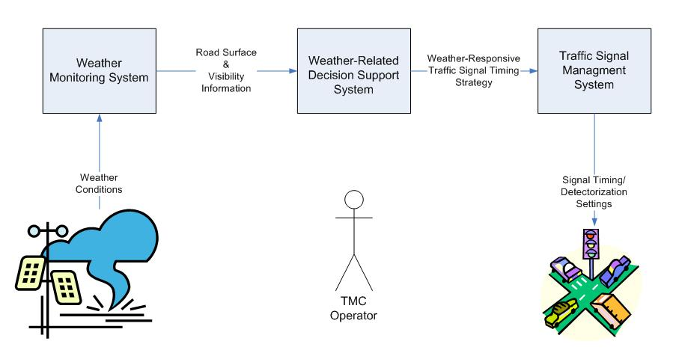
Figure D-11. Components of Weather-Responsive Traffic Signal Management Strategy (Source: Texas Transportation Institute)

Road Weather Monitoring Subsystem
The weather monitoring component is responsible for obtaining all the road surface and weather information needed to assist in determining when and where to implement a weather-responsive traffic signal management strategy. It is through this component that the system operator obtains updates of road weather conditions, particularly visibility, surface conditions and/or precipitation accumulations, through sensors located in the field communicating back to the weather monitoring system. These sensors could be agency- owned, or the information can be provided by a private weather information provider. The types of data needed from the road weather monitoring component would include the following:
- Current wind speed and direction,
- Current ambient air temperature,
- Presence of precipitation,
- Rate at which precipitation is currently falling and the start and stop times of the latest recorded precipitation,
- Current visibility distance,
- Current temperature of the pavement surface and an indication of the presence of any moisture on the surface,
- Current depth of snow and packed snow on the traveled way,
- Expected time of snow fall or rain storm, and the probability of snow and rain, and
- Current thickness of ice on the traveled way.

Weather Responsive Decision Support Subsystem
The decision support subsystem is responsible for making the decisions about when and what type of traffic signal management strategy to implement. This component would contain the rules and criteria for when and where to implement the various traffic signal management strategies. Measured weather, roadway surface, and traffic conditions would be compared with agency criteria established for each traffic signal management strategy approved by the agency. The output of this component would be the recommended signal timing strategy. The subsystem could be designed such that the recommended timing plan could be sent to the traffic management system component with or without operator approval.

Traffic Signal Management Subsystem
The traffic signal management component is responsible for implementing the selected timing strategy on the traffic signal controller. This component is the traffic signal management software system used by many agencies to remotely control and operate their traffic signal system. The decision support system would interface with this software to select timing plans from stored library, alter signal timing parameters (such as yellow and all-red duration), change detector settings (place recalls on critical phase, place phase omits , etc.) , or change phase duration (minimum greens, maximum greens, split times, etc.). Generally, these systems are directly connected to traffic signal controllers in the field via a communications system. This allows the TMC operator to remotely control the traffic signal controllers and implement a new timing plan without going to the field. The subsystem also collects and monitors traffic condition information through roadside detection along all approaches.

TMC Operator
The TMC operator would remain a vital component of the system. Depending upon the implementation, recommended timing plans would need to be approved by the TMC operator; however, the primary function of the TMC operator would be to monitor and evaluate the strategy once it is deployed to determine whether or not traffic operations were actually improved by the strategy. The TMC operator would be responsible for overriding the decision support system component as well as fine-tuning the strategy once deployed. The TMC operator would also be responsible for evaluating the strategy once deployed.

Potential Deployment Scenarios
A number of ways exist by which the weather-responsive traffic signal management strategies can be implemented. Figure D-12 shows one potential deployment scenario where the operator serves as the decision maker. In this deployment scenario, roadway surface, visibility, and precipitation information would be collected from either sensors in the field or through private weather information providers. The weather-responsive decision support system would process this information and provide recommended signal timing strategies (e.g., increased clearance intervals, changes in coordination timing plans, changes in phase splits, etc.). The system would allow the operator to approve the recommended timing plan changes prior to implementing them in the field. The operator would have the ability to implement the recommended signal timing changes as is, make modification to the timing plans, or reject the timing plan changes outright. After approval, the system would send the approved signal timing plan changes through the traffic signal management system.
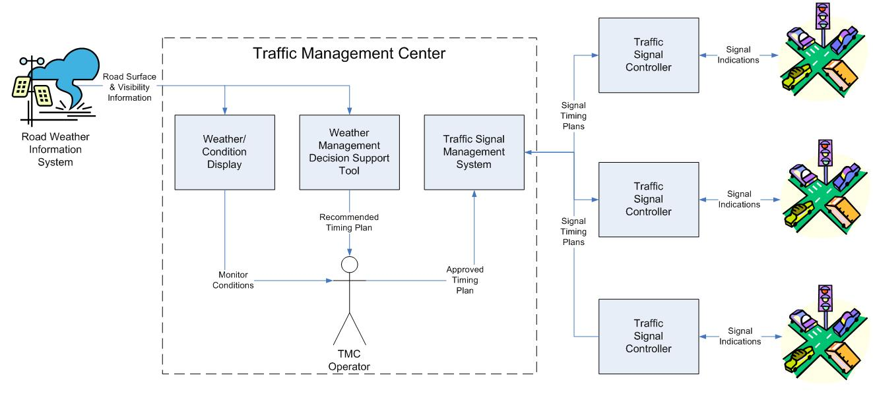
Figure D-12. Concept of Weather-Responsive Traffic Signal Management Deployment with Operator as Decision Maker (Source: Texas Transportation Institute)
This strategy could also be implemented automatically, wherein the weather responsive decision support system would be tied directly to the traffic signal management system. Using information obtained directly from field sensors or weather information service providers, the decision support system would be responsible for determining when and where signal timing changes will be implemented. The weather-responsive decision support system would then communicate the signal timing plan changes directly to the traffic signal management system, which would be responsible for implementing the traffic signal timing plan changes in the controller(s). Under this deployment scenario, the operator’s role would be to serve as a supervisor of the decision-making process and override or fine-tune decisions made by the system. Figure D-13 provides a logical representation of this type of deployment scenario.
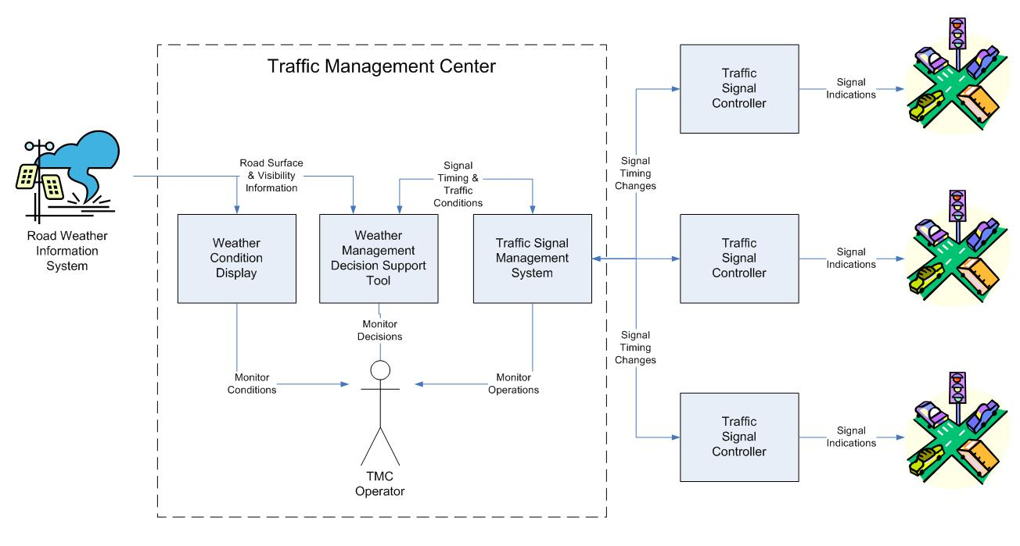
Figure D-13. Concept of a Fully Automated Weather Responsive Traffic Signal Management Deployment (Source: Texas Transportation Institute)
Figure D-14 shows a potential deployment of this strategy in a Connected Vehicles environment. In this deployment, the weather-responsive decision support system could be moved to the field, and decisions about traffic signal timing plan changes could be made at the intersection level (as opposed to the system level.) With connected vehicle technologies, on-board equipment (OBE) sensors on the vehicle can determine when individual vehicles are beginning to lose traction due to ice or snow accumulation on the pavements. This information can be communicated directly from the vehicle to the traffic signal controller through a dedicated short-range communication (DSRC) device or similar wireless communications link. The weather-responsive decision support system would collect and fuse information from multiple connected vehicles approach the intersection and determine the most appropriate weather-responsive signal strategy to implement at that particular intersection. In this deployment, the weather-responsive decision support system can be implemented as an external process to the traffic signal controller or fully integrated into the traffic signal controller. An alarm message would be sent by the traffic signal controller to the TMC alerting operators that the intersection is operating in a weather-responsive mode. Adjacent traffic signal controllers could be “alerted” to changes in traffic signal timing parameters at one intersection either through a peer-to-peer or centralized communications architecture.
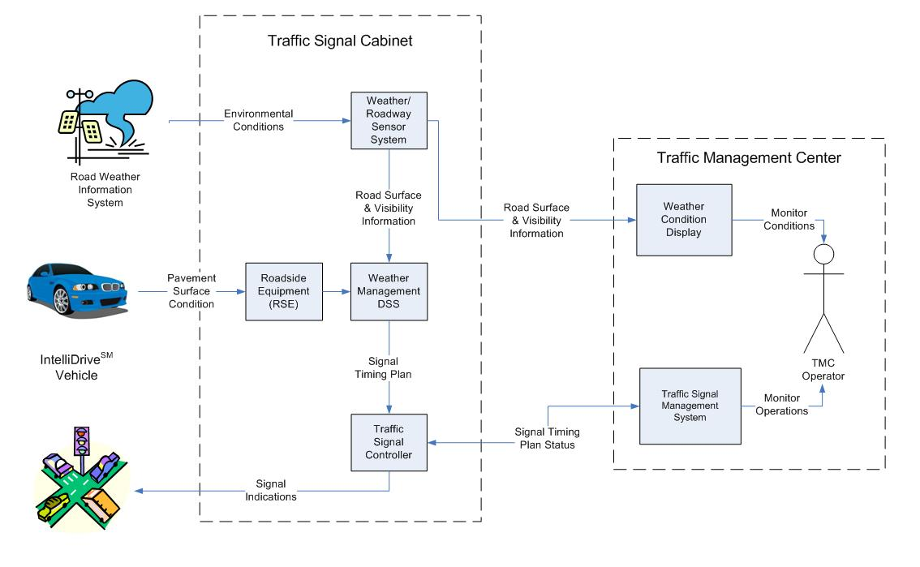
Figure D-14. Concept of Weather-Responsive Traffic Signal Timing Deployment in a Connected Vehicle Environment (Source: Texas Transportation Institute)

2.6 Operational Scenarios
Following are four operating scenarios that represent weather-responsive signal timing changes.

2.6.1 Normal Conditions
When weather is not a factor, traffic signals generally operate in two modes: pre-timed or actuated. In an actuated mode, the timing and sequencing of the signal indications are based upon the traffic demands at the intersection. In a pre-timed mode, phase timings and sequencing follow a routine, predictable pattern. Traffic signal may also operate in isolation or as part of a coordinated system. Each individual agency is responsible for establishing the timing plan and operating parameters of those signals based on local policies and traffic management objectives. When weather is not a factor, the traffic signals would continue to operate according to the timing plans and policies of the local agencies.
Under normal operating conditions, the weather decision support system has little impact on the operations of the traffic signals – the traffic signals would operate in accordance to the traffic management plans designed and installed by the agencies. The weather conditions would be monitored by the weather monitoring system, but operations of the traffic signals would not be changed until the weather-responsive decision support system determines that conditions had deteriorated (or likely to deteriorate) to a point where safety and operational efficiency are impacted.

2.6.2 Altering Detection Zone and Detection Parameters
The following operational scenario is intended to illustrate how the system might be used to alter detection zones and detection parameters that could potentially improve safety and traffic operations at signalized intersections during weather events.
In the predawn hours in the morning, an unexpected snow storm begins to traverse a city. During the last hour, the snow storm has dumped a significant amount of heavy, wet snow throughout the city. Because the pavement surface temperature is below freezing, enough snow has accumulated on the pavement surface to begin covering the lane lines to the point that they are no longer visible to drivers. Also, because the snow event was unexpected and occurred early in the morning, snow removal crews are unable to keep roadways clear of significant accumulation. As it is the natural tendency of drivers during periods of inclement weather to increase both the lateral and longitudinal separation between vehicles (to limit the likelihood of collisions), drivers often create their own travel paths when the pavement markings become covered. These travel paths do not necessarily conform to the pavement markings on the roadway. As the traffic detectors are designed, installed, and operated assuming that drivers’ paths through intersections are governed by the lanes lines, they have become ineffective as drivers begin creating their own pathways through the intersection.
Weather monitoring stations installed at strategic locations in the corridor would monitor pavement surface conditions and snow fall rates. This information would be fed to the weather decisions support system that would determine the effects and impacts of the weather conditions on traffic operations. The weather decision support system would also be used to determine rate, duration, and extent of the snow fall. Because the pavement surface temperature and the snow accumulation rates are predicted to be substantial, the weather decision support system alerts the operator that a potential exists for snow accumulations to begin obliterating lane markings. If available, the operator might use a video surveillance system to confirm this prediction and to assess the extent to which the falling snow has covered the existing lane markers. If the lane markings are obscured, the operator could also use the traffic signal management system to dynamically reconfigure the detector and controller settings to improve operations of the detection system. Examples of strategies that could be implemented by operators include the following:
- Utilizing special detection features (such as call delays and/or call extensions) to prevent detector calls to specific phases from being dropped by the controller.
- Combining detectors and/or detection zones to extend the area of detection on each approach.
- Placing constant calls on detectors to ensure that phases are not skipped because of missed detections.
- Changing the phase initial and extension interval settings to accommodate for slow vehicle start-ups and travel speeds.
These settings would remain in effect until the weather conditions improved and vehicle travel paths are controlled by the lane markings again. At this time, the operator would use the traffic signal management system to reset the detection system to its normal operating condition.

2.6.3 Lengthening Red Clearance Interval
Another change to signal operations that could be made during weather events might be lengthening the red clearance intervals in response to weather conditions. The following operational scenario describes one possibility of how this might occur.
According to FHWA’s Traffic Signal Timing Manual, the red clearance interval (also known as the all-red clearance interval) is the “interval at the end of the yellow change interval during which the phase has a red-signal display before the display of green for the following phase.” The purpose of this interval is to allow time for vehicles that entered the intersection during the yellow-change interval to clear the intersection prior to the activating of a conflicting vehicle movement phase. During inclement weather, such as rain, snow, ice, or fog, pavement friction may deteriorate increasing stopping distances at intersections. Because clearance intervals are generally timed assuming good pavement friction, agencies may find their current red clearance intervals to be insufficient to allow vehicles to stop before the signal turns red during inclement weather. To reduce the potential for right-angle collisions from occurring at these intersections, transportation agencies may want to provide a little extra time to separate conflicting traffic streams.
Under this scenario, the weather decision support system would monitor weather and pavement conditions in the corridor. If pavement conditions that might lead to longer stopping distances are detected, the weather decisions support system could automatically implement new timing plans, through the traffic signal management system, that increases the duration of the red clearance interval. The weather decision support system would also notify the operator that a change in the signal timing plan was implemented. As pavement conditions improve, the decision support system would then implement a request to return the traffic signal system to normal operations.

2.6.4 New Traffic Signal Coordination Timing Plans
Another change to signal operations that could be made during weather events might be to automatically implement new traffic signal coordination timing plans in a group of intersections to account for slower travel speeds caused by weather.
Coordination is a traffic signal timing strategy whereby the traffic signal indications at multiple intersections turn green just prior to the arrival of a platoon of vehicles. Generally, coordinating traffic signal operations provides increased vehicle throughput through a corridor and reduces driver frustration. The process of determining when to turn the signal indication green at each subsequent intersection depends on a number of factors, one of which is speed. Speed is used to determine how much time is needed to offset the beginning of the coordinated phase at downstream intersections. Therefore, weather conditions (such as snow, rain, ice, fog, etc.) that impact speed could cause a series of intersections to lose efficiency. To account for lower travel speeds, agencies may want to implement coordination timing plans that are designed specifically for poor weather conditions.
Under this strategy, the weather decision support system would merge measurements from both the weather monitoring system and the traffic detection system to determine if weather conditions were having an impact on travel speeds in the corridor. As weather conditions worsen and pavement surface conditions deteriorate, travel speeds on arterials are likely to decline. The weather decision support system would correlate the drop in travel speeds with weather conditions and determine if a new timing plan designed for specific weather conditions might be implemented. The weather decision support system would then request that the traffic signal management software implement the appropriate weather-responsive plan. The traffic signal management system would be responsible for communicating the timing plan request directly to the traffic signal controllers. The weather responsive timing plan would remain in effect until 1) weather and roadway conditions improved enough to cause travel speeds to return to their normal level, 2) the next time-of-day schedule plan changes, or 3) the operator implemented a new timing plan.

2.7 High-Level System Design

2.7.1 User Needs
The following is a list of high-level user needs a TMC operator must satisfy in order to deploy this strategy. These user needs are not in any particular order, and their order is not intended to imply any level of priority.
- Monitor weather and roadway surface conditions in the vicinity of the desired intersection.
- Assess the degree to which the measured roadway surface and weather conditions are likely to impact traffic performance and efficiency at or near a signalized intersection.
- Determine the most appropriate traffic signal timing plan changes to observed roadway surface and weather conditions.
- Implement changes in traffic signal timing plans from remote location.
- Monitor traffic signal operations in order to verify that timing plan changes are helping (not hindering) operational efficiency and safety at intersections.
- Deactivate weather-responsive traffic signal timing plan and parameter settings and return traffic signal controllers to normal operations once roadway surface and weather conditions have improved.

2.7.2 High-Level System Requirements
The following table shows the high-level functional system requirements needed to fulfill the identified user needs associated with deploying the weather responsive traffic signal strategy.

Table D-3. System Requirements for Deploying Weather Responsive Traffic Signal Strategy
User Need ID | User Need | Functional Requirement ID | Functional Requirement
1. | Monitor weather and traffic conditions in the vicinity of the desired intersection(s). | 1.0 | The system shall obtain weather and roadway surface conditions from sensors in the vicinity of the desired intersection(s).
1. |  | 1.1 | The system shall be able to obtain road weather information from multiple sources.
1. |  | 1.1.1 | The system shall obtain road weather information from environmental sensor stations (ESS).
1. |  | 1.1.2 | The system shall obtain route or intersection specific road weather information from private weather information service provider.
1. |  | 1.2 | The system shall determine the location of the nearest ESS station in the vicinity of the desired intersection or group of intersections.
1. |  | 1.2.1 | The system shall allow the operator to define which ESS stations to associate with a desired intersection or group of intersections.
1. |  | 1.3 | The system shall obtain current road weather information likely to impact traffic flow and traffic signal operations at the vicinity of the desired intersection or group of intersections.
1. |  | 1.3.1 | The system shall obtain the current wind speed and direction.
1. |  | 1.3.2 | The system shall obtain the current ambient air temperature.
1. |  | 1.3.3 | The system shall obtain the presence of precipitation.
1. |  | 1.3.4 | The system shall obtain the rate at which precipitation is falling.
1. |  | 1.3.5 | The system shall obtain the start time of the latest recorded precipitation.
1. |  | 1.3.6 | The system shall obtain the stop time of the latest recorded precipitation.
1. |  | 1.3.7 | The system shall obtain the current visibility distance.
1. |  | 1.4 | The system shall obtain current roadway surface information likely to impact traffic flow and traffic signal operations.
1. |  | 1.4.1 | The system shall obtain the current temperature of the pavement surface.
1. |  | 1.4.2 | The system shall obtain an indication of the presence of moisture of the pavement surface.
1. |  | 1.4.3 | The system shall obtain the current depth of snow.
1. |  | 1.4.4 | The system shall obtain the current thickness of ice.
1. |  | 1.5 | The system shall continue to receive and incorporate standard traffic sensor inputs.
2. | Assess the degree to which the measured road weather conditions combined with existing traffic volumes are likely to impact traffic performance and efficiency at or near a signalized intersection. | 2.0 | The system shall have the ability to assess the degree to which the measured weather and roadway surface conditions will impact traffic operations.
2. |  | 2.1 | The system shall determine the degree to which the measured weather and roadway surface conditions will impact travel speeds at main street approaches (i.e., the coordinated phases).
2. |  | 2.2 | The system shall determine the degree to which the measured weather and roadway surface conditions will impact stopping distance.
2. |  | 2.3 | The system shall determine the degree to which the measured weather and roadway surface conditions will impact start-up lost time.
2. |  | 2.4 | The system shall determine the degree to which the measured weather and roadway surface conditions will impact saturation flow rate.
2. |  | 2.5 | The system shall determine the degree to which the measured weather and roadway surface conditions will impact vehicle placement over traffic system detectors.
2. |  | 2.6 | The system shall determine the degree to which the measured weather and roadway surface conditions will impact vehicle gaps.
3. | Determine the most appropriate traffic signal timing plan changes to observed roadway surface and weather conditions. | 3.0 | The system shall recommend to the operator the most appropriate traffic signal timing plan changes.
3. |  | 3.1 | The system shall allow the operator to set the types of traffic signal timing plan changes to be considered.
3. |  | 3.2 | The system shall obtain the current operating mode (e.g., free, or in coordination) of the desired intersections.
3. |  | 3.3 | The system shall recommend to the operator changes that can be made to the vehicle detector settings.
3. |  | 3.3.1 | The system shall recommend to the operator changes that can be made to the vehicle detector phase call.
3. |  | 3.3.2 | The system shall recommend to the operator changes that can be made to the vehicle detector extend parameter.
3. |  | 3.4 | The system shall recommend to the operator changes that can be made to the phase vehicle clearance.
3. |  | 3.4.1 | The system shall recommend to the operator changes that can be made to the phase yellow change intervals.
3. |  | 3.4.2 | The system shall recommend to the operator changes that can be made to the phase red clear intervals.
3. |  | 3.5 | The system shall recommend to the operator changes that can be made to the phase intervals settings.
3. |  | 3.5.1 | The system shall recommend to the operator changes that can be made to the phase minimum green interval duration.
3. |  | 3.5.2 | The system shall recommend to the operator changes that can be made to the phase maximum green interval duration.
3. |  | 3.5.3 | The system shall recommend to the operator changes that can be made to the phase passage duration.
3. |  | 3.6 | The system shall recommend to the operator changes that can be made to the coordination timing settings.
3. |  | 3.6.1 | The system shall recommend to the operator a coordination plan.
3. |  | 3.6.2 | The system shall allow the operator to adjust the coordination settings (cycle lengths, splits, and offsets) to fine-tune the timing plan to the current conditions.
3. |  | 3.7 | The system shall recommend to the operator changes that can be made to omit phases.
3. |  | 3.8 | The system shall recommend to the operator changes to the phase.
4. | Implement changes in traffic signal timing plans from remote location | 4.0 | The system shall allow the operator to implement recommended changes to the current signal timing plans.
4. |  | 4.1 | The system shall implement the recommended signal timing plan changes through an agency’s existing traffic signal management system.
4. |  | 4.2 | The system shall display the recommended timing plan changes to the operator.
4. |  | 4.3 | The system shall receive confirmation from the operator before recommended timing plans are implemented.
4. |  | 4.4 | The system shall permit the operator to amend the recommended traffic signal controller settings prior to implementation in the field.
4. |  | 4.5 | The system shall generate a properly formatted request to implement the approved signal timing plan changes.
4. |  | 4.6 | The system shall send a properly formatted request to the traffic signal management system requesting the approved changes in the current traffic signal timing plan.
4. |  | 4.7 | The system shall notify the operator when changes to the current traffic signal timing setting have been implemented by the traffic signal management system.
5. | Monitor traffic signal operations in order to verify that timing plan changes are helping (not hindering) operational efficiency and safety at intersections during adverse weather conditions. | 5.0 | The system shall monitor the impacts of implementing the weather-responsive traffic signal timing plan changes on intersection operations and performance.
5. |  | 5.1 | The system shall obtain the traffic performance data from the traffic signal management system to allow the operator to assess the impact of the implemented signal timing plan changes.
5. |  | 5.2 | The system shall generate traffic performance measures from the measured traffic data.
5. |  | 5.2.1 | The system shall generate quality of progression performance measures.
5. |  | 5.2.2 | The system shall generate phase utilization performance measures.
5. |  | 5.2.3 | The system shall generate number of stops performance measures.
5. |  | 5.2.4 | The system shall generate speed differential performance measures
5. |  | 5.3 | The system shall display the traffic performance measures to the operator for verification of effectiveness.
6. | Deactivate the weather-responsive signal timing plan when conditions no longer warrant using it. | 6.0 | The system shall notify the operator when the weather-responsive traffic signal timing parameters no longer needed.
6. |  | 6.1 | The system shall retrieve non-weather responsive (normal) traffic signal timing parameters.
6. |  | 6.2 | The system shall rest the non-time sensitive signal control parameters (phase min green, yellow change interval, red clear interval, etc.) back to normal conditions using the traffic signal management system.
6. |  | 6.3 | The system shall cause the traffic signal management system to implement the coordination timing plan appropriate for the time-of-day.
6. |  | 6.4 | The system shall notify the operator when the traffic signal control settings have been returned to “normal” operations.

2.8 Analysis of the Proposed System
This section describes some the operation-oriented and safety-oriented performance measures which can be used to assess the effectiveness of different weather-responsive traffic signal timing strategies.

2.8.1 Operation-Oriented Performance Measures

Quality of Progression
Quality of progression is a measure used to assess the effectiveness of coordinated traffic signal operations. It is measured by observing the proportion of vehicles arriving during the green phase of the coordinated movements (e.g., the main street movements). As weather impacts travel speeds on the roadway, the quality of progression is reduced.

Number of Stops
Many agencies also use stops as a measure of effectiveness for their traffic signal systems. Measuring the number of stops is important for the following reasons: 1) stops have a higher impact on emissions than delay because an accelerating vehicle emits more pollutants and uses more fuel than an idling vehicle and 2) motorists are often frustrated when they have to make multiple stops. During weather events, minimizing stops can be an important objective in evaluating a weather-responsive traffic signal timing plan. Stops are often also used as a measure of progression quality as an increased number of stops is often equated qualitatively to the perception of the effectiveness of a signal timing plan along an arterial street or network.

Travel Time and Travel Speed
Travel time and travel speed are two popular measures commonly used by agencies to assess traffic signal performance on an arterial. Travel speeds account for both the delay at intersections as well as the time to travel between intersections. The 2000 Highway Capacity Model bases arterial level of service (LOS) on travel speed. This speed includes the running time between intersections and the control delay to through vehicles at each signalized intersection. Travel time and travel speed is often expected to decrease during weather events.

2.8.2 Safety-Oriented Performance Measures

Collisions
Signal timing is only one contributing factor to crashes at signalized intersections. Evaluating crash frequency, crash patterns, and crash severity remain an important part of a safety analysis; however, crashes have a tendency to fluctuate up and down over time. In assessing whether weather-responsive traffic signal timing changes had an impact of the number, type, and severity of crashes, an analyst will need to attempt to isolate weather related crashes for other contributing factors. The analyst should also examine those types of crashes most impacted by the weather-responsive traffic signal timing improvement. For example, an analyst might want to examine the frequency and severity of right-angle and rear-end related collisions when implementing traffic signal timing improvements that affect the clearance intervals. Similarly, right-angle and rear-end collisions can be associated with poor quality of progression.

Violations
Violations, particularly red-light running violations, can also be used as a potential safety measure related to weather responsive traffic signal timing. As weather can impact pavement friction, drivers may find it more difficult to stop during the signal clearance intervals. Agencies may want to compare the number and rate of red-light running violations during weather events to assess the effectiveness of particular weather-responsive traffic signal timing strategies.

D-3 Regional Traveler Information for Weather Events

3.1 Scope

3.1.1 Document Overview
The purpose of this document is to describe a concept of operations for an enhanced regional traveler information system for disseminating road weather information and its associated impacts. Real-time regional traveler information is fast gaining in availability, capability and usage around the country. This document focuses on providing relevant, timely and actionable weather related information as part of advanced traveler information systems. This concept of operations shows how enhanced road weather conditions can be disseminated through pre-trip and en route traveler information systems during inclement weather.
- Section 3.2: Indicates the documents referenced in the development of this concept of operations.
- Section 3.3: Provides an overview of the current uses of weather information in traveler information systems.
- Section 3.4: Includes justification of the changes in existing procedures.
- Section 3.5: Discusses the proposed changes to the system to enhance road weather information dissemination.
- Section 3.6: Describes several operational scenarios to illustrate how enhanced road weather information can be used by travelers to make pre-trip and en route decisions.
- Section 3.7: Identifies high-level user needs and system requirements.
- Section 3.8: Discusses the evaluation procedures and the potential performance metrics that can be used to measure system effectiveness.

3.1.2 System Overview
This strategy takes both real-time and forecasted road weather conditions in a region to predict travel conditions on specific sections of roadway in the region. Information about predicted roadway and atmospheric conditions would be used to provide travelers with information about current and predicted travel conditions. The goal is to use this information to influence both pre-trip and en route mode, route, and departure time decisions.

3.2 Referenced Documents
The following documents were used in the development of this concept of operations document.
- National Transportation Communications for ITS Protocol: Environmental Sensor Station (ESS) Interface Protocol. NTCIP 1204 version v03. October 2009.
- Meridian Environmental Technology, Inc. Clarus Multi-State Regional Demonstration: High level Requirements – Use Case 5. Prepared for U.S. Department of Transportation, Federal Highway Administration. (April 30), 2009.
- Hani S. Mahmassani, Jing Dong, Jiwon Kim, Roger B. Chen and Byungkyu (Brian) Park, September 2009, Incorporating Weather Impacts in Traffic Estimation and Prediction Systems, FHWA-JPO-09-065, EDL# 14497, available at http://ntl.bts.gov/lib/31000/31400/31419/14497.htm.

3.3 Current System or Situation
Many States routinely provide travelers with information on atmospheric weather conditions that may impact travel. Travelers can typically access this information prior to beginning a trip on their State DOT’s website. Travelers can also receive en-route weather information through their car radio, Highway Advisory Radio (HAR), Dynamic Message Signs (DMS), or “511” system. In many cases, road weather information is compiled from Road Weather Information System (RWIS) and field reports from maintenance personnel. These systems provide transportation operations and maintenance personnel with information about road conditions. Many agencies also provide this information to travelers through websites or use the information to provide travel condition alerts.
Many State DOTs continue to be challenged on how to convert atmospheric and sensor data to meaningful road advisories. Atmospheric information alone lacks the relevancy and usefulness of road weather information from a traveler perspective. Travelers often have to make their own interpretation on how atmospheric information might impact travel on a particular roadway. Furthermore, drivers need information about not only what the current conditions are, but also what travel conditions are likely to be when they reach a particular section of highway at some time in the future (e.g., 2 or 3 hours from now). While travelers can obtain forecasts of weather conditions from both public and private weather providers, those services often do not offer recommendations on travel routes, nor do they forecast roadway conditions. Road condition data offers travelers with information more pertinent to their travel, such as pavement conditions, ice formation, and snow accumulation, but often suffers from latency and accuracy issues related to delays and non-scientific field reported information.
As part of the Clarus Multi-State Regional Demonstration Program, FHWA recently demonstrated a prototype tool for disseminating road weather information to travelers: Enhanced Road Weather Travel Advisories. The tool uses a complex model that takes into account atmospheric conditions close to the road surface, information from quality-checked ESS in the Clarus database regarding pavement surface conditions, State agency road condition reports, and Clarus-enhanced weather and road condition forecasts to predict road travel conditions up to 12 hours in advance. The tool provides enhanced road weather forecast information for interstate highways on websites and through the 511 systems. By providing current and forecasted road conditions, the tool decreases the latency and improves the usefulness of road condition information systems. A prototype of this tool was recently demonstrated in five States: Montana, North Dakota, South Dakota, Idaho and Minnesota.
As illustrated in Figure D-15, the prototype tool provides a visual representation of the forecasted road condition information. This information can be disseminated to travelers through a website and a 511 telephone system.
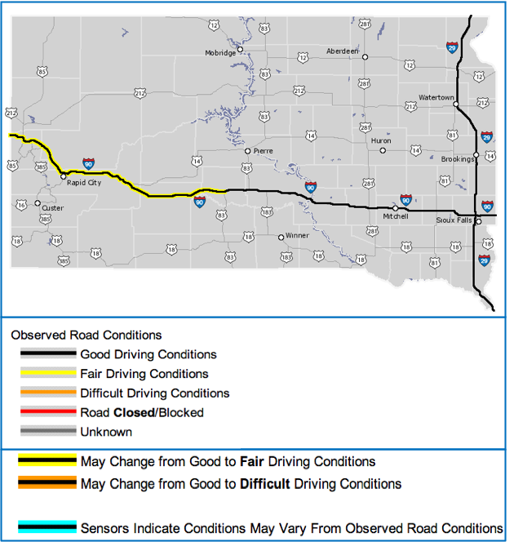
Figure D-15. Map of South Dakota Showing Forecast Road Conditions (Source: Meridian Environmental Technologies)
The tool also provides a continuous loop forecast of anticipated precipitation and road conditions. A snapshot from this loop for a past weather event is shown inFigure D-16. The loop depicts the path of a rain and snow weather system as it moves across a five State region. What is unique about the tool is its depiction of the changing road conditions as the weather event passes through the region. A user of the website can observe how various segments of the interstate are forecast to change over a 12-hour period based on the current and forecast road weather conditions.
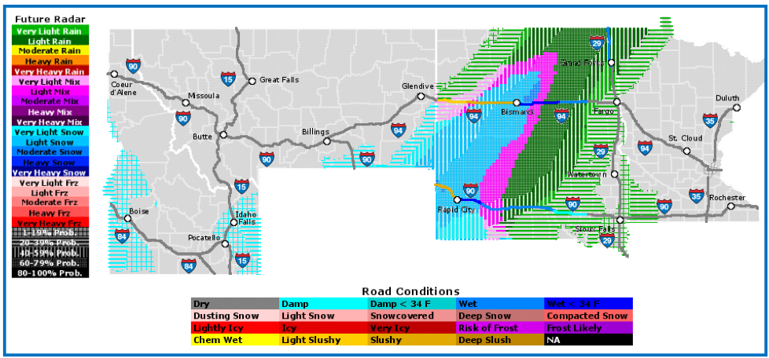
Figure D-16. Precipitation and Road Condition Forecast for April 2, 2010 (Source: Meridian Environmental Technologies)

3.4 Nature and Justification of Changes
Most of the existing systems for disseminating road weather information focus on current conditions. However, when planning a trip, travelers not only need information about current road weather conditions but also want information about what travel conditions will be like on specific sections of roadway in the future. Information about future road weather conditions will have a significant impact on travelers’ departure time, route and potential mode choice decisions. Furthermore, while en route, travelers (particularly long-distance travelers) need information about current and predicted road weather conditions in making route change decisions. Roadway weather information needs to be specific to a particular section and needs to be based on forecasted weather conditions. As different vehicle types are impacted differently by weather conditions, road weather information needs to be tailored to specific user groups or vehicle types as well.

3.5 Concepts for the Proposed Strategy
This concept expands upon the Clarus demonstration of Enhanced Road Weather Travel Advisories to include predictions of road weather conditions and impacts. Under this module, not only does the system provide agencies with route-specific forecasts of road weather conditions, but it also provides a prediction of the degree to which the forecasted weather event will impact traffic flow in the network. Transportation agencies would be able to use such a tool to predict when and where congestion and operational problems are likely to occur based on the severity and intensity of the weather conditions in the near-term future. Transportation agencies need near-term predictions (e.g., up to 12-hours in advance) so that they can take steps to mitigate the effects of weather on traffic operations.
In order to provide these near-term predictions of road conditions, the system needs to be developed to perform the following functions:
- Collect, aggregate, and synthesize weather information from a number of different sources, including (but not limited to) Road Weather Information/Environment Sensing Stations, Clarus, and both public and private weather information service providers.
- Provide route-specific road weather condition forecasts up to 12-hours in the future.
- Using the forecasted weather conditions as well as current and historical traffic conditions, predict the impacts of weather conditions on traffic operations in a regional network, specifically identifying when and where weather events will create operational deficiencies in the network.
- Generate appropriate route-specific road weather and traffic forecast messages to be distributed through regional pre-trip traveler information dissemination systems, such as websites, traveler kiosks, etc.
- Generate appropriate route-specific road weather and traffic forecast messages to be distributed through regional en-route traveler information dissemination systems, such as dynamic message signs (DMS), highway advisory radio (HAR), 511 and others.
- Generate appropriate route-specific road weather and traffic forecast messages to be distributed through regional non-traditional traveler information dissemination systems, such as social networking systems, text alerts, and others.

3.5.1 Functional Components
Figure D-17 shows the functional components for developing and integrating predicted road weather travel conditions into a regional traveler information system. The pink shaded boxes with bold typeface represent new components being added to the system to accomplish the functions listed above. The following provides a high-level description of the functional components envisioned for this system.
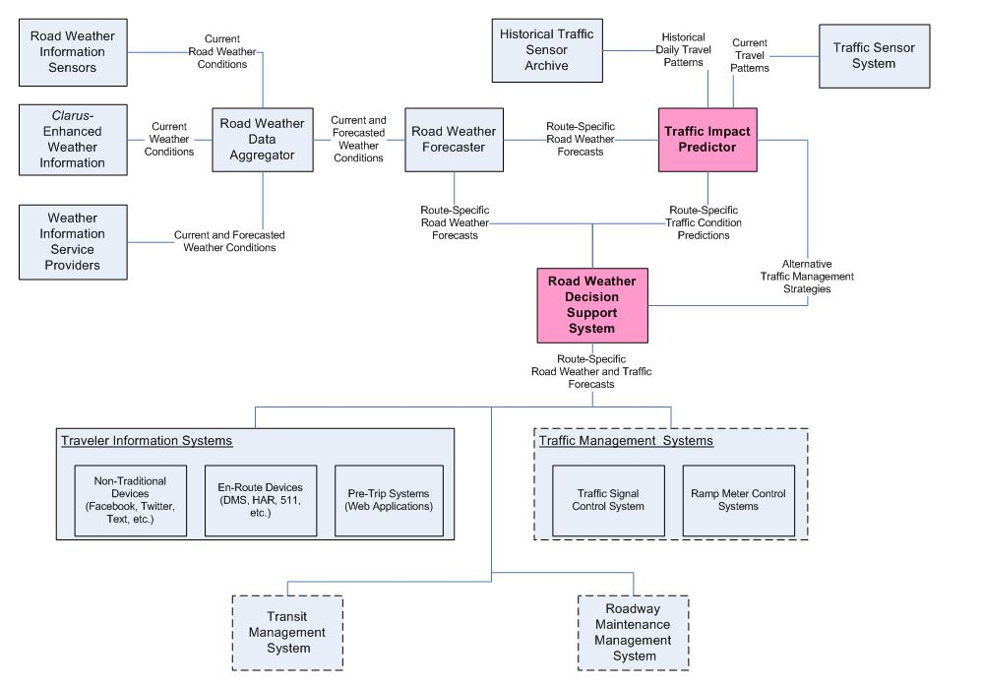
Figure D-17. Functional Components of a Regional Road Weather Travel Impact Prediction System (Source: Texas Transportation Institute)

3.5.2 Weather Monitoring Subsystem
The weather monitoring component is responsible for obtaining all the road weather information needed to assist in determining when and where travel conditions are likely to deteriorate. It is through this component that system operators obtain updates of weather conditions, particularly visibility, surface conditions and/or precipitation accumulations, through sensors located in the field communicating back to the weather monitoring system.

Road Weather Information Sensors
These sensors could be agency-owned or information can be provided by private weather information providers. The types of data needed from the weather monitoring component would include the following:
- Current wind speed and direction,
- Current ambient air temperature,
- Presence of precipitation,
- Rate at which precipitation is currently falling and the start and stop time of the latest recorded precipitation,
- Current visibility distance,
- Current temperature of the pavement surface and an indication of the presence of any moisture on the surface,
- Current depth of snow and packed snow on the traveled way,
- Expected time of snow fall or rain storm, and the probability of snow and rain, and
- Current thickness of ice on the traveled way.
The weather monitoring system may also provide situation assessments of weather conditions, such as the following:
- An assessment of the current wind condition (e.g., calm, light breeze, gale, gusty, etc.),
- An assessment of the type and intensity of the current precipitation (e.g., no precipitation, moderate snow, heavy rain, etc.)
- An assessment of the visibility (e.g., clear, foggy, smoke, sun glare, etc.), and
- An assessment of the pavement state (e.g., dry, standing water, flowing water, packed snow, etc.)

Clarus-Enhanced Weather Information
Among other things, Clarus is a national network for sharing, quality checking, and exchanging surface environmental data and relevant transportation conditions. As currently implemented, Clarus provides the following:
- A one-stop location portal for all surface transportation environmental observations;
- Data provided with and without post-processing, ready to be incorporated into value-added products including weather and traffic models as well as decision support systems;
- Continuous quality checking of data with feedback to operators of the originating sensor stations;
- Data transferred in one common protocol with full metadata;
- Management of users' rights to input or extract specific data components;
- Data retrieval tools; and
- Support for the inclusion of new technologies such as vehicle-based sensors, surface visibility information from cameras, and remote sensing technologies.
In this application, Clarus data may supplement or even be the primary source of weather observational data for agencies. The type of data that would be expected to be provided by the Clarus data is similar to that provided by individual weather monitoring stations.

Weather Information Service Provider
Agencies can use both public and private weather information service providers to obtain atmospheric weather conditions and long-term forecasts of weather conditions. For example, transportation agencies can obtain information about weather alerts, watches and warnings from direct feeds from the National Weather Service. Many agencies also subscribe to private weather information providers to obtain area or roadway specific forecasts and alerts. Transportation agencies may use this information to determine when, where, and how long weather events may impact traffic operations.

Road Weather Data Aggregator
This module would be responsible for obtaining the road weather data from the various sources available in the region. This module would extract the information from the sources and place the data in the proper format required by the road weather forecaster. The Road Weather Data Aggregator would also be responsible for performing quality checks on the data and eliminating any anomalies in the weather monitoring data.

Road Weather Forecaster
The road weather forecaster is responsible for producing route-specific forecasts of weather and roadway surface travel conditions. Specifically, the road weather forecaster would predict when and where travelers on specific routes will encounter operational deficiencies due to weather events. The road weather forecaster would also be responsible for providing agencies with estimated durations of traffic operation impacts and interruptions. Examples of the type of predictions that would be made through the road weather forecaster include the following:
- Specific bridges or overpasses that have a high probability of experiencing icing;
- Specific times and sections of roadways expected to experience flooding or significant snow accumulations;
- Particular sections of highway or bridges that are likely to experience winds of sufficient velocity to overturn high profile vehicles;
- Specific times and sections of roadway where fog conditions will limit visibility; and
- Specific time and locations where severe thunderstorms and tornado are likely to cross certain sections of highway.
The output of this module would be the time, duration, and extent of weather conditions impacting traffic operations. This information would need to be updated at least once every 15 minutes.

Traffic Impact Predictor
This component of the system would be responsible for providing near-term predictions (e.g., 15- to 60-minutes in the future) of the impacts of impending weather events on traffic operations. This component is likely to be a traffic simulation model capable of providing short-term traffic predictions, such as dynamic traffic assignment models or Traffic Estimation and Prediction Systems (TrEPS). While, traditional analysis tools do not have the capability to predict the impacts of weather, recent FHWA research has developed weather-sensitive traffic prediction and estimation models and incorporated them in TrEPS tools intended for online operation in TMCs as well as for offline evaluation of contemplated measures. This tool would be responsible for identifying when and where traffic operational problems are likely to occur in the transportation network because of an impending weather event. This tool should not only be capable of modeling the driver behavior in response to traffic control strategies, but also need to model how drivers might behave in response to both pre-trip and en route traveler information.

3.5.3 Road Weather Decision Support System
This component of the system would be responsible for taking output from the traffic impact predictor (e.g., when and where traffic operational problems are likely to occur in the network) and identifying potential traffic operational strategies for addressing these problems. The road weather decision support system might also be responsible for determining what type of traffic management control, advisory, and treatment strategies might be appropriate for a specific route or location given the predicted weather and traffic conditions. The road weather decision support system could feed this information back to the traffic impact predictor to determine if the recommended strategies had a positive effect on correcting the operational deficiency. Once an appropriate strategy had been determined, the road weather decision support system would then be responsible for implementing the recommended strategy on the appropriate devices. These devices are likely to consist of a number of different traffic management responses including traveler information systems, traffic management systems, transit management systems, and roadway maintenance management systems.

3.5.4 Traveler Information Systems
This functional component is responsible for disseminating both pre-trip and en route information directly to the driver. This functional component includes one or more of the following traveler information dissemination mechanisms:
- In-vehicle devices (such as integrated navigation devices),
- Personal communication devices (such as smart phones, personal digital assistance devices, personal computers, etc.),
- Private communication media (such as television, radio, third-party information service providers, etc.), and
- Agency-owned communication devices (such as dynamic message signs, highway advisory radio systems, websites, etc.).

3.6 Operational Scenarios
This section contains two operational scenarios that illustrate the need for a system that provides near-term predictions of roadway travel conditions based on weather forecasts building upon the suggested approaches in Section 5. This section shows how information produced by this system can be used by travelers making pre-trip and en route travel decisions – especially departure time and route choice decisions. The operational scenarios attempt to show how this information can be disseminated using several different types of traveler information dissemination technologies. These scenarios, developed based on the experiences of real travelers during a winter storm, highlight the types of decisions facing long-distance travelers and their information needs. The scenarios also illustrate the need for communicating and sharing forecasts of road weather information and predictions of the impacts of weather on traffic operations between local and regional transportation management centers.

3.6.1 Pre-Trip
The Smith family, on vacation, has stopped for the night and is at least 8 hours drive time from their ultimate destination two States away. While watching the local weather forecast that night, they learn they are going to have to pass through an area where the National Weather Service has just posted Severe Winter Storm Warnings. Snow is expected along their planned route, but the Smith family does not know where or when driving conditions are likely to deteriorate. They go to a weather forecasting website and learn that it will begin snowing on their planned route mid-morning, but it is not expected to become heavy until early afternoon. The Smith family is faced with a number of critical decisions to be made that night that impact their travel plans the following day:
- Given that the worst part of the storm is not expected to arrive until mid-afternoon, should they get up early and try to arrive at their destination before the weather gets too bad or should they wait out the storm at their current location? If they wait out the storm in their current location, are they likely to get caught in their current location for more than one night? If they try to beat the storm, what time are roadway conditions likely to deteriorate given the timing of the storm?
- How long is the weather event likely to impact their travel options? If they try to beat the storm, what time are roadway conditions likely to deteriorate given the timing of the storm? If they wait out the storm, how long are they going to have to wait until travel conditions have improved?
- Given that several alternate routes exist to reach their destination, which one should they take? Would it be better to use the Interstate (which is likely to receive the brunt of the storm but at the same time more likely to be better maintained) or use an alternate route (which may be impacted less by the storm but is also less traveled)? Where along each route are they likely to encounter difficult driving conditions? What are their available options for shelter, places to stop, etc. along each route?
Luckily, the Smith family remembers hearing about a website where they can get forecasts of road weather information. The Smith family accesses this website from the DOT website of the State where their destination is located. This website uses hour-by–hour forecasts of weather information along with real-time pavement surface condition information to obtain hourly forecasts of the anticipated roadway travel conditions along the routes that they will be potentially traveling. From this website, they can determine what sections along each roadway are likely to be more difficult to travel at different times into the future. By knowing what the weather and roadway conditions are predicted to be as the storm tracks its way through the areas they will be traveling, the Smith family can determine when they should leave their hotel to avoid the worst travel conditions. Because they know when travel on particular sections is likely to deteriorate or become congested, they can also pre-plan locations where they will stop, check for updates on travel and weather conditions, and determine points along their way where alternate route decisions can be made. From this website, they can also sign up for alerts to be sent to their smart phone that are specific to their routes and estimated travel times through those areas. These decision points are tied to the GPS in their smart phone. The Smith family downloads the application directly to their smart phone.

3.6.2 En Route
Before leaving the hotel in the morning, the Smith family checks the travel condition website they found last night for any last minute changes in weather and travel predictions. After reaffirming the decisions they made the night before, they begin on their trip. While they are en route, the weather takes an unexpected turn for the worse and the travel conditions on the route they are traveling is expected to turn worse much sooner than predicted. The smart phone application searches their alternate routes and provides them with expected travel conditions on each route at their estimated time of arrival on that route, given the predicted travel conditions. Matching their current positions from the GPS in their smart phone to the route planned in their trip planning application, the Smiths receive updates about weather and travel conditions at key decision points as they are traveling en route. These weather alerts provide them not only with information about the current travel conditions, but also the predicted travel conditions for when they are estimated to be arriving in each section of roadway. The application also provides them with estimates as to how long travel is likely to be disrupted in the different sections along their route. The application can also provide them with information about status and availability of emergency shelters, hotels, and other travel amenities along their route.
As they continue their trip, they continue to receive updated roadway status information from their downloaded applications as well as dynamic message signs along the roadway. As the travel conditions worsen, they begin to get more nervous about the road travel conditions ahead. They call 511 and are connected with an operator that can provide them with travel condition reports and predictions along several alternate routes. The operator reports to them the current and predicted travel conditions along several of the alternate routes available to the Smiths, from their current location. Using this information, the Smiths elect to change routes further to the west where the storm has already traveled and the roadway conditions are improving.

3.7 High-level System Design

3.7.1 User Needs
Following is a list of high-level user needs that State and local transportation agencies must satisfy in order to successfully deploy this strategy. The user needs are not listed in any particular order, nor is their order intended to imply any level of priority.
- Collect and synthesize weather and roadway surface condition data from multiple sources, both public and private, including RWIS and private weather information providers, to provide a comprehensive picture.
- Using information about current and future weather and roadway surface conditions, predict near-term impacts (15- to 60-minutes into the future) of weather conditions on traffic operations in the transportation network (including automobile and transit operations) and identify when and where congestion is likely to form as a result of impending weather conditions.
- Using predictions of roadway and traffic operations, evaluate alternative traffic management and traveler information dissemination strategies for addressing and identifying congestion locations and selecting the strategies that best improve safety and operations within the network.
- Disseminate the predicted impact of weather on traffic operations to travelers both before they initiate their trip and while en route.
- Coordinate and share information about their responses to predicted congestion and travel impacts due to an impending weather event.

3.7.2 High-Level Functional Requirements
The following table shows the high-level system requirements needed to fulfill the identified user needs associated with deploying the weather responsive regional traveler information.

Table D-4. System Requirements for Deploying Weather Responsive Regional Traveler Information Strategy
User Need ID | State and Local Transportation Agency User Need | Functional Requirement ID | Functional Requirement
1. | Synthesize road weather condition data from multiple sources. | 1.1 | The system shall integrate road weather information from multiple sources.
1. |  | 1.1.1 | That system shall include road weather information and forecasts from public sources.
1. |  | 1.1.1.1 | The system shall include road weather information and forecasts from agency operated RWIS and ESS.
1. |  | 1.1.1.2 | The system shall include enhanced road weather information and forecasts from Clarus.
1. |  | 1.1.2 | The system shall have the capabilities of incorporating road weather condition information and forecasts from private sources.
1. |  | 1.2 | The system shall include current weather observations.
1. |  | 1.2.1 | The system shall include observations of the current wind speed and direction.
1. |  | 1.2.2 | The system shall include observations of current ambient air temperature.
1. |  | 1.2.3 | The system shall include observations of the current presence of precipitation.
1. |  | 1.2.4 | The system shall include observations of the rate of precipitation.
1. |  | 1.2.5 | The system shall include observations of the current visibility distance.
1. |  | 1.2.6 | The system shall include observations of the pavement surface temperature.
1. |  | 1.2.7 | The system shall include observations of current depth of snow and packed snow on the traveled way.
1. |  | 1.2.8 | The system shall include observations of the current thickness of ice on the traveled way.
1. |  | 1.3 | That system shall include forecast road weather information.
1. |  | 1.3.1 | Forecasted weather information shall be provided up to 12 hours in advance.
1. |  | 1.3.2 | Forecasted weather information shall be on a subarea basis.
1. |  | 1.3.3 | Forecasted weather information shall be in 15-minute intervals.
1. |  | 1.3.4 | Weather forecasts shall be updated every 15 minutes.
1. |  | 1.3.5 | Forecasted weather conditions shall include prediction of wind speed and direction.
1. |  | 1.3.6 | Forecasted weather conditions shall include predictions of prediction rates and accumulations.
1. |  | 1.3.7 | Forecasted weather conditions shall include predictions of types of precipitation.
1. |  | 1.3.8 | Forecasted weather conditions shall include predictions of visibility distances.
2. | Predict near-term road weather conditions based on current weather observations. | 2.0 | The system shall include predictions weather conditions on roadway operations.
2. |  | 2.1 | Road weather predictions shall be based on current and forecasted weather conditions.
2. |  | 2.2 | Road weather predictions shall be provided up to 12 hours in advance.
2. |  | 2.3 | Road weather predictions shall be provided in 15 minute intervals.
2. |  | 2.4 | Road weather predictions shall be provided for individual roadway segments.
2. |  | 2.4.1 | Road weather predictions shall include predictions of the status of the surface conditions (wet, dry, icy, etc.).
2. |  | 2.4.2 | Road-weather predictions shall include predictions of the pavement surface temperature.
2. |  | 2.4.3 | Road weather prediction shall include predictions of depth of precipitation accumulation.
2. |  | 2.4.4 | Road weather prediction shall include predictions of pavement friction.
2. |  | 2.4.5 | Road weather predictions shall include predictions of the presences of conditions affecting visibility (blowing snow, fog, etc.).
2. |  | 2.4.6 | Road weather predictions shall include predictions of visibility distance.
3. | Evaluate alternative traffic management and traveler information dissemination strategies for addressing identify congestion locations and select the strategies that best improve safety and operations within the network. | 3.0 | The system shall provide predicted travel conditions based on the estimated arrival times of travelers on specific road segments.
3. |  | 3.1 | The system shall predict the effects of predicted roadway weather conditions on operational effectiveness (capacity).
3. |  | 3.1.1 | The system shall assess the effects of predicted roadway weather conditions on freeway speeds/travel times.
3. |  | 3.1.2 | The system shall assess the effects of predicted roadway weather conditions on arterial travel speeds/travel times.
3. |  | 3.1.3 | The system shall assess the effects of weather on arterial coordination.
3. |  | 3.2 | The system shall predict the effects of different roadway conditions on operating demand.
3. |  | 3.2.1 | The system shall predict the effects of forecast roadway weather conditions on freeway demands.
3. |  | 3.2.2 | The system shall predict the effects of forecast roadway weather conditions on arterial demands.
3. |  | 3.2.3 | The system shall predict the effects of forecast roadway weather conditions on transit demands.
3. |  | 3.3 | The system shall allow agencies to assess the effectiveness of different active traffic management strategies to overcome the predicted operational deficiencies caused by predicted roadway events.
3. |  | 3.3.1 | The system shall allow agencies to assess effectiveness of different traffic signal coordination strategies.
3. |  | 3.3.2 | The system shall allow agencies to assess the effectiveness of different traffic signal timing settings.
3. |  | 3.3.3 | The system shall allow agencies to assess the effectiveness of different types of vehicles restrictions.
3. |  | 3.3.4 | The system shall allow agencies to assess the effectiveness of different types of lane restrictions.
4. | Disseminate the predicted impact of weather on traffic operations to travelers both before they initiate their trip and while en route on their trip. | 4.0 | The system shall disseminate current and forecasted road weather conditions.
4. |  | 4.1 | The system shall support the dissemination of current and forecasted road weather condition information affecting pre-trip decision making.
4. |  | 4.1.1 | The system shall provide current and predicted road weather information for each roadway segment.
4. |  | 4.1.2 | The system shall display the predicted travel conditions for the time period selected by the user.
4. |  | 4.1.3 | The system shall display the predicted travel conditions for the time the user is expected to enter each segment, based on predicted travel times.
4. |  | 4.1.4 | The system shall allow the user to assess multiple routes based on current and predicted travel conditions.
4. |  | 4.1.5 | The system shall allow the user to assess different departure times.
4. |  | 4.1.6 | The system shall support the dissemination of pre-trip information through multiple devices, including Smart Phones, websites, and 511.
4. |  | 4.2 | The system shall support the dissemination of current and forecasted road weather condition information affecting en route decision making.
4. |  | 4.2.1 | The system shall provide updates of current and predicted road weather information for each roadway segment every 15-minutes.
4. |  | 4.2.2 | The system shall disseminate en route predicted road weather conditions through traditional information dissemination technologies (DMS, HAR, 511, etc.).
4. |  | 4.2.3 | The system shall disseminate predicted road weather conditions from 30 mins to 1 hour in the future.
4. |  | 4.2.4 | The system shall be used to assist travelers to make route choice decisions.
4. |  | 4.2.5 | The systems shall be used by operators to encourage drivers to alter through routes, or to seek shelter for deteriorating weather conditions.
5. | Coordinate and share information about their responses predicted congestion and travel impacts due to an impending weather event. | 5.0 | The system shall support data sharing of current and predicted impacts of weather on roadway operations with other agencies.
5. |  | 5.1 | The system shall support data sharing of current and predicted road weather information with transportation management personnel.
5. |  | 5.2 | The system shall support data sharing of current and predicted road weather information with emergency management personnel.
5. |  | 5.3 | The system shall support data sharing of current and predicted road weather information with roadway maintenance personnel.

3.8 Analysis of the Proposed System
The effects of traveler information on driver route, departure time, and mode choice decisions are difficult to capture through direct field measurements. Instead, studies have generally relied upon user-stated preference studies and interviews to determine the degree to which travelers’ and agency decisions are impacted by improved traveler information. Examples of the types of information that are used to assess the effectiveness of improved pre-trip and en route traveler information include the following:
- Does having access to current road weather information change your trip-making decisions? Did it cause you to alter you departure time, route, or travel mode decisions? If so, how?
- Does having access to predicted road weather information change your trip-making decisions? Did it cause you to alter you departure time, route, or travel mode decisions? If so, how?
- How often do you change your 1) route, 2) mode, and 3) departure time decisions based on having access to current and predicted road weather information?
- Did you find the 1) current and 2) predicted road weather information to be 1) accurate, 2) timely, and 3) useful in your trip decision making process?

D-4 Seasonal Weight Restrictions

4.1 Scope

4.1.1 Concept Overview
This section presents a Concept of Operations for Seasonal Weight Restrictions (SWR) that are imposed by transportation agencies to prevent pavement damage on specific roads by heavy loads due to subsurface freeze/thaw actions during the spring season. The Concept of Operations (ConOps) is intended to improve the techniques used to forecast the need for truck weight restrictions on specific roads and the processes for implementing and communicating the restriction decision. The following are the intended audiences for the ConOps:
- State Departments of Transportation (DOT) – The SWR ConOps enables a robust and scientifically based decision-making process for seasonal weight restrictions, minimizing pavement damage while allowing for optimum goods movement across the state. Typical groups who might benefit from the ConOps within the State DOT include:
- District Maintenance Chiefs
- Motor Carrier Divisions
- Public Information Staff (who will be able to provide advance notification to the commercial vehicle community)
- System Developers and Integrators -- The SWR ConOps helps create a context for the development of a SWR tool which can be used by state DOTs.

4.1.2 Strategy Overview
A Seasonal Weight Restriction (SWR) strategy is intended to provide decision-support to state DOTs that deal with freeze/thaw conditions. The decision-support capability uses atmospheric weather, road surface and sub-surface information as inputs to a forecasting model to predict thaw occurrence, freeze depth, and resiliency of the pavement. The basic premise behind the concept is that advanced weather and road weather information sources, combined with modeling of sub-surface conditions, will result in earlier notification of sub-surface thaw to the transportation system managers who can then take more timely decisions to prevent pavement damage while providing better and advanced notification to the impacted truckers/haulers. Similarly, once the pavement has regained its strength, restrictions can be speedily removed minimizing the impact to the commercial vehicle traffic.
As such, the vision for the SWR strategy is to provide a more reliable, scientifically-based decision support process to guide placement of weight restrictions balancing the interests of the commercial trucking community and the structural integrity of the transportation system. The goals of the strategy are four-fold:
- Allow State decision makers to more effectively determine when to place and remove load restrictions, preserving both the pavement integrity and commercial vehicle operator productivity.
- Increase the level of confidence in the SWR decision-making process.
- Improve coordination and consistency between jurisdictions during load restriction season.
- Improve communications and notifications to commercial operators about restriction placement and removal.
SWR involves primarily State DOTs as implementers of the strategy. Various groups within the State DOTs that are involved in the decision-making process include:
- Maintenance Districts – Typically, the decision to impose restrictions comes from the maintenance districts. The district chiefs, in collaboration with their field staff, determine the location and the dates of restriction placement and removal. They will be the primary users of a SWR Strategy ConOps.
- Motor Carrier Divisions – Once the decision to place restrictions has been made, it has to go through an administrative process that can take several days before restrictions are actually posted. This involves coordination with the motor carrier division for issuing advisories and email alerts to the commercial vehicle operator community.
- Public Information – The groups responsible for public information including signage on roadways and traveler information systems are critical stakeholders in SWR.
- Headquarters or Central Offices – As maintainers of Road Weather Information Systems and Pavement Management systems in most agencies, they provide important inputs to the decision-making process.
The second primary stakeholder group is the Commercial Vehicle Operator community representing the entities that operate commercial vehicles in the state including long-haul truckers, heavy equipment movers, and farming-related operators.
Some of the assumptions made were:
- Roles and responsibilities between the maintenance districts and central offices within the DOT. The relationship between the various groups within state DOTs may vary significantly depending on the institutional framework of the DOT.
- Availability of quality-checked ESS information was presumed.
- The concept does not assume the wide-spread availability of frost-probes or direct sub-surface measurements.

4.2 Referenced Documents
The following documents were used in the development of this ConOps document.
- Development and Deployment of Clarus-Enabled Services, Clarus Multi-State Regional Demonstration: Concept of Operations (Version 1.0), Submitted to the Federal Highway Administration, February 27, 2009.
- Development and Deployment of Clarus-Enabled Services, Clarus Multi-State Regional Demonstration: High Level Requirements – Use Case 2, Submitted to the U.S. Department of Transportation, Federal Highway Administration, April 30, 2009.

4.3 Current System or Situation

4.3.1 Background, Objectives, and Scope
In cold weather States in the U.S, thawing periods result in pavement damage during late winter and early spring leading to the formation of potholes and cracks. This is primarily due to the presence of water in the sub-grade resulting in a loss of pavement strength. To prevent such damage from occurring, state DOTs impose SWR for truck traffic on specific sections of the roadway during the thaw period. The primary objective of the SWR is to prevent pavement damage while still providing access and mobility to the freight traffic.

4.3.2 Description of the Current System or Situation
Load restrictions vary by State and region. Typically, they are based on the pavement conditions like surface thickness and type of sub-grade, local knowledge of weather and pavement conditions, expected truck traffic volumes, and field observations related to observed moisture and pavement distress.
In placing restrictions, decision makers currently rely on a variety of information that seeks to inform them about the conditions under the pavement. This information includes visual observations of moisture weeping through surface cracks, atmospheric temperature trends, environmental sensor station (ESS) readings of subsurface temperatures in limited locations, historical restriction patterns, and conditions and decisions in neighboring districts. Some States have heuristic guidelines based on atmospheric condition trends (number of freezing days as an indication of frozen depth, and number of melting days as an indication of thaw). Very few to no agencies have extensive sub-surface probes to use direct measures of temperatures.
When the time to remove restrictions approaches in the late spring or early summer, DOTs use a combination of decision strategies, such as falling weight deflectometer (FWD) readings, field observations of soil conditions, plus ESS and atmospheric temperature readings to estimate the appropriate time to remove restrictions. Typically DOTs are inclined to leave restrictions posted longer than may actually be necessary to protect the pavement. Normally, when the subgrade reaches about 80% of full strength, DOTs are comfortable removing weight restrictions.

4.4 Nature and Justification of Changes
Currently, when a DOT decides to place restrictions based on observed pavement conditions at the onset of warming spring conditions, it is likely to be too late to fully protect the pavement from vehicle damage, as subsurface thawing is likely to have occurred several days prior to observed evidence at the surface. Furthermore, State DOTs may have in place an administrative process that can take several days before restrictions are actually posted after the decision to restrict has been made, adding further delay and potential risk to the pavement. New advances in availability of weather information such as quality-checked Clarus data, coupled with enhanced sub-surface modeling techniques, can provide DOTs with thermal and strength profiles of their pavements. This information can be forecast for several weeks allowing an agency an unprecedented window of opportunity to better schedule their SWR and beat the thaw. In addition, various city and county jurisdictions follow the lead of State DOTs in setting and removing restrictions and are impacted by delays and administrative lags in restriction placement or removal times.

4.5 Concepts for the Proposed Strategy
The following sections describe the proposed improvements to the SWR strategy based on desired changes specified in Section 4 above.

4.5.1 Description of Proposed Strategy
The process starts with a decision-support system which provides forecasted sub-surface information to supplement typical existing sources of ESS data and field observations. These data combined with State policies and guidelines form the basis of the restriction placement decision by the maintenance chief. This information is then communicated to the central office where various administrative processes are initiated for the official placement and notification of decisions. These processes may include sharing the impending placement decisions with pre-registered commercial vehicle operator lists, creating and distributing maps of restricted and unrestricted roadways, providing alerts and advisories via traveler information systems such as 511 or websites, and sharing restriction information with enforcement personnel. The process is repeated for removal of restrictions. Figure D-18 shows the high-level concept diagram depicting the strategy and the environment in which it operates. Each element of the figure is described here.

Weight Restriction Decision-Support Subsystem
This is the heart of the strategy, coupling a pavement and subsurface temperature prediction model with a long-range atmospheric model to forecast thermal profiles of subsurface conditions up to two (2) meters depth and 10 days into the future. The decision-support tool provides the state DOTs with a forecast of impending sub-surface conditions (such as temperatures, resilient modulus, percent water, pore pressures) to enable a more proactive placement of restrictions.
The Clarus Multi-State Regional Demonstration developed a detailed Concept of Operations and systems requirements for such a decision-support tool. Figure D-19 provides a screen shot of a detailed subsurface temperature profile with time out to 10 days from the user selected start date shown on the x-axis and depth in inches from the surface down to four feet shown on the y-axis. This information is for a particular location in the state. Figure D-20 provides a screen shot of the resilience profile with all other conditions set the same as in Figure D-19. These two examples are from April 30, 2010, and they illustrate how a drop in atmospheric temperature occurred during a longer warming trend. As the warming continued and began raising the temperatures in the sub-base, the resilient modulus began to drop (from 1.0 to 0.6), indicating increased vulnerability of the pavement to potential truck damage.

Figure D-18. High-Level Concept Diagram for Seasonal Weight Restriction (Source: Created by Authors)

Figure D-19. Example Temperature Profile (Source: Meridian, Clarus Multi-state Regional Demonstration, Use-Case #2 Website)

Figure D-20. Example Resilience Profile (Source: Meridian, Clarus Multi-state Regional Demonstration, Use-Case #2 Website)

Other Inputs
The decision-support system is only a tool in the tool box for maintenance chiefs as they consider restriction placement or removal. In addition to the weight restriction decision support system, other inputs for the SWR decision-making include field observations, ESS observations, FWD measurements, and historical restriction experience. Each of these inputs is explained below:
- ESS Information – ESS pavement and sub-surface temperature information is vital in verifying decision-support tool outputs as well as providing direct sub-surface measures (if sub-surface probes are part of the ESS). Ideally, these probes will be located at a depth of most concern to the DOT.
- Field Observations – Maintenance personnel look for visible signs of thaw such as moisture seeping through the cracks. As noted earlier, while waiting for visible signs may be too late for placement of restrictions, field observations will continue to be vital in deciding how restrictions occur.
- FWD Information – A direct measure of pavement carrying capacity, the Modulus (stiffness) can be determined using portable FWDs during the spring thaw. However, typical FWD programs are based on a sampling design and are part of larger pavement management programs and may not be available for the desired roads at the desired times. Where available, they play an important role in restriction removal as they can provide a direct measurement of the pavement strength. Typically, when FWD readings indicate 70-80% of pre-thaw strengths, the restrictions are removed.
- Historical Restriction Information - Historical restriction information plays a critical role in determining seasonal weight restriction. Agencies start paying attention to pavement conditions typically after a certain date when they have historically considered appropriate for restrictions for their area. Restrictions are also typically placed on the same sections of roadways based on historical trends of pavement distress and trucking patterns

4.5.2 Administrative Processes
Administration processes include notification of Commercial Vehicle Operators (CVOs), notification of enforcement, roadside signage, mapping, and website updates. Information about seasonal weight restrictions can be conveyed through maps and information on agency websites. Information about restrictions can be shared through email lists of commercial vehicle operators including advanced notification of impending restrictions. Typical administrative processes also include the nature of the restrictions in the State.
Figure D-21 from the North Dakota website lists the different classifications of road restrictions that they use. Depending on pavement conditions, a road may be classified into one of the described classes of restrictions.
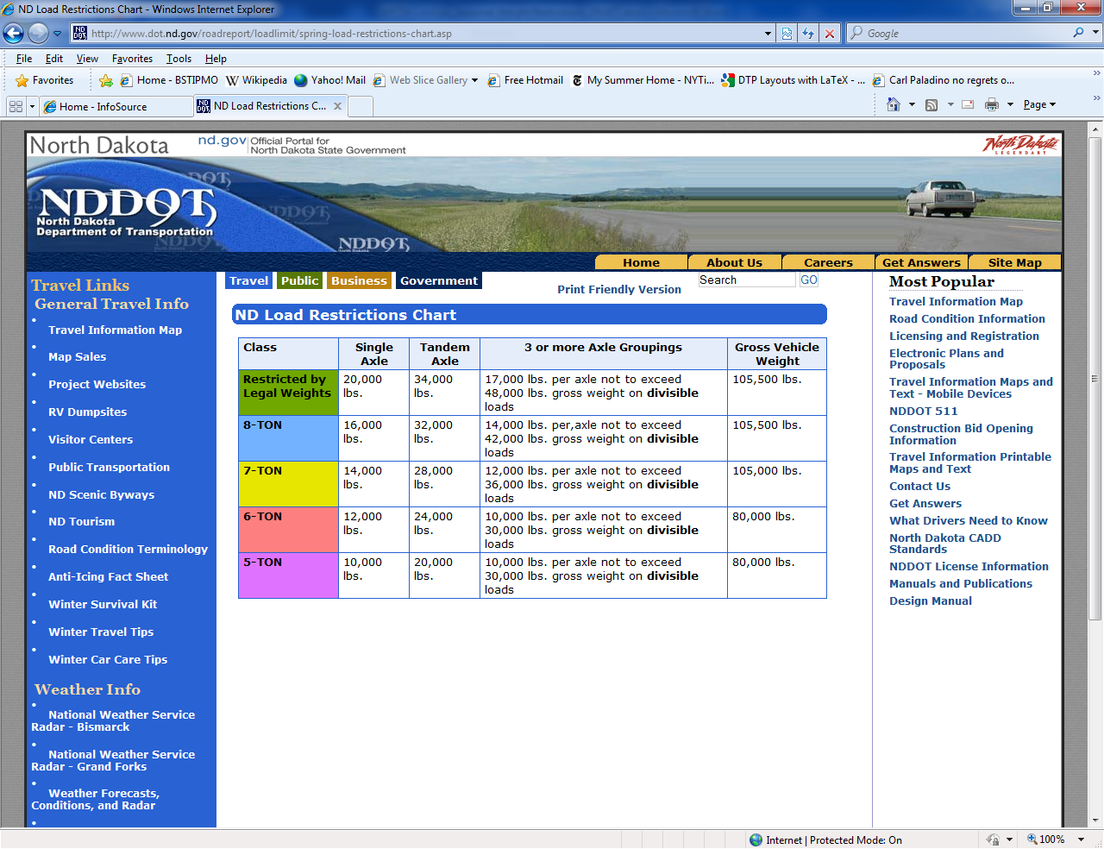
Figure D-21. NDOT Load Restrictions Chart (Source: NDOT Website, http://www.dot.nd.gov/roadreport/loadlimit/spring-load-restrictions-chart.asp)

4.5.3 Operational Policies and Constraints

Operational Policies
Policy and guideline information that each State currently uses for implementation of seasonal weight restrictions will continue to be used. Any exemptions to the weight restrictions will continue to hold as before.

Operational Constraints
No new operational constraints are envisioned due to the implementation of the concept. Existing approaches to mitigating mobility impacts of commercial vehicle operations will continue to be in effect.

4.6 Operational Scenarios
This section describes two operational scenarios that illustrate load restriction placement and removal using a SWR decision support tool and other inputs as defined in Section 5.

4.6.1 Weight Restriction Placement
Mr. Smith is in charge of a maintenance district in north-central Montana. The roadway network in the maintenance district is characterized mostly by 2-lane rural roads typically used by local haulers (mostly wood and farm products) and local traffic. Recently however, there has been an increase in heavy truck traffic due to mineral and oil deposits found in Alberta, Canada. The roads in Mr. Smiths’ district are viable options for truckers hauling heavy equipment to the mining areas across the border.
Mr. Smith has traditionally placed restrictions on his roadways using an ad-hoc approach relying on the two ESS stations in his district and reports from his field personnel. He recognizes that often times, by the time the restriction decision is made and actually placed, the thaw has already occurred and the restrictions too late to prevent pavement damage.
This winter, Mr. Smith started working with a SWR decision-support tool to see if the timing of the restrictions can be improved using forecast information. After being trained on the tool, Mr. Smith began monitoring the tool on a daily basis, starting in mid-February, a time when the weather in Montana would start turning warm. Each day, not only was he able to look at the current temperatures and the pavement strengths (in terms of resilient modulus; a term he is familiar with because of the FWD program in his state), he was able to look at the forecasts 10 days in advance.
In early March, he noticed that the decision-support tool indicated a long period of warm temperatures with sub-grade thaw occurring up to 24 inches. He knew that this was the critical time for the SWR. On March 7th, he communicated to the central office in Montana that he intends to place restrictions on the 16th. On the same day, the central office sent out a pre-notification to the e-mail list that they maintain indicating that restrictions are imminent as soon as they heard from Mr. Smith. By March 10th, an official notification was sent out and the restriction went into place on the 16th.
Mr. Smith realized that using this approach allowed him to proactively place restrictions and provide better and advance notification to the trucker community while significantly reducing pavement damage.

4.6.2 Weight Restriction Removal
For the first time in many years, Mr. Smith has not received any complaints from the truckers on the timing of the restriction placement. However, he knows that restriction placement is only one part of the equation and truckers are often more impacted by the timing of the restriction removal in early summer. He knows that as soon as he lifts the restrictions he will be bombarded with requests for oversize and overweight permits for heavy equipment movement in his district.
Traditionally, it has been difficult to ascertain an exact timeframe for restriction removal. With spring rains, and unseasonal snowfall (not uncommon in April in Montana), it is often difficult to determine if the pavement strength is back to the pre-thaw days. In recent years, as part of the pavement management system, the state DOT began conducting a survey using a portable FWD. While this is very useful, the sampling design has the portable FWD in his district only once a month.
Mr. Smith notices that that the SWR decision support tool has an indicator of pavement strengths available. He starts monitoring the tool at the beginning of April and carefully noting the return of pavement strengths.
During the first week of April, his district experiences some glorious summer days with temperatures in the high 60s and early 70s. He starts getting calls from truckers asking him why the restrictions are still in place. He is able to use the screenshots from the tool to show them that the pavement strengths haven’t returned and that heavy rain is expected in the next couple of weeks.
By mid-April, he starts seeing long-term warming trends, and decides to lift the restrictions at the end of April. Similar to the placement, he is able to let the Central Office know in advance, who in turn are able to provide notification to truckers.
In both the removal and restriction case, Mr. Smith reflects that having forecast information of subsurface conditions was vital and he would continue using this approach for future restrictions.

4.7 High-level System Design

4.7.1 User Needs
Following is a list of the high-level user needs of transportation agencies for SWR placement and removal. These user needs are not in any particular order, and their order does not imply priority level.
- Need current and forecast sub-surface condition information at select locations of interest across the state.
- Need decision-support on timing of restriction placement and removal information.

4.7.2 High-Level Functional Requirements
Much of the SWR strategy depends on the operational policies and practices in the state. However, the crux of the strategy lies in the decision support tool. The following table shows the high-level functional requirements needed to fulfill the identified user needs associated with deploying a decision-support system to assist with the SWR strategy.

Table D-5. System Requirements for Deploying SWR Strategy
User Need  ID | User Need | Functional Requirement ID | Functional Requirement
1. | Need current and forecast sub-surface condition information at select locations of interest across the state. | 1.0 | The SWR system shall generate current and 10-day forecasts of subsurface conditions at pre-determined locations.
1. |  | 1. 1 | The SWR system shall ingest weather and road weather data to support 10-day forecasts.
1. |  | 1.1.1 | The SWR system shall acquire surface transportation weather analysis and forecast products from available models.
1. |  | 1.1.2 | The system shall obtain real-time road weather information from environmental sensor stations (ESS) deployed.
1. |  | 1.2 | The SWR system shall acquire roadway information.
1. |  | 1.2.1 | The SWR system shall acquire available pavement information (depth, type of pavement) data from State DOTs.
1. |  | 1.2.2 | The SWR system shall acquire sub-surface information (depth, type of material) from State DOTs.
1. |  | 1.3 | The SWR system shall generate sub-surface conditions information based on ingested data twice a day.
1. |  | 1.3.1 | The SWR system shall generate sub-surface temperatures up to specified depth.
1. |  | 1.3.2 | The SWR system shall generate sub-surface resilient modulus up to a specified depth.
1. |  | 1.4 | The SWR system shall display observed ESS conditions.
2. | Need decision-support on timing of restriction placement and removal information. | 2..0 | The SWR system shall generate seasonal weight restriction guidance.
2. |  | 2.1 | The SWR system will generate an alert when forecast sub-surface profile conditions reach thresholds.
2. |  | 2.1.1 | The SWR system will allow setting of different thresholds for sub-surface conditions.
2. |  | 2.1.1.1 | The SWR system will allow setting of temperature thresholds at specific depths.
2. |  | 2.1.1.2 | The SWR system will allow setting of resilient modulus thresholds at specific depths.
2. |  | 2.1.2 | The System shall have the capability to publish alerts to users as e-mails.

4.8 Analysis of the Proposed System
The objective of the analysis and evaluation is to assess how DOTs use and benefit from this ConOps to make their SWR placement and removal decisions. It seeks to understand the perspectives of decision makers on the benefits of the tool and its ability to offer a more reliable, scientifically-based decision making process. Whether following the tool’s guidance results in changes in the duration of restrictions, compared to durations that would be obtained using traditional decision making approaches, is also of interest in the evaluation. Table D-6contains a list of potential performance measures that could be used to assess the effectiveness of deploying a SWR strategy.
Table D-6. Performance Measures for SWR
Category | Performance Measures
Mobility, Efficiency, Productivity | - Increase in number of days between placement of restrictions and visual observations of thawing on the pavement  - Increase in the number of days of advance notification provided to truckers/haulers  - Short-Term and long-term pavement distress indicators (rutting, cracking) on seasonally restricted roads
Customer Satisfaction (State DOTs) | - Perceptions and satisfaction of state DOT personnel involved in SWR decision-making
Customer Satisfaction (Commercial Operators) | - Number of complaints about the timing and duration of SWR  - Perception and satisfaction of the Commercial Vehicle Operator community with SWR in the state

D-5 Intra-Agency and Inter-agency Coordination

5.1 Scope
Effective management of traffic during adverse weather typically rests on institutional cooperation and arrangements both within and outside the agency. Weather responsive traffic management (WRTM) depends on sharing information and resources between transportation management centers, maintenance units, law enforcement centers, media and information service providers and transit operators (where appropriate), as the weather event unfolds. In recent years, the need for intra-agency and inter-agency cooperation has been clearly recognized and efforts to improve information sharing and control strategies are beginning to bear fruit. Typically, there are multiple personnel, management centers, field devices and systems involved in responding to inclement weather. This concept of operations clearly articulates an integrated multimodal approach to establish a foundation to implement many of the advisory, control, and treatment strategies for WRTM. It is important to note that unlike the other ConOps described in this Appendix, this ConOps does not recommend developing a particular system but rather focuses on the interfaces and linkages between the various stakeholders and the systems they use. Relying on the interfaces and data flows specified in the National ITS Architecture (Version 6.1), this document provides a high-level summary of the services and functional requirements for intra- and inter- agency coordination for WRTM.

5.1.1 Document Overview
- Section 5.2: Lists the documents referenced in the development of this concept of operations.
- Section 5.3: Provides an overview of current systems and level of agency coordination during weather events in the United States.
- Section 5.4: Provides a justification of the changes required in current coordination approaches
- Section 5.5: Provides a discussion of the proposed changes to the systems/centers.
- Section 5.6: Provides several operational scenarios that illustrate the new approaches to intra- and inter-agency coordination.
- Section 5.7: Provides the high-level user needs and requirements for the various centers and field equipment involved in intra- and inter-agency coordination.
- Section 5.8: Discusses the analysis and the potential performance metrics that can be used to measure system effectiveness.

5.1.2 Concept Overview
The agency coordination strategies would be similar in nature to those used to develop multi-agency incident response plans. Examples of techniques that might be pursued by agencies in this strategy include the following:
- Convene inter-jurisdictional taskforce to examine weather impacts of traffic operations and develop standard response plans for those emergencies.
- Develop standard operating procedures outlining the roles, responsibilities, and actions to be taken by operating agencies during inclement weather events.
- Develop multi-jurisdictional routing plans that can be implemented during inclement weather events.
- Develop systems and technologies that allow the sharing of information during emergency conditions.
These increased levels of coordination and integration are intended to facilitate better event planning, knowledge sharing, effective decision making, and efficient response. Experience indicates that implementing these strategies to major weather events can have dramatic positive impacts on improving their operations. Tools to achieve increased coordination include improved data sharing, integration of weather information, decision-support systems

5.1.3 Stakeholders
The following are the key stakeholders for agency coordination for WRTM:
- City and Local Departments of Transportation - this includes the public work departments within the city governments.
- City and Local Police and Fire Departments
- Local Media
- Private Traveler Information Service Providers
- State Department of Transportation
- State Police and Public Safety
- Transit Agencies
- Weather Service Providers - this includes both the private sector (value-added meteorological service providers) and public sector (National Weather Service)
Each of the stakeholders operates centers, systems, and field equipment which will need to exchange information during weather response.

5.2 Referenced Documents
- FHWA, National ITS Architecture, Version 6.1, www.iteris.com/itsarch, as of May 2011.
- Battelle, Baseline Conditions Report: Integration of Emergency and Weather Elements into Transportation Management Centers, Prepared for the FHWA Road Weather Management Program, May 2005.

5.3 Current System or Situation
The need for better agency coordination for weather is well-recognized and indeed, new approaches and strategies are starting to be used in the transportation community. However, coordination during weather has still not reached its full potential. Intra and Inter-agency coordination during weather is at an intermediate level of sophistication as of today. There is basic understanding of strategies and applications, key systems and processes are being developed, and both internal and external capacity is being enhanced in regions around the country.
However, the bulk of the coordination during weather relies on informal communications based on personal relationships, and conducted in an ad-hoc manner. Even in existing systems intended to share information such as CAD integration systems or regional event management systems, weather and road weather conditions are not often fully incorporated. Recent initiatives like the Integrated Corridor Management and regional Traffic Incident Management focus on regional, multi-jurisdictional approaches for operations linking traffic, maintenance, safety, and weather stakeholders and systems.
The primary challenge in improving intra and inter-agency coordination is the availability of actionable, timely information from the various stakeholders (and their systems) involved in the response. By their nature, weather events are stressful situations for the agencies. Each agency primarily focuses on mitigation approaches starting with their jurisdictions with coordination over a region or corridor often taking a back seat to triage actions. While there are good practices across the nation, especially for the larger weather events, routine coordination still remains a challenge. Even within agencies, sharing of information is often secondary.
Over the past ten years, many transportation agencies have been reaching out to the National Weather Service and are getting them involved in coordination activities. The Baseline Conditions Report: Integration of Emergency and Weather Elements into Transportation Management Centers provides several examples of agency coordination especially the use of traffic operations data by maintenance staff and weather forecasters to confirm conditions and improve responses. The primary traffic operations data observed to be of value to maintenance and weather forecasters were CCTV images (to confirm weather and traffic conditions) and severe traffic speed reductions due to an incident or heavy congestion (possible notification of a weather related problem or a situation requiring maintenance action).
Maintenance personnel play an extremely important role in traffic safety and mobility. They pre-treat before winter storms, plow or apply abrasives to improve traction, remove roadway debris, and implement traffic control during a major incident. The report noted that cases where maintenance dispatchers were integrated with traffic operations and information was easily shared, the TMC improved operations. In these integrated cases, data collected and assembled by traffic operations staff (including weather forecasts, road conditions, and CCTV images) were made available to maintenance dispatchers for their use in determining the best course of action. In every case the maintenance dispatchers were collocated in the TMC, although technically it is certainly feasible to provide the necessary data to another location for maintenance dispatch use.
For example, in Salt Lake City, the weather operations group (collocated in the TMC) used CCTV images and road condition reports from traffic operations to confirm weather conditions and refine forecasts provided to Statewide maintenance dispatchers (also located in the TMC). In Los Angeles, major traffic incidents identified and tracked by traffic operations personnel were provided to collocated maintenance dispatchers who deployed incident response teams to the problem to help ensure safety of other travelers and clear the traffic back-up. In Minneapolis, maintenance monitors the traffic system during traffic management off-hours using the CCTV and other ATMS tools as weather information sources. In Maryland, maintenance is nearby the control room and, when they are not present in the room, they are regularly apprised of the effects seen on the roadways due to weather. In New Jersey, the entire TMC system shifts and the ATMS tools present in the control room (CCTV) become some of the key sources of weather information.

5.4 Nature and Justification of Changes
Improved intra- and inter-agency coordination can result in specific and desirable outcomes to travelers:
- Improved response time to incidents by traffic management personnel.
- Improved clearance time for incidents that affect efficiency and safety of the transportation network.
- Increased throughput for travelers during weather events.
- Improved trip travel times and reliability for travelers in the region.
- Improved traction on the roadway during winter weather conditions to enhance safety of travel.
- Lower overall impact on operations due to weather.
By improving the situational awareness of the operators in the region, overall response and control actions can be coordinated to a high-degree of efficiency. For example, a traffic management agency may coordinate freeway ramp metering with weather-responsive traffic signal plans on the adjacent arterials. Similarly, a traffic management center may provide updated road condition information for transit agencies to make service changes (route, time) during winter.

5.5 Concepts for the Proposed Strategy

5.5.1 Overview
The following concepts are derived from the terminology and definitions used in the National ITS Architecture (Version 6.1). The concepts describe the key systems (inventory), the services necessary for agency coordination, and the overall operating constraints. This section represents the bulk of the regional architecture necessary for effective communications and coordination during weather events.

5.5.2 Key Systems
Table D-7 identifies the key systems for intra- and inter-agency coordination. As the table indicates, WRTM agency coordination involves a wide variety of systems (center, field and vehicles).
Table D-7. Key Systems for Weather-Related Intra- and Inter-agency Coordination
System Name | Description
City and Local Maintenance Vehicles | Maintenance vehicles owned and operated by city and local jurisdictions. These include snow plows, and other maintenance and construction vehicles which may play a role in responding to weather events. Typically, these vehicles include radio communications to the dispatch centers with potentially a vehicle-location and equipment monitoring system. Primarily responsible for roadway conditions on arterials and other city streets including snow removal, debris, construction, and lane control.
City and Local Police and Fire Vehicles | Emergency vehicles (police and fire) owned and operated by city and local jurisdictions. These vehicles generally include radio communications to the centers but also may include vehicle location, mobile data communications. Some of these vehicles may be equipped for traffic signal preemption. Typically, the first responders to incidents but also play vital roles in traffic control and operations during weather conditions.
City and Local Police Dispatch Centers | Dispatch centers for city and local police and fire departments. May include Public Safety Access Points, 911 Centers. Responsible for receiving and responding to ongoing weather impacts. May be integrated via system to system connection with traffic management (CAD integration) or may be co-located with traffic management.
City and Local Public Works Centers | Dispatch and monitoring centers responsible for public works and street operations within cities. Typically, these centers house the maintenance chiefs and superintendents who direct response to weather conditions.
City and Local TOC Operator | Operator responsible for overseeing traffic at a city and local level at the Traffic Operations Center (TOC)
City and Local Traffic Operations Centers | City and local traffic operations centers (TOC) responsible for traffic operations (including signal control) on city streets. These centers include traffic signal operations, CCTV monitoring and roadside infrastructure for traffic monitoring as well as traveler advisories (portable DMS etc)
City and Local Traffic Roadside Equipment | Roadside equipment operated by cities including Environmental Sensing Stations, DMS, HAR, vehicle detection stations and CCTV cameras.
State DOT TMC Operator | Operator responsible for overseeing traffic at a state level at the Traffic Management Center (TMC).
Media outlets | Media outlets including TV and radio stations in the region are a key system to interface with often serving as the primary source of weather and road condition information in the region.
State DOT Maintenance and Construction | The group within the State DOT responsible for maintenance and construction. Typically, this group is responsible for both winter and non-winter activities on interstates and state highways.
State DOT Maintenance and Construction Vehicles | Similar to the city and local vehicles, these represent the maintenance vehicles owned and operated by the State DOT.
State DOT Roadside Infrastructure | Data gathering systems such as the RWIS network, the pavement sensors, the vehicle detection systems, CCTV camera network and roadside data dissemination equipment (Highway Advisory Radio, DMS, beacons, closure systems) are all included as the state DOT roadside infrastructure.
State DOT Traffic Management Centers | Often the nerve center for the traffic management and response during the weather events, the Traffic Management Center provides a central coordination role communicating information to different systems in the region by a variety of methods.
State Police Dispatch Centers | Dispatch center for the state highway police. Similar to the city and local police department centers, these centers represent emergency center functionality on state-owned facilities.
State Police Vehicles | State Police vehicles who are often first responders on the state owned facilities.
Statewide 511 and Traveler Information Services | State-owned and operated systems for traveler information including 511 telephone and websites, road condition information systems, and other alert systems.
Statewide and Regional Emergency Operations Centers (EOCs) | Emergency Operations Centers which are either permanent or get activated when certain criteria are met. These include both state-level EOCs and regional EOCs which bring together staff from different agencies before, during and in the aftermath of an event.
Surface Transportation Weather Information | This system represents both the public and private meteorological sources of information available in the region. Could range from NWS information to value-added private services.
Transit Management Centers | Regional transit management centers operating bus, rail systems in the region. Weather poses unique challenges to transit management centers resulting in schedule disruptions, cancellations or rerouting.
Transit Operations Personnel | Personnel with the transit management responsible for transit operations
Transit Traveler Information | Traveler information provided by transit systems. May include kiosks, websites, phone systems, and in-station equipment
Transit Vehicles | Transit vehicles including buses and light rail. Often includes communication capabilities to the centers via radio but more and more equipped with vehicle location and mobile data computers.
Traveler Information Services | Other privately owned traveler information services available in the region.

5.5.3 Services
Together, the systems in Table D-7 work together to provide specific regional services during weather events in the region. This section describes the various services that can be offered during weather events utilizing data from different agencies and systems. Service descriptions are tailored from the National Architecture to increase the focus on weather-related communication and coordination. A summary of the systems involved in each services are summarized in Table D-8 in the section below.
Broadcast Traveler Information during Weather: This service collects traffic conditions, advisories, general public transportation, incident information, roadway maintenance and construction information, air quality and weather information, and broadcasts the information to travelers using technologies such as FM subcarrier, satellite radio, cellular data broadcasts, and Internet web casts. The information may be provided directly to travelers or provided to merchants and other traveler service providers so that they can better inform their customers of travel conditions. Successful deployment of this service relies on availability of real-time traveler information from roadway instrumentation, probe vehicles or other sources.
Interactive Traveler Information: This service provides tailored information in response to a traveler request. Both real-time interactive request/response systems and information systems that "push" a tailored stream of information to the traveler based on a submitted profile are supported. The traveler can obtain current information regarding traffic conditions, detours, and road conditions information.
Although the Internet is the predominant network used for traveler information dissemination, a range of two-way wide-area wireless and fixed-point to fixed-point communications systems may be used to support the required data communications between the traveler and Information Service Provider. A variety of interactive devices may be used by the traveler to access information prior to a trip or en route including phone via a 511-like portal and web pages via kiosk, personal digital assistant, personal computer, and a variety of in-vehicle devices.
This service also allows value-added resellers to collect transportation information that can be aggregated and made available to their personal devices or remote traveler systems to better inform their customers of transportation conditions. Successful deployment of this service relies on availability of real-time transportation data from roadway instrumentation, transit, probe vehicles or other means.
Transportation Operations Data Sharing for Weather: This service makes real-time transportation operations data available to transportation system operators. Various systems collect, process, and store current information on traffic and travel conditions and other information about the current state of the transportation network, and make this information available to transportation system operators, facilitating the exchange of qualified, real-time information between agencies. Using the provided information, transportation system operators can manage their individual systems based on an overall view of the regional transportation system.
Consistent with approaches in Integrated Corridor Management, the regional transportation operations data resource may be implemented as a web application that provides a web-based access to system operators, an enterprise database that provides a network interface to remote center applications, or any implementation that supports regional sharing of real-time transportation operations data including weather.
Traffic Decision Support and Demand Management: This service recommends courses of action to traffic operations personnel based on an assessment of current and forecast road network performance. Recommendations may include predefined incident response plans and regional surface street and freeway control strategies that correct network imbalances. All recommendations are based on historical evaluation, real-time assessment, and forecast of the roadway network performance based on predicted travel demand patterns. Traffic data is collected from sensors and surveillance equipment, other traffic management centers. During weather events, this service provides the capability to influence pre-trip and en-route mode, destination, route and time choices.
Emergency Call-Taking and Dispatch: This service provides basic public safety call-taking and dispatch services. It includes emergency vehicle equipment, equipment used to receive and route emergency calls, and wireless communications that enable safe and rapid deployment of appropriate resources to an emergency. Coordination between Emergency Management Subsystems supports emergency notification between agencies. Wide area wireless communications between the Emergency Management Subsystem and an Emergency Vehicle supports dispatch and provision of information to responding personnel. Systems include:
Wide-Area Alert: This service uses driver and traveler information systems to alert the public of severe weather events. The alert includes information and instructions for transportation system operators and the traveling public, improving public safety and enlisting the public’s help in some scenarios. When an emergency situation is reported and verified and the terms and conditions for system activation are satisfied, a designated agency broadcasts emergency information to traffic agencies, transit agencies, information service providers, toll operators, and others that operate ITS systems. The systems, in turn, provide the alert information to transportation system operators and the traveling public using ITS technologies such as dynamic message signs, highway advisory radios, in-vehicle displays, transit displays, 511 traveler information systems, and traveler information web sites. Systems include;
Disaster Response and Recovery: This service enhances the ability of the surface transportation system to respond to and recover from disasters. It addresses the most severe incidents that require an extraordinary response from outside the local community. All types of disasters are addressed including natural disasters (hurricanes, earthquakes, floods, winter storms, tsunamis, etc.).
The service supports coordination of emergency response plans, including general plans developed before a disaster as well as specific tactical plans with short time horizon that are developed as part of a disaster response. The service provides enhanced access to the scene for response personnel and resources, provides better information about the transportation system in the vicinity of the disaster, and maintains situation awareness regarding the disaster itself. In addition, this service tracks and coordinates the transportation resources - the transportation professionals, equipment, and materials - that constitute a portion of the disaster response.
Maintenance and Construction Vehicle and Equipment Tracking: This service will track the location of maintenance and construction vehicles and other equipment to ascertain the progress of their activities. These activities can include ensuring the correct roads are being plowed and work activity is being performed at the correct locations.
Road Weather Data Collection: This service collects current road and weather conditions using data collected from environmental sensors placed on and near the roadway (or guideway in the case of transit rail systems). In addition to fixed sensor stations at the roadside, sensing of the roadway environment can also occur from sensor systems located on maintenance and construction vehicles. The collected environmental data is used by the Weather Information Processing and Distribution service (see next service description) to process the information and make operational decisions. The collected environmental data may be aggregated, combined with data attributes and sent to meteorological systems for data qualification and further data consolidation.
Weather Information Processing and Distribution: This service processes and distributes the environmental information collected from the Road Weather Data Collection service. This service uses the environmental data to detect road weather hazards such as icy road conditions, high winds, dense fog, etc. in order that system operators and decision support systems can recommend and make appropriate decisions. The continuing updates of road condition information including current temperatures can be used by system operators to more effectively deploy road maintenance resources, issue general traveler advisories and issue location specific warnings to drivers.
Roadway Automated Treatment: This service automatically treats a roadway section based on environmental or atmospheric conditions. Treatments include fog dispersion, anti-icing chemicals, etc. The service includes the environmental sensors that detect adverse conditions, the automated treatment system itself, and driver information systems (e.g., dynamic message signs) that warn drivers when the treatment system is activated.
Winter Maintenance: This service supports winter road maintenance including snow plow operations, roadway treatments (e.g., salt spraying and other anti-icing material applications), and other snow and ice control activities. This service monitors environmental conditions and weather forecasts and uses the information to schedule winter maintenance activities, determine the appropriate snow and ice control response, and track and manage response operations.
Roadway Maintenance and Construction: This service supports numerous services for scheduled and unscheduled maintenance and construction on a roadway system or right-of-way. Maintenance services would include landscape maintenance, hazard removal (roadway debris, dead animals), routine maintenance activities (roadway cleaning, grass cutting), and repair and maintenance of both ITS and non-ITS equipment on the roadway (e.g., signs, traffic controllers, traffic detectors, dynamic message signs, traffic signals, CCTV, etc.). Environmental conditions information is also received from various weather sources to aid in scheduling maintenance and construction activities.
Systems involved in the above services are summarized in Table D-8 below.

Table D-8. Systems included in Intra and Inter-Agency Coordination Services
Systems | Broad-cast Traveler Info | Inter-active Traveler Info | Tranps. Ops Data Sharing | Traffic Decision Support & Demand Manage-ment | Emerg. Call-Taking & Dispatch | Wide Area Alert | Disaster Response & Recovery | Main and Constr. Vehicle & Equip Tracking | Road Weather Data Coll. | Weather Info Process & Distribu-tion | Roadway Auto-mated Treat-ment | Winter Main. | Roadway Main and Constr.
City and Local Maintenance Vehicles |  |  |  |  |  |  |  | X | X |  |  | X | X
City and Local Police and Fire Vehicles |  |  |  |  | X
City and Local Police Dispatch Centers |  |  | X |  | X |  | X |  |  |  |  | X
City and Local Public Works Centers |  |  | X |  |  |  | X | X | X | X | X | X | X
City and Local TOC Operator |  |  | X | X |  | X | X
City and Local Traffic Operations Centers | X |  | X | X |  | X | X |  | X | X |  | X | X
City and Local Traffic Roadside Equipment |  |  |  | X |  | X |  |  | X |  | X |  | X
State DOT TMC Operator |  |  | X | X |  | X | X
Media outlets | X |  | X |  |  |  |  |  |  | X |  | X
State DOT Maintenance and Construction |  |  | X |  |  |  | X | X | X | X | X | X | X
State DOT Maintenance and Construction Vehicles |  |  |  |  |  |  |  | X | X |  |  | X | X
State DOT Roadside Infrastructure |  |  |  | X |  | X |  |  | X |  | X |  | X
State DOT Traffic Management Centers | X |  | X | X | X | X | X |  | X | X |  |  | X
State Police Dispatch Centers |  |  |  |  | X
State Police Vehicles |  |  |  |  | X
Statewide 511 and Traveler Information Services | X | X | X | X |  | X |  |  |  | X |  |  | X
Statewide and Regional Emergency Operations Centers (EOCs) |  |  | X |  | X | X | X |  |  | X
Surface Transportation Weather Information |  |  | X |  |  | X |  |  | X | X |  |  | X
Transit Management Centers | X |  | X | X |  | X | X
Transit Operations Personnel |  |  |  |  |  | X | X
Transit Traveler Information |  | X |  | X |  | X
Transit Vehicles
Traveler Information Services | X | X |  |  |  | X

5.5.4 System Interconnections
Table D-9 represents the interconnections between the various systems required to provide the services listed in Section 5.2. While no communications method is specified for each interconnection, the nature of the communication method (wired or wireless) will be driven by the data being exchanged between the systems. Connections listed in the table are bi-directional and include all the data flows between the two systems.
Table D-9. System Interconnections for Inter- and Intra-agency Communications
System 1 is | Connected to
City and Local Maintenance Vehicles | City and Local Public Works
City and Local Maintenance Vehicles | State DOT Maintenance and Construction
City and Local Police and Fire Vehicles | City and Local Police Dispatch Centers
City and Local Police and Fire Vehicles | Statewide and Regional Emergency Operations Centers (EOCs)
City and Local Police Dispatch Centers | City and Local Public Works
City and Local Police Dispatch Centers | City and Local Traffic Operations Centers
City and Local Police Dispatch Centers | State DOT Traffic Management Centers
City and Local Police Dispatch Centers | State Police Dispatch Centers
City and Local Police Dispatch Centers | Statewide and Regional Emergency Operations Centers (EOCs)
City and Local Police Dispatch Centers | Surface Transportation Weather Information
City and Local Police Dispatch Centers | Transit Management Centers
City and Local Public Works | City and Local Traffic Operations Centers
City and Local Public Works | City and Local Traffic Roadside Equipment
City and Local Public Works | Media outlets
City and Local Public Works | State DOT Maintenance and Construction
City and Local Public Works | Surface Transportation Weather Information
City and Local Public Works | Transit Management Centers
City and Local TOC Operator | City and Local Traffic Operations Centers
City and Local Traffic Operations Centers | City and Local Traffic Roadside Equipment
City and Local Traffic Operations Centers | State DOT Maintenance and Construction
City and Local Traffic Operations Centers | State DOT Traffic Management Centers
City and Local Traffic Operations Centers | State Police Dispatch Centers
City and Local Traffic Operations Centers | Statewide and Regional Emergency Operations Centers (EOCs)
City and Local Traffic Operations Centers | Surface Transportation Weather Information
City and Local Traffic Operations Centers | Transit Management Centers
DOT TMC Operator | State DOT Traffic Management Centers
Media outlets | State DOT Maintenance and Construction
Media outlets | Statewide 511 and Traveler Information Services
Media outlets | Transit Traveler Information
State DOT Maintenance and Construction | State DOT Maintenance and Construction Vehicles
State DOT Maintenance and Construction | State DOT Roadside Infrastructure
State DOT Maintenance and Construction | State DOT Traffic Management Centers
State DOT Maintenance and Construction | State Police Dispatch Centers
State DOT Maintenance and Construction | Statewide 511 and Traveler Information Services
State DOT Maintenance and Construction | Statewide and Regional Emergency Operations Centers (EOCs)
State DOT Maintenance and Construction | Surface Transportation Weather Information
State DOT Maintenance and Construction | Transit Management Centers
State DOT Maintenance and Construction Vehicles | State DOT Roadside Infrastructure
State DOT Roadside Infrastructure | State DOT Traffic Management Centers
State DOT Roadside Infrastructure | Surface Transportation Weather Information
State DOT Traffic Management Centers | State Police Dispatch Centers
State DOT Traffic Management Centers | Statewide 511 and Traveler Information Services
State DOT Traffic Management Centers | Statewide and Regional Emergency Operations Centers (EOCs)
State DOT Traffic Management Centers | Surface Transportation Weather Information
State DOT Traffic Management Centers | Transit Management Centers
State Police Dispatch Centers | State Police Vehicles
State Police Dispatch Centers | Statewide 511 and Traveler Information Services
State Police Dispatch Centers | Statewide and Regional Emergency Operations Centers (EOCs)
State Police Dispatch Centers | Surface Transportation Weather Information
State Police Dispatch Centers | Transit Management Centers
State Police Vehicles | Statewide and Regional Emergency Operations Centers (EOCs)
Statewide 511 and Traveler Information Services | Statewide and Regional Emergency Operations Centers (EOCs)
Statewide 511 and Traveler Information Services | Surface Transportation Weather Information
Statewide 511 and Traveler Information Services | Transit Management Centers
Statewide 511 and Traveler Information Services | Transit Traveler Information
Statewide 511 and Traveler Information Services | Traveler Information Services
Statewide and Regional Emergency Operations Centers (EOCs) | Surface Transportation Weather Information
Statewide and Regional Emergency Operations Centers (EOCs) | Transit Management Centers
Surface Transportation Weather Information | Transit Management Centers
Transit Management Centers | Transit Operations Personnel
Transit Management Centers | Transit Traveler Information
Transit Management Centers | Transit Vehicles
Transit Management Centers | Traveler Information Services

5.5.5 Operational Policies and Constraints

Standards
The following standards are especially important to services and systems included in this strategy (see Table D-10). These standards will need to be revisited as the data flows are defined during the design phase.
Table D-10. Applicable Standards for WRTM Strategy
Standards Development Organization | Standard Title | Standard Type
AASHTO/ITE | Traffic Management Data Dictionary (TMDD) and Message Sets for External Traffic Management Center Communications (MS/ETMCC) | Message/Data
AASHTO/ITE/NEMA | Data Element Definitions for Transportation Sensor Systems (TSS) | Message/Data
AASHTO/ITE/NEMA | Global Object Definitions | Message/Data
AASHTO/ITE/NEMA | NTCIP Center-to-Center Standards Group | Group
AASHTO/ITE/NEMA | NTCIP Center-to-Field Standards Group | Group
AASHTO/ITE/NEMA | Object Definitions for Dynamic Message Signs (DMS) | Message/Data
AASHTO/ITE/NEMA | Object Definitions for Environmental Sensor Stations (ESS) | Message/Data
AASHTO/ITE/NEMA | Object Definitions for Signal Control and Prioritization (SCP) | Message/Data
APTA | Standard for Transit Communications Interface Profiles | Message/Data
ASTM/IEEE/SAE | Dedicated Short Range Communication at 5.9 GHz Standards Group | Group
IEEE | Incident Management Standards Group | Group
SAE | Advanced Traveler Information Systems (ATIS) General Use Standards Group | Group

Agreements
Various agreements are necessary to support this strategy. The exact nature of the agreements will vary by region and agency but the following broad categories of agreements are typically necessary for effective coordination:
- Standard Operating Procedures for weather data coordination within DOT maintenance and traffic management
- Data sharing agreements between TMCs and traveler information service providers and media
- Agreements between city, local jurisdictions and state DOT for regional data sharing and control (including shared device control)
- Agency agreements and sign-off on coordinated response plans and strategy in the region for weather events
- Agreements on resource sharing and institutional arrangements during weather events
- Vendor and private sector provider agreements

5.6 Operational Scenarios
This section describes several operational scenarios that illustrate how an integrated intra- and inter-agency approach can be used to manage traffic during adverse weather conditions. With the base of services provided, various operational scenarios are possible. The following three scenarios are illustrative of the range of applications under this strategy.

5.6.1 Transit Service Coordination during Weather Events
Transit is often overlooked during weather events as both a partner as well as an impacted party in weather response. As a partner, transit service can provide vital mobility during severe weather events, provide opportunity for mode shifts, and relieve congestion on key corridors. As an impacted party, transit capacity and service quality are severely compromised during weather events.
Intra and inter-agency coordination can provide new opportunities to coordinate transit and traffic operations during weather. This scenario may include:
- Priority for transit-intensive service lines for snow removal activities
- Provision of comparative travel times for transit and traffic during weather events
- Real-time road condition information sharing with transit management centers
- Temporary addition of transit capacity to relieve traffic congestion and delays during weather
- Cooperative agreements for winter maintenance activities between local and city jurisdictions and transit authorities for focused management of transit roadside infrastructure (bus stops, sidewalks etc)
- Interactive and broadcast traveler information for temporary schedule and route changes during weather
- Traffic signal priority during weather events for transit
- Removal of parking restrictions/fees during weather events to promote en-route mode shifts
Services which are primarily applicable to this scenario include:
- Transportation Operations Demand Management
- Traffic Decision Support and Demand Management
- Broadcast and Interactive Traveler Information
Other services like winter maintenance and road weather data collection also support this scenario.

5.6.2 Route Diversions and Restrictions during Weather Events
This scenario focuses on the managing high-demand situations safely and effectively during weather events. Frequently, agencies need to close roads, restrict vehicles and divert traffic due to unsafe driving conditions. Often, these restrictions are made in isolation based on the jurisdiction they occur in. This often results in traffic being diverted to routes and jurisdictions which are not prepared for the influx.
Inter and intra-agency coordination creates a framework to provide proactive information to all affected parties before, during, and after the imposition of the restriction or diversion. This scenario includes:
- Use of common incident and event management systems across the region
- Agreements and standard operating procedures for vehicle and route restrictions in the region
- Coordination of impacted signal systems due to diversions
- Provision of arterial and diverted route travel times via broadcast and interactive traveler information
- Improved route guidance signage and portable dynamic signs to inform travelers across jurisdictions
- Prediction of impacts and sharing of traffic impacts with regional stakeholders
- Joint control of advisory and control devices such as cameras, CCTVs
- Identification of pre-determined response strategies and diversion points
Services which are primarily applicable to this scenario include:
- Transportation Operations Demand Management
- Traffic Decision Support and Demand Management
- Broadcast and Interactive Traveler Information
Other services like winter maintenance, road weather data collection also support this scenario.

5.6.3 Regional Incident and Emergency Management
Unique to Traffic Incident Management programs, the benefits of managing incidents better do not result from the actions of a single agency, but rather the collective actions of personnel in law enforcement, fire and rescue operations, emergency medical services (EMS), transportation, and towing and recovery. Individually, each of these TIM participants has a designated role at the incident scene. Collectively, the performance of these respective activities directly influences overall incident duration and subsequent system-wide impacts to safety and mobility.
Especially in weather related situations, this problem becomes exacerbated by the chaotic nature of weather events and the fragmented approach to maintenance and incident management. Intra/inter-agency coordination can create new multi-disciplinary and multi-jurisdictional approaches. This scenario may include:
- Use of unified command structure for incident response during weather
- Creation and activation of multi-disciplinary teams during weather events
- Pre-staging of incident management resources based on traffic management coordination
- Development of joint agency/jurisdictional protocols, and implementation of joint facilities
- Developing regional agreements for coordinated TIM operations, including cost-share and resource-sharing agreements.
- Supporting enhanced resource allocation based on efficient and effective TIM resource management.
- Identifying operational gaps in coordinated TIM operations.
- Allocating financial resources aimed at improving coordinated TIM operations.
- Multidisciplinary TIM training exercises.
- Disseminating best practices among TIM agencies.
Services which are primarily applicable to this scenario include:
- Emergency call-taking
- Transportation Operations Demand Management
- Wide area alert
- Disaster response and recovery
- Winter maintenance

5.7 Functional Requirements for Intra- and Inter-agency Coordination
Following is a list (Table D-11) of the high-level functional requirements that need to be satisfied for intra- and inter-agency coordination. These requirements are organized by the systems specified in Section 5.2. The requirements were generated based on the functional requirements specified in the National ITS Architecture (Version 6.1) and customized for weather-related functions. The set of requirements for each system represents the set of functionality that is required from each system to enable effective inter- and intra-agency coordination.

Table D-11. High-Level Functional Requirements for Intra- and Inter-agency Coordination
System Name | Functional Requirement
City and Local Maintenance Vehicles | - Collect environmental data from on-board sensors, including air temperature, wind speed, surface temperature, traction conditions, etc.  - Transmit environmental sensor data to the traffic management/operation center. The sensor data includes location and timestamp information.  - Provide environmental sensor equipment operational status to the center.  - Collect environmental data from sensors located at the roadway but are monitored inside the vehicle.  - Monitor materials information including remaining quantity and current application rate of materials on the vehicle.  - Respond to dispatch information from the center, presented to the vehicle operator for acknowledgement and returning status.  - Track current location.  - Send the time stamped vehicle location to the controlling center.  - Track the location and status of safety systems on-board the vehicle.  - Monitor materials information including remaining quantity and current application rate of materials on the vehicle.  - Respond to dispatch information from the center, presented to the vehicle operator for acknowledgement and returning status.  - Send operational data to the center including the operational state of the maintenance equipment (e.g., blade up/down, spreader pattern), types and quantities of materials used for construction and maintenance activities, and a record of the actual work performed.
City and Local Police and Fire Vehicles | - Track current location.  - Send the vehicle's location and operational data to the center for emergency management and dispatch.  - Receive incident details and a suggested route when dispatched to a scene.  - Send the current en route status (including estimated time of arrival) and requests for emergency dispatch updates.  - Provide the personnel on-board with dispatch information, including incident type and location, and forward an acknowledgment from personnel to the center that the vehicle is on its way to the incident scene.
City and Local Police Dispatch Centers | - Support the interface to the Emergency Telecommunications System (e.g. 911 or 7-digit call routing) to receive emergency notification information and provide it to the emergency system operator.  - Receive emergency call information from 911 services and present the possible incident information to the emergency system operator.  - Receive emergency call information from motorist call-boxes and present the possible incident information to the emergency system operator.  - Receive emergency call information from mayday service providers and present the possible incident information to the emergency system operator.  - Receive emergency notification information from other public safety agencies and present the possible incident information to the emergency system operator.  - Receive emergency notification information from public transit systems and present the possible incident information to the emergency system operator.  - Coordinate, correlate, and verify all emergency inputs, including those identified based on external calls and internal analysis of security sensor and surveillance data, and assign each a level of confidence.  - Send a request for remote control of CCTV systems from a traffic management center in order to verify the reported incident.  - Forward the verified emergency information to the responding agency based on the location and nature of the emergency.  - Update the incident information log once the emergency system operator has verified the incident.  - Provide the capability for digitized map data to act as the background to the emergency information presented to the emergency system operator.  - Dispatch emergency vehicles to respond to verified emergencies under center personnel control.  - Store the current status of all emergency vehicles available for dispatch and those that have been dispatched.  - Relay location and incident details to the responding vehicles.  - Track the location and status of emergency vehicles responding to an emergency based on information from the emergency vehicle.  - Store and maintain the emergency service responses in an action log.  - Provide the capability for digitized map data to act as the background to the information presented to the emergency system operator.  - Receive traffic images to support dispatch of emergency vehicles.  - Provide the capability to request remote control of traffic surveillance devices  - Coordinate response to incidents with other Emergency Management centers to ensure appropriate resources are dispatched and utilized.  - Develop, coordinate with other agencies, and store emergency response plans.  - Track the availability of resources and coordinate resource sharing with allied agency centers including traffic, maintenance, or other emergency centers.  - Allocate the appropriate emergency services, resources, and vehicle (s) to respond to incidents, and shall provide the capability to override the current allocation to suit the special needs of a current incident.  - Support remote control of field equipment normally under control of the traffic management center including traffic signals, dynamic message signs, gates, and barriers.  - Provide the capability to remotely control and monitor CCTV systems normally operated by a traffic management center.  - Provide the capability to identify neighborhoods and businesses that should be informed of an emergency situation based on information collected about incidents including their severity, impacted locations, and recovery schedule.  - Collect real-time information on the state of the regional transportation system including current traffic and road conditions, weather conditions, special event and incident information.  - Provide tactical decision support, resource coordination, and communications integration for Incident Commands that are established by first responders to support local management of an incident.  - Provide incident command communications with public safety, emergency management, transportation, and other allied response agency centers.  - Track and maintain resource information and action plans pertaining to the incident command.  - Share incident command information with other public safety agencies including resource deployment status, hazardous material information, rail incident information, evacuation advice as well as traffic, road, and weather conditions.
City and Local Public Works | - Remotely control automated roadway treatment systems. Treatments can be in the form of fog dispersion, anti-icing chemicals, etc.  - Remotely control the environmental sensors that, upon detecting changes in environmental or atmospheric conditions, automatically activate roadway treatment systems.  - Collect automated roadway treatment system and associated environmental sensor operational status.  - Collect automated roadway treatment system and associated environmental sensor fault data and request repair.  - Accept requests for automated roadway treatment system activation from center personnel.  - Remotely control environmental sensors that measure road surface temperature, moisture, icing, salinity, and other measures.  - Remotely control environmental sensors that measure weather conditions including temperature, wind, humidity, precipitation, and visibility.  - Remotely control environmental sensors on-board maintenance and construction vehicles that measure road and weather conditions including air and surface temperatures, wind speed, humidity, precipitation, visibility and other measures.  - Collect environmental probe data (air temperature, exterior light status, wiper status, traction control status, etc.) from short-range communications equipment that communicates with appropriately equipped probe vehicles.  - Assimilate current and forecast road conditions and surface weather information using a combination of weather service provider information (such as the National Weather Service and value-added sector specific meteorological services), data from traffic and traveler information providers, and environmental data collected from sensors deployed on and about the roadway as well as the fleet of maintenance and construction vehicles and the broader population of vehicle probes.  - Provide weather and road condition information to weather service providers and center personnel.  - Respond to control data from center personnel regarding environmental sensor control and weather data collection and processing.  - Collect operational status for the roadside and vehicle-based environmental sensor equipment.  - Assimilate current and forecast road conditions and surface weather information using a combination of weather service provider information (such as the National Weather Service and value-added sector specific meteorological services) and local environmental sensor data.  - Use the various data inputs of environmental sensors and road weather data to develop a view of current and predicted road weather and road conditions.  - Disseminate current and forecasted road weather and road condition information to weather service providers (such as the National Weather Service and value-added sector specific meteorological services) as well as other agencies including traffic, emergency, and transit management, traveler information providers, rail operations centers, media, and other maintenance management centers.  - Provide value-added sector specific meteorological services with information on basic road facility and treatment information that supports forecasts for road conditions.  - Receive inputs from the Alerting and Advisory System concerning the possibility or occurrence of severe weather, terrorist activity, or other major emergency, including information provided by the Emergency Alert System.  - Exchange alert information and status with emergency management centers. The information includes notification of a major emergency such as a natural or man-made disaster, civil emergency, or child abduction. The information may include the alert originator, the nature of the emergency, the geographic area affected by the emergency, the effective time period, etc.  - Exchange incident and threat information with emergency management centers as well as traffic management centers; including notification of existence of incident and expected severity, location, time and nature of incident.  - Coordinate planning for incidents with emergency management centers - including pre-planning activities for disaster response, evacuation, and recovery operations.  - Respond to requests from emergency management to provide maintenance and construction resources to implement response plans, assist in clean up, verify an incident, etc. This may also involve coordination with traffic management centers and other maintenance centers.  - Exchange road network status assessment information with emergency management and traffic management centers including an assessment of damage sustained by the road network including location and extent of the damage, estimate of remaining capacity, required closures, alternate routes, necessary restrictions, and time frame for repair and recovery.  - Receive information indicating the damage sustained by transportation assets, derived from aerial surveillance, field reports, inspections, tests, and analyses to support incident management.  - Provide the center personnel with tailored external information, including weather or road condition observations, forecasted weather information or road conditions, current usage of treatments and materials, available resources, equipment and vehicle availability, road network information, and source reliability information.  - Tailor the decision support information to include filtering (selection from a large amount of external information), error reduction ('smoothing' the information), fusion (combination of disparate information to match the decision needs), and analysis (creating the decision).  - Provide dispatch information to maintenance and construction vehicles based on the outputs of the decision support system, including recommended roadway treatment actions.  - Respond to requests from emergency management and traffic management centers for hazard removal, field equipment repair, and other roadway maintenance.  - Provide emergency management and traffic management centers with information about scheduled maintenance and construction work activities including anticipated closures and impact to the roadway, alternate routes, anticipated delays, closure times, and durations.  - Collect the status and fault data from roadside equipment, such as traffic, infrastructure, and environmental sensors, highway advisory radio and dynamic message signs, automated roadway treatment systems, barrier and safeguard systems, cameras, traffic signals and override equipment, ramp meters, short range communications equipment, security sensors and surveillance equipment, etc., and provide a cohesive view of equipment repair needs.  - Collect current and forecast traffic and weather information from traffic management centers and weather service providers (such as the National Weather Service and value-added sector specific meteorological services).  - Collect real-time information on the state of the regional transportation system including current traffic and road conditions, weather conditions, special event and incident information.  - Monitor the locations of all maintenance and construction vehicles and other equipment under its jurisdiction.  - Present location data to center personnel for the fleet of maintenance and construction vehicles and other equipment.  - Respond to requests from emergency management and traffic management centers for hazard removal, field equipment repair, and other winter roadway maintenance.  - Provide status information about scheduled winter maintenance activities including anticipated closures and impact to the roadway, alternate routes, anticipated delays, closure times, and durations. The information is provided to other management centers such as traffic, emergency, transit, traveler information providers, other maintenance centers, and the media.  - Collect real-time information on the state of the regional transportation system from other centers including current traffic and road conditions, weather conditions, special event and incident information and use the collected information to support winter maintenance operations.  - Dispatch and route winter maintenance vehicle drivers and support them with route- specific environmental, incident, advisory, threat, alert, and traffic congestion information.  - Determine the need for roadway treatment based on current and forecasted weather information, current usage of treatments and materials, available resources, requests for action from other agencies, and recommendations from the Maintenance Decision Support system, specifically under winter conditions. This supports winter maintenance such as plowing, treating, anti-icing, etc.  - Provide dispatch instructions for vehicle operators based on input parameters from center personnel, specifically for winter conditions. This could include a treatment route, treatment application rates, start and end times, and other treatment instructions.  - Assess the current status of all winter maintenance activities, including actual work activities performed, current locations and operational conditions of vehicles, materials and equipment inventories, field equipment status, environmental information, etc.
City and Local Traffic Operations Centers | - Send requests to transit management centers to change the current transit services - schedules or fares of the transit services including park-and-ride lots.  - Remotely control environmental sensors that measure road surface temperature, moisture, icing, salinity, and other measures.  - Assimilate current and forecast road conditions and surface weather information using a combination of weather service provider information (such as the National Weather Service and value-added sector specific meteorological services), data from roadway maintenance operations, and environmental data collected from sensors deployed on and about the roadway.  - Provide weather and road condition information to weather service providers and center personnel.  - Coordinate planning for incidents with emergency management centers - including pre-planning activities for disaster response, evacuation, and recovery operations.  - Exchange incident information with emergency management centers, maintenance and construction centers, transit centers, information service providers, and the media including description, location, traffic impact, status, expected duration, and response information.  - Share resources with allied agency centers to implement special traffic control measures, assist in clean up, verify an incident, etc. This may also involve coordination with maintenance centers.  - Exchange road network status assessment information with emergency management and maintenance centers including an assessment of damage sustained by the road network including location and extent of the damage, estimate of remaining capacity, required closures, alternate routes, necessary restrictions, and time frame for repair and recovery.  - Remotely control dynamic messages signs for dissemination of traffic and other information to drivers.  - Remotely control driver information systems that communicate directly from a center to the vehicle radio (such as Highway Advisory Radios) for dissemination of traffic and other information to drivers.  - Collect operational status for the driver information systems equipment (DMS, HAR, etc.).  - Retrieve locally stored traffic information, including current and forecasted traffic information, road and weather conditions, traffic incident information, information on diversions and alternate routes, closures, and special traffic restrictions (lane/shoulder use, weight restrictions, width restrictions, HOV requirements), and the definition of the road network itself.  - Distribute traffic data to maintenance and construction centers, transit centers, emergency management centers, and traveler information providers.  - Provide center personnel with an integrated regional view of current and forecast road and traffic conditions including traffic incidents, special events, maintenance activities and other events or conditions that impact capacity or demand.  - Compare the impact of potential courses of action and make recommendations to the operator.  - The recommended actions shall include predefined incident response plans, signal timing plan changes, DMS/HAR messages, and freeway control strategies including ramp metering, interchange control, and lane controls.  - Collect real-time information on the state of the regional transportation system including current traffic and road conditions, weather conditions, special event and incident information.  - Support the capability for the system operator to monitor and control the information collection service.  - Collect and store CCTV surveillance system (traffic, pedestrian) operational status.  - Collect environmental sensor operational status.
City and Local Traffic Roadside Equipment | - Activate automated roadway treatment systems based on environmental or atmospheric conditions. Treatments can be in the form of fog dispersion, anti-icing chemicals, etc.  - Activate automated roadway treatment systems under center control. Treatments can be in the form of fog dispersion, anti-icing chemicals, etc.  - Include surface and sub-surface environmental sensors that measure road surface temperature, moisture, icing, salinity, and other measures.  - Include environmental sensors that measure weather conditions including temperature, wind, humidity, precipitation, and visibility.  - Environmental sensors shall be remotely controlled by a maintenance center.  - Environmental sensors shall be remotely controlled by a traffic management center.  - Environmental sensors shall be remotely controlled by weather service providers such as the National Weather Service or value-added sector specific meteorological services.  - Provide weather and road surface condition data to centers.  - Include dynamic messages signs for dissemination of traffic and other information to drivers, under center control; the DMS may be either those that display variable text messages, or those that have fixed format display(s) (e.g. vehicle restrictions, or lane open/close).  - Include driver information systems that communicate directly from a center to the vehicle radio (such as Highway Advisory Radios) for dissemination of traffic and other information to drivers, under center control.  - Provide operational status for the driver information systems equipment (DMS, HAR, etc.) to the center.  - Provide fault data for the driver information systems equipment (DMS, HAR, etc.) to the center for repair.
State DOT Maintenance and Construction | - Remotely control automated roadway treatment systems. Treatments can be in the form of fog dispersion, anti-icing chemicals, etc.  - Remotely control the environmental sensors that, upon detecting changes in environmental or atmospheric conditions automatically activate roadway treatment systems.  - Collect automated roadway treatment system and associated environmental sensor operational status.  - Accept requests for automated roadway treatment system activation from center personnel.  - Remotely control environmental sensors that measure road surface temperature, moisture, icing, salinity, and other measures.  - Remotely control environmental sensors that measure weather conditions including temperature, wind, humidity, precipitation, and visibility.  - Remotely control environmental sensors on-board maintenance and construction vehicles that measure road and weather conditions including air and surface temperatures, wind speed, humidity, precipitation, visibility and other measures.  - Assimilate current and forecast road conditions and surface weather information using a combination of weather service provider information (such as the National Weather Service and value-added sector specific meteorological services), data from traffic and traveler information providers, and environmental data collected from sensors deployed on and about the roadway as well as the fleet of maintenance and construction vehicles and the broader population of vehicle probes.  - Provide weather and road condition information to weather service providers and center personnel.  - Respond to control data from center personnel regarding environmental sensor control and weather data collection and processing.  - Assimilate current and forecast road conditions and surface weather information using a combination of weather service provider information (such as the National Weather Service and value-added sector specific meteorological services) and local environmental sensor data.  - Use the various data inputs of environmental sensors and road weather data to develop a view of current and predicted road weather and road conditions.  - Disseminate current and forecasted road weather and road condition information to weather service providers (such as the National Weather Service and value-added sector specific meteorological services) as well as other agencies including traffic, emergency, and transit management, traveler information providers, rail operations centers, media, and other maintenance management centers.  - Receive inputs from the Alerting and Advisory System concerning the possibility or occurrence of severe weather, terrorist activity, or other major emergency, including information provided by the Emergency Alert System.  - Coordinate planning for incidents with emergency management centers - including pre-planning activities for disaster response, evacuation, and recovery operations.  - Respond to requests from emergency management to provide maintenance and construction resources to implement response plans, assist in clean up, verify an incident, etc. This may also involve coordination with traffic management centers and other maintenance centers.  - Exchange road network status assessment information with emergency management and traffic management centers including an assessment of damage sustained by the road network including location and extent of the damage, estimate of remaining capacity, required closures, alternate routes, necessary restrictions, and time frame for repair and recovery.  - Provide the center personnel with tailored external information, including weather or road condition observations, forecasted weather information or road conditions, current usage of treatments and materials, available resources, equipment and vehicle availability, road network information, and source reliability information.  - Tailor the decision support information to include filtering (selection from a large amount of external information), error reduction ('smoothing' the information), fusion (combination of disparate information to match the decision needs), and analysis (creating the decision).  - Provide an interface to the center personnel to input control parameters for the decision support process and receive decisions or information presentation.  - Provide dispatch information to maintenance and construction vehicles based on the outputs of the decision support system, including recommended roadway treatment actions.  - Collect current and forecast traffic and weather information from traffic management centers and weather service providers (such as the National Weather Service and value-added sector specific meteorological services).  - Collect real-time information on the state of the regional transportation system including current traffic and road conditions, weather conditions, special event and incident information.  - Monitor the locations of all maintenance and construction vehicles and other equipment under its jurisdiction.  - Respond to requests from emergency management and traffic management centers for hazard removal, field equipment repair, and other winter roadway maintenance.  - Exchange information with administrative systems to support the planning and scheduling of winter maintenance activities. This information includes: equipment and consumables resupply purchase request status, personnel qualifications including training and special certifications, environmental regulations and rules that may impact maintenance activities, and requests and project requirements from contract administration.
State DOT Maintenance and Construction Vehicles | - Collect environmental data from on-board sensors, including air temperature, wind speed, surface temperature, traction conditions, etc.  - Transmit environmental sensor data to the center. The sensor data includes location and timestamp information.  - Track the location and status of safety systems on-board the vehicle.  - Monitor materials information including remaining quantity and current application rate of materials on the vehicle.  - Respond to dispatch information from the center, presented to the vehicle operator for acknowledgement and returning status.  - Track current location.  - Send the time stamped vehicle location to the controlling center.  - Monitor materials information including remaining quantity and current application rate of materials on the vehicle.  - Respond to dispatch information from the center, presented to the vehicle operator for acknowledgement and returning status.
State DOT Roadside Infrastructure | - Activate automated roadway treatment systems based on environmental or atmospheric conditions. Treatments can be in the form of fog dispersion, anti-icing chemicals, etc.  - Activate automated roadway treatment systems under center control. Treatments can be in the form of fog dispersion, anti-icing chemicals, etc.  - Return automated roadway treatment system and associated environmental sensor operational status to the maintenance center.  - Include surface and sub-surface environmental sensors that measure road surface temperature, moisture, icing, salinity, and other measures.  - Include environmental sensors that measure weather conditions including temperature, wind, humidity, precipitation, and visibility.  - Environmental sensors shall be remotely controlled by a maintenance center.  - Environmental sensors shall be remotely controlled by a traffic management center.  - Provide weather and road surface condition data to centers.  - Send operational status of connected field equipment to the maintenance center.  - Include dynamic messages signs for dissemination of traffic and other information to drivers, under center control; the DMS may be either those that display variable text messages, or those that have fixed format display(s) (e.g. vehicle restrictions, or lane open/close).  - Include driver information systems that communicate directly from a center to the vehicle radio (such as Highway Advisory Radios) for dissemination of traffic and other information to drivers, under center control.  - Provide operational status for the driver information systems equipment (DMS, HAR, etc.) to the center.  - Provide fault data for the driver information systems equipment (DMS, HAR, etc.) to the center for repair.
State DOT Traffic Management Centers | - Collect and store toll pricing data from toll administration centers, including the price for each road segment to which a toll applies, with the time and date for when it applies.  - Send requests to transit management centers to change the current transit services - schedules or fares of the transit services including park-and-ride lots.  - Remotely control environmental sensors that measure road surface temperature, moisture, icing, salinity, and other measures.  - Remotely control environmental sensors that measure weather conditions including temperature, wind, humidity, precipitation, and visibility.  - Assimilate current and forecast road conditions and surface weather information using a combination of weather service provider information (such as the National Weather Service and value-added sector specific meteorological services), data from roadway maintenance operations, and environmental data collected from sensors deployed on and about the roadway.  - Provide weather and road condition information to weather service providers and center personnel.  - Respond to control data from center personnel regarding environmental sensor control and weather data collection and processing.  - Coordinate planning for incidents with emergency management centers - including pre-planning activities for disaster response, evacuation, and recovery operations.  - Exchange incident information with emergency management centers, maintenance and construction centers, transit centers, information service providers, and the media including description, location, traffic impact, status, expected duration, and response information.  - Share resources with allied agency centers to implement special traffic control measures, assist in clean up, verify an incident, etc. This may also involve coordination with maintenance centers.  - Provide road network conditions and traffic images to emergency management centers, maintenance and construction centers, and traveler information service providers.  - Monitor incident response performance and calculate incident response and clearance times.  - Exchange road network status assessment information with emergency management and maintenance centers including an assessment of damage sustained by the road network including location and extent of the damage, estimate of remaining capacity, required closures, alternate routes, necessary restrictions, and time frame for repair and recovery.  - Coordinate information and controls with other traffic management centers.  - Remotely control dynamic messages signs for dissemination of traffic and other information to drivers.  - Collect operational status for the driver information systems equipment (DMS, HAR, etc.).  - Collect fault data for the driver information systems equipment (DMS, HAR, etc.) for repair.  - Retrieve locally stored traffic information, including current and forecasted traffic information, road and weather conditions, traffic incident information, information on diversions and alternate routes, closures, and special traffic restrictions (lane/shoulder use, weight restrictions, width restrictions, HOV requirements), and the definition of the road network itself.  - Distribute traffic data to maintenance and construction centers, transit centers, emergency management centers, and traveler information providers.  - Distribute traffic data to the media; the capability to provide the information in both data stream and graphical display shall be supported.  - Provide center personnel with an integrated regional view of current and forecast road and traffic conditions including traffic incidents, special events, maintenance activities and other events or conditions that impact capacity or demand.  - Identify network imbalances and potential courses of action.  - Compare the impact of potential courses of action and make recommendations to the operator.  - The recommended actions shall include predefined incident response plans, signal timing plan changes, DMS/HAR messages, and freeway control strategies including ramp metering, interchange control, and lane controls.  - The recommended actions shall include multimodal strategies that include suggested transit strategies and suggested route and mode choices for travelers.  - Provide an interface to center personnel to input control parameters for the decision support process and receive recommended actions and supporting information presentation.  - Use the collected information to measure overall current and forecast network performance and predict travel demand patterns.  - Collect real-time information on the state of the regional transportation system including current traffic and road conditions, weather conditions, special event and incident information.
State Police Dispatch Centers | - Support the interface to the Emergency Telecommunications System (e.g. 911 or 7-digit call routing) to receive emergency notification information and provide it to the emergency system operator.  - Receive emergency call information from 911 services and present the possible incident information to the emergency system operator.  - Receive emergency call information from motorist call-boxes and present the possible incident information to the emergency system operator.  - Receive emergency notification information from other public safety agencies and present the possible incident information to the emergency system operator.  - Coordinate, correlate, and verify all emergency inputs, including those identified based on external calls and internal analysis of security sensor and surveillance data, and assign each a level of confidence.  - Send a request for remote control of CCTV systems from a traffic management center in order to verify the reported incident.  - Forward the verified emergency information to the responding agency based on the location and nature of the emergency.  - Update the incident information log once the emergency system operator has verified the incident.  - Dispatch emergency vehicles to respond to verified emergencies under center personnel control.  - Store the current status of all emergency vehicles available for dispatch and those that have been dispatched.  - Relay location and incident details to the responding vehicles.  - Track the location and status of emergency vehicles responding to an emergency based on information from the emergency vehicle.  - Store and maintain the emergency service responses in an action log.  - Receive traffic images to support dispatch of emergency vehicles.  - Coordinate response to incidents with other Emergency Management centers to ensure appropriate resources are dispatched and utilized.
State Police Vehicles | - Track current location.  - Send the vehicle's location and operational data to the center for emergency management and dispatch.  - Receive incident details and a suggested route when dispatched to a scene.  - Send the current en route status (including estimated time of arrival) and requests for emergency dispatch updates.  - Provide the personnel on-board with dispatch information, including incident type and location, and forward an acknowledgment from personnel to the center that the vehicle is on its way to the incident scene.
Statewide 511 and Traveler Information Services | - Disseminate traffic and highway condition information to travelers, including incident information, detours and road closures, event information, recommended routes, and current speeds on specific routes.  - Disseminate weather information to travelers.  - Provide the capability to support requests from the media for traffic and incident data.  - Provide the capability for a system operator to control the type and update frequency of broadcast traveler information.  - Disseminate customized traffic and highway condition information to travelers, including incident information, detours and road closures, recommended routes, and current speeds on specific routes upon request.  - Disseminate customized weather information to travelers upon request.  - Provide all traveler information based on the traveler's current location or a specific location identified by the traveler, and filter or customize the provided information accordingly.  - Accept traveler profiles for determining the type of personalized data to send to the traveler.  - Disseminate emergency evacuation information to the traveler interface systems, including evacuation zones, shelter information, available transportation modes, road closures and detours, changes to transit services, and traffic and road conditions at the origin, destination, and along the evacuation routes.  - Disseminate wide-area alert information to the traveler interface systems, including major emergencies such as a natural or man-made disaster, civil emergency, child abductions, severe weather watches and warnings, military activities, and law enforcement warnings.  - Select real-time information on the state of the regional transportation system including current traffic and road conditions, weather conditions, transit information, parking information, special event and incident information.  - Distribute real-time transportation operations data to centers in the region. The data may be broadcast or customized based on the receiving center’s specified requests or subscriptions.  - Provide a web site that provides real-time transportation data to transportation system operators in the region.  - Collect, process, and store traffic and highway condition information, including incident information, detours and road closures, event information, recommended routes, and current speeds on specific routes.  - Accept traveler profiles that define alert thresholds that establish the severity and types of alerts that are provided to each traveler.  - Disseminate personalized road weather alerts reporting adverse road and weather conditions.  - Provide the capability to process voice-formatted requests for traveler information from a traveler telephone information system, and return the information in the requested format.  - Provide information on traffic conditions in the requested voice format and for the requested location.  - Provide roadway environment conditions information in the requested voice format and for the requested location.  - Provide weather and event information in the requested voice format and for the requested location.  - Receive and forward region-specific wide-area alert and advisory information to the traveler telephone information system, including major emergencies such as a natural or man-made disaster, civil emergency, child abductions, severe weather watches and warnings, military activities, and law enforcement warnings.
Statewide and Regional Emergency Operations Centers (EOCs) | - Coordinate, correlate, and verify all emergency inputs, including those identified based on external calls and internal analysis of security sensor and surveillance data, and assign each a level of confidence.  - Send a request for remote control of CCTV systems from a traffic management center in order to verify the reported incident.  - Dispatch emergency vehicles to respond to verified emergencies under center personnel control.  - Store the current status of all emergency vehicles available for dispatch and those that have been dispatched.  - Store and maintain the emergency service responses in an action log.  - Receive traffic images to support dispatch of emergency vehicles.  - Provide the capability to request remote control of traffic surveillance devices.  - Response to incidents with other Emergency Management centers to ensure appropriate resources are dispatched and utilized.  - Provide the capability to correlate alerts and advisories, incident information, and security sensor and surveillance data.  - Broadcast wide-area alerts and advisories to traffic management centers for emergency situations such as severe weather events, civil emergencies, child abduction (AMBER alert system), military activities, and other situations that pose a threat to life and property.  - Broadcast wide-area alerts and advisories to transit management centers for emergency situations such as severe weather events, civil emergencies, child abduction (AMBER alert system), military activities, and other situations that pose a threat to life and property.  - Broadcast wide-area alerts and advisories to traveler information service providers for emergency situations such as severe weather events, civil emergencies, child abduction (AMBER alert system), military activities, and other situations that pose a threat to life and property.  - Broadcast wide-area alerts and advisories to maintenance centers for emergency situations such as severe weather events, civil emergencies, child abduction (AMBER alert system), military activities, and other situations that pose a threat to life and property.  - Broadcast wide-area alerts and advisories to other emergency management centers for emergency situations such as severe weather events, civil emergencies, child abduction (AMBER alert system), military activities, and other situations that pose a threat to life and property.  - Broadcast wide-area alerts and advisories to commercial vehicle administration centers and roadside check facilities for emergency situations such as severe weather events, civil emergencies, child abduction (AMBER alert system), military activities, and other situations that pose a threat to life and property.  - Coordinate the broadcast of wide-area alerts and advisories with other emergency management centers.  - Collect current and forecast road and weather information from weather service providers (such as the National Weather Service and value-added sector specific meteorological services).  - Collect current road and weather information from roadway maintenance operations.  - Assimilate current and forecast road conditions and surface weather information to support incident management.  - Present the current and forecast road and weather information to the emergency system operator.  - Provide strategic emergency response capabilities provided by an Emergency Operations Center for large-scale incidents and disasters.  - Manage coordinated inter-agency responses to and recovery from large-scale emergencies. Such agencies include traffic management, transit, maintenance and construction management, rail operations, and other emergency management agencies.  - Provide the capability to implement response plans and track progress through the incident by exchanging incident information and response status with allied agencies.  - Develop, coordinate with other agencies, and store emergency response plans.  - Track the availability of resources and coordinate resource sharing with allied agency centers including traffic, maintenance, or other emergency centers.  - Support remote control of field equipment normally under control of the traffic management center including traffic signals, dynamic message signs, gates, and barriers.  - Provide the capability to remotely control and monitor CCTV systems normally operated by a traffic management center.  - Assimilate the damage assessment of the transit, traffic, rail, maintenance, and other emergency center services and systems to create an overall transportation system status, and disseminate to each of these centers and the traveling public via traveler information providers.  - Provide the capability for center personnel to provide inputs to the management of incidents, disasters and evacuations.  - Collect information about the status of the recovery efforts for the infrastructure during disasters.  - Provide the overall status of infrastructure recovery efforts to traveler information providers and media.  - Provide the capability to communicate information about emergency situations to local population through the Emergency Telecommunications System.  - Provide the capability to identify neighborhoods and businesses that should be informed of an emergency situation based on information collected about incidents including their severity, impacted locations, and recovery schedule.  - Collect real-time information on the state of the regional transportation system including current traffic and road conditions, weather conditions, special event and incident information.  - Share incident command information with other public safety agencies including resource deployment status, hazardous material information, rail incident information, evacuation advice as well as traffic, road, and weather conditions.
Transit Management Centers | - Broadcast transit advisory data, including alerts and advisories pertaining to major emergencies, or man-made disasters.  - Coordinate schedules and services between transit agencies, traffic management, maintenance and construction operations, parking management, and other surface or air transportation modes.  - Provide transit operations personnel with the capability to control and monitor transit service coordination activities.  - Receive information pertaining to a wide-area alert such as weather alerts, disaster situations, or child abductions. This information may come from Emergency Management or from other Alerting and Advisory Systems.  - Send wide-area alert information to travelers (on-board transit vehicles or at stations/stops) and transit vehicle operators.  - Collect real-time information on the state of the regional transportation system including current traffic and road conditions, weather conditions, special event and incident information.
Transit Traveler Information | - Disseminate customized traffic and highway condition information to travelers, including incident information, detours and road closures, recommended routes, and current speeds on specific routes upon request.  - Disseminate customized weather information to travelers upon request.  - Provide all traveler information based on the traveler's current location or a specific location identified by the traveler, and filter or customize the provided information accordingly.  - Provide the capability for a system operator to control the type and update frequency of traveler information.  - Disseminate emergency evacuation information to the traveler interface systems, including evacuation zones, shelter information, available transportation modes, road closures and detours, changes to transit services, and traffic and road conditions at the origin, destination, and along the evacuation routes.  - Disseminate wide-area alert information to the traveler interface systems, including major emergencies such as a natural or man-made disaster, civil emergency, child abductions, severe weather watches and warnings, military activities, and law enforcement warnings.  - Provide the capability for a system operator to control the type and update frequency of emergency and wide-area alert information distributed to travelers.  - Collect, process, and store traffic and highway condition information, including incident information, detours and road closures, event information, recommended routes, and current speeds on specific routes.  - Accept traveler profiles that define alert thresholds that establish the severity and types of alerts that are provided to each traveler.  - Disseminate personalized road weather alerts reporting adverse road and weather conditions.  - Provide the capability to process voice-formatted requests for traveler information from a traveler telephone information system, and return the information in the requested format.  - Provide the capability to process dual-tone multi-frequency (DTMF)-based requests (touch-tone) for traveler information from a traveler telephone information system.  - Provide information on traffic conditions in the requested voice format and for the requested location.  - Provide roadway environment conditions information in the requested voice format and for the requested location.  - Provide weather and event information in the requested voice format and for the requested location.

5.8 Analysis of the Proposed Strategy
Weather-responsive coordination is one of the tools that agencies can use to improve safety and operating efficiencies during adverse weather events. Following are the key output measures for intra and inter-agency coordination.
- Change in percent of weather-related incident notifications received within X minutes (across modes, routes in the corridor) before and after improving coordination
- Change in incident and routine data feeds available to each individual agency before and after improving coordination
- Change in number of agencies using common incident reporting system during weather events
- Change in incident response and clearance time during weather events
- Change in time required to implement proposed response strategies and dispose system resources for the corridor/region during weather events
- Change in perceptions of improved capability to monitor and report effectively on the system resources in the corridor during weather events
- Change in perceived improvements in system data quality to assist operators in making decisions
- Change in perceived usefulness of predicted and real-time information provided to operators for interpretation and decision making
- Change in level of satisfaction with inter-organizational coordination measures based on operator feedback
- Change in perceived effectiveness of coordinated response plans implemented
- Change in time to notification of incidents, other capacity reductions, other disruptions and return to normal operations to traveler information providers (including 3rd Party ISPs, Media, agency websites and 511)
- Changes in the nature and the number of unique DMS messages executed in response to incidents and other conditions in the corridor/region during weather events
- Change in number of media updates made for distribution to the traveling public during weather events
- Change in number and nature of instances of weather-related information on DMS, HAR, 511, and other ATIS
In addition to the above output measures, the following outcome measures are valuable for this strategy.
Mobility:
- Vehicle and Person Travel times on facilities during weather events
- Trip Reliability measures during weather events
- Incident and non-incident delay during weather events
- Time to return to pre-event level of service
Safety:
- Reduction in number of injuries/close calls for first responders
- Change in the number of accidents/incidents
- Change in the number of secondary crashes/accidents/incidents
- Change in the geographic clustering of incidents/accidents.
- Change in the severity of accidents (rating)
- Change in the percent of responders citing improvements in safety
- Change in the percent of travelers citing improvements in safety

Personal contact with Hal Decker, TMC Manager, Connecticut Department of Transportation.
Personal contact with Jim Clecher, TMC Manager, Delaware Department of Transportation.
Personal contact with Mark Taylor, Signal Engineer, Utah Department of Transportation.
Personal contact with Cory Martens, Signal System, City of Clearwater, Florida.
Personal contact with Scott Tashney, Traffic Engineer, City of Minneapolis, Minnesota.
Personal contact with Charles Abel, Signal Systems Section Manager, City of Charlotte, North Carolina.
Battelle, Baseline Conditions Report: Integration of Emergency and Weather Elements into Transportation Management Centers, Prepared for the FHWA Road Weather Management Program, May 2005

